What is Doctrine?
Three verses that set the parameters of this study:
Hosea 4:6 - “My people are destroyed for lack of knowledge: because thou has rejected knowledge, I will also reject thee, that thou shalt be no priest to me: seeing thou hast forgotten the law of thy God, I will also forget thy children.” (See 4:1-11, this is the outcome of ignoring Doctrine)

2 Corinthians 3:6 - “Who also hath made us able ministers of the New Testament (Covenant); not of the letter, but of the Spirit: for the letter kills but the Spirit gives life.” (see 3:3-6)

John 4:24 - “God is Spirit, and those who worship Him must worship in spirit and truth.”

Verses that Address Doctrine Directly:
Romans 16:17 - “Now I beseech you, brethren, mark them which cause divisions and offenses contrary to the doctrine which ye have learned; and avoid them.”

1 Timothy 4:1-5 - “Now the Spirit speaketh expressly, that in the latter times some shall depart from the faith, giving heed to seducing spirits, and doctrines of devils…”

1 Timothy 4:13-16 - “Till I come, give attendance to reading, to exhortation, to doctrine. Neglect not the gift that is in thee, which was given thee by prophecy, with the laying on of the hands of the presbytery. Meditate upon these things; give thyself wholly to them; that thy profiting may appear to all.”

2 Timothy 3:13-17 - “But evil men and seducers shall wax worse and worse, deceiving, and being deceived. But continue thou in the things which thou hast learned and hast been assured of, knowing of whom thou hast learned them; And that from a child thou hast known the holy scriptures, which are able to make thee wise unto salvation through faith which is in Christ Jesus. All scripture is given by inspiration of God, and is profitable for doctrine, for reproof, for correction, for instruction in righteousness: That the man of God may be perfect, thoroughly furnished unto all good works.”

2 Timothy 4:1-4 - “I charge thee therefore before God, and the Lord Jesus Christ, who shall judge the quick and the dead at his appearing and his kingdom; Preach the word; be instant in season, out of season; reprove, rebuke, exhort with all longsuffering and doctrine. For the time will come when they will not endure sound doctrine; but after their own lusts shall they heap to themselves teachers, having itching ears; And they shall turn away their ears from the truth, and shall be turned unto fables.”

Titus 1:7-9 - “For a bishop must be blameless, as the steward of God; not self willed, not soon angry, not given to wine, no striker, not given to filthy lucre; But a lover of hospitality, a lover of good men, sober, just, holy, temperate; Holding fast the faithful word as he hath been taught, that he may be able by sound doctrine both to exhort and to convince the gainsayers.”

Doctrine Defined
Didaché (30 occurrences in NT): doctrine, teaching. From didaskó (97 occurrences in the NT): to teach (literally, "cause to learn"); instruct, impart knowledge (disseminate information). Doctrine is something that is taught; a principle or creed of principles presented for acceptance or belief; a system of beliefs.

Doctrine refers to a codification of beliefs or a body of teachings or instructions. The word doctrine often specifically suggests a body of religious principles as promulgated by a church. The Doctrine of Belief proposes a practical definition of believing in God, and describes what God expects from us to fulfill His mandate for salvation. It also explains how believing in God is the key to sanctification and experiencing an abundant life.

Doctrine and Belief are intricately linked. Belief informs our worldview and our worldview dictates our behavior, therefore doctrine is fundamental to how we go through life!
James 1:22 - “But be ye doers of the Word, and not hearers only, deceiving your own selves.”

In Scripture, doctrine takes on a broader meaning. In the Evangelical Dictionary of Biblical Theology this explanation of doctrine is given: “Christianity is a religion founded on a message of good news (the Gospel) rooted in the significance of the life of Jesus Christ. In Scripture, then, doctrine refers to the entire body of essential theological truths that define and describe that message. The message includes historical facts, such as those regarding the events of the life of Jesus Christ, but it is deeper than biographical facts alone. Doctrine, then, is scriptural teaching on theological truths.”
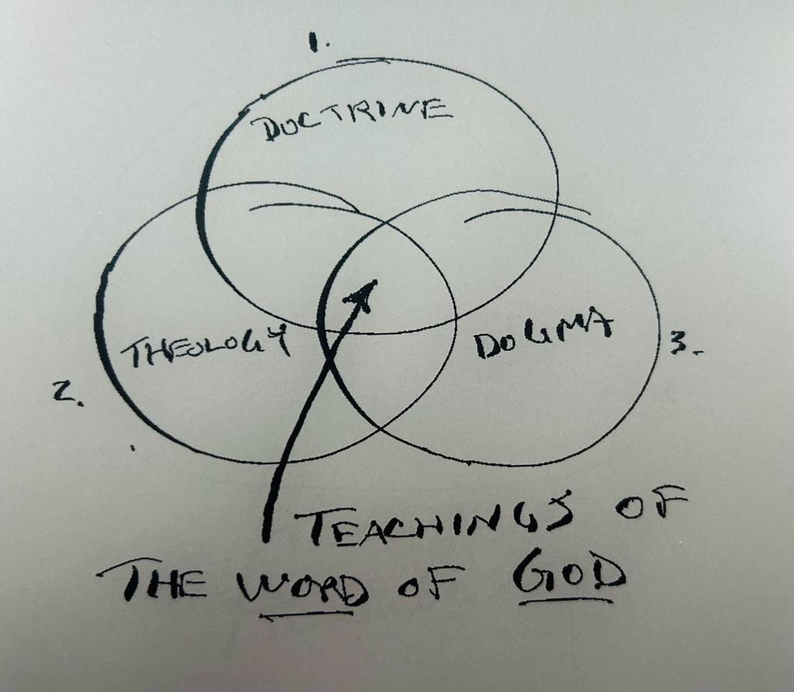
Theology. Theologia is a combination of Theos, meaning "God", and logos, meaning "word, discourse, or reasoning." Theology should be distinguished from doctrine, though they are closely related and often used interchangeably. In the strictest sense, Theology is the study of God - His existence, His knowablility, His attributes, and so on. But generally, when people refer to “theology,” they have in mind “Systematic Theology,” the logical ordering of the doctrines derived from the Bible. Doctrine is the broader term that refers to the Bible’s teaching regardless of how it is categorized.

Dogma. A doctrine or body of doctrines concerning faith or morals formally stated and authoritatively proclaimed by a church

How do we determine which doctrine is correct?
True doctrine originates with God, comes from the Bible and agrees with the whole of Scripture. Because such doctrine is sound, it is healthy and profitable for us, and we are responsible for holding to it.

1 Cor. 2:12-16 - “Now we have received, not the spirit of the world, but the spirit which is of God; that we might know the things that are freely given to us of God. Which things also we speak, not in the words which man's wisdom teacheth, but which the Holy Ghost teacheth; comparing spiritual things with spiritual. But the natural man receiveth not the things of the Spirit of God: for they are foolishness unto him: neither can he know them, because they are spiritually discerned. But he that is spiritual judgeth all things, yet he himself is judged of no man. For who hath known the mind of the Lord, that he may instruct him? but we have the mind of Christ.”

False doctrine originates with Satan (devils) and/or man, does not come from the Bible and contradicts portions of Scripture. Because such doctrine is unsound, it is unhealthy and unprofitable for us, and we are responsible for rejecting it.

3 Examples of False Doctrine
1) Taking scripture out of context or “Cherry picking” (see: Phil 4:13)
2) Mixture - Mixing truth with lies. This goes all the way back to the garden of Eden.
Gen. 3: 4,5 - “And the serpent said unto the woman, Ye shall not surely die: For God doth know that in the day ye eat thereof, then your eyes shall be opened, and ye shall be as gods, knowing good and evil.”
3) Terminology - Loaded words that sound good but often come from occult/New Age sources: Portals, Downloads, Awakening, Dominion, Soaking, etc.

The Christian Responsibility is Clear
We are to learn God’s Truth by searching His Word. We must carefully evaluate every teaching according to God’s unfailing standard.
Hebrews 5:12-6:2 - “In fact, though by this time you ought to be teachers, you need someone to teach you the elementary truths of God’s word all over again. You need milk, not solid food! Anyone who lives on milk, being still an infant, is not acquainted with the teaching about righteousness. But solid food is for the mature, who by constant use have trained themselves to distinguish good from evil. [6:1] Therefore let us move beyond the elementary teachings about Christ and be taken forward to maturity, not laying again the foundation of repentance from acts that lead to death, and of faith in God, instruction about cleansing rites, the laying on of hands, the resurrection of the dead, and eternal judgment.”

The Core Tenets
There are Core Tenets of Doctrine that must be held in order to claim Christianity. In addition, there are many other doctrines that do not determine salvation yet are very important as they may lead to apostasy if incorrect.

In order to determine the Core Tenets and Doctrines we must recognize the origin, which is the Word of God commonly called The Bible. If we do not have an inspired canon of scripture (Word of God) with core doctrines, then Christianity is just like many theories of our existence; i.e. religions, philosophies, sciences, psychology, etc., with no power to save!

The Word of God is the Revelation of God! The content of the Bible is “revelation” and the process of revelation is “inspiration.” There are two fundamental pillars of the inspired revelation of God, the Bible:
- Veracity (Truth)
  - Infallible Word of God, written by the inspiration of the Holy Spirit
  - Canon of Scripture is Discovered NOT created, it has been revealed to man
  - The Bible was NOT edited at the Council of Nicea by the Catholic Church (as claimed by many Gnostics)
  - Translations ARE sufficient (not interpretations)

- Sufficiency
  - Passages warning not to add to or take away from scriptures:
Deut. 4:2 - “Ye shall not add unto the word which I command you, neither shall ye diminish ought from it, that ye may keep the commandments of the Lord your God which I command you.”
Deut. 12:32 - “What thing soever I command you, observe to do it: thou shalt not add thereto, nor diminish from it.”
Josh. 1:7-8 - “Only be thou strong and very courageous, that thou mayest observe to do according to all the law, which Moses my servant commanded thee: turn not from it to the right hand or to the left, that thou mayest prosper withersoever thou goest. This book of the law shall not depart out of thy mouth; but thou shalt meditate therein day and night, that thou mayest observe to do according to all that is written therein: for then thou shalt make thy way prosperous, and then thou shalt have good success.”
Revelations 22:18-19 - “I testify unto every man that heareth the words of the prophecy of this book, If any man shall add unto these things, God shall add unto him the plagues that are written in this book: And if any man shall take away from the words of the book of this prophecy, God shall take away his part out of the book of life, and out of the holy city, and from the things which are written in this book.”
Additional Verses: Psalm 19:7; Psalm 119: 89, 105, 142, 160; Proverbs 30:5-6; Jer. 26:2; Matthew 4:4; 2 John 12:47-50; Eph 2:20; Timothy 3:14-17; James 1:25
  - Christ used the Scriptures throughout His ministry and He only had access to what we call the Old Testament known as the Tanakh to the Jews. We have been given the New Testament or Covenant in addition to the Old Testament/Covenant.
  - The Word of God is totally sufficient for Salvation as the primary means the Holy Spirit utilizes to convict men of sin and to inform us of the Cross work of Christ and the way of Salvation. Nothing needs to be added to the Word… no tradition of man, no signs and wonders, no extra emotionalism.

D.O.C.T.R.I.N.E
D - Deity of Christ: Jesus Christ IS God!

O - Origin of Sin: All mankind are sinners, only Jesus Christ is Perfect.

C - Canon of Scripture: The Scripture IS the true and sufficient Word of God and the Canon is closed!

T - Trinity: God is Three Persons in One Essence.

R - Resurrection: Jesus Christ died, resurrected and ascended.

I - Incarnation: God incarnated as a human in the person of Jesus Christ. Jesus is fully man and fully God!

N - New Creation / Salvation: Jesus Christ’s sacrifice on the cross and subsequent resurrection provide for us a way of Salvation back to the Father prepared for before the foundation of the world!

E - Eschatology: Jesus is coming again to judge the living and the dead in the Eschaton; the fulfillment of Time.

Historical Progression
30 - 100 AD: The Gospel spreads quickly and churches are established in many cities. All but John the Beloved are martyred for their Faith. The books of the New Testament are completed but not yet “canonized.” The first churches are established and we get a view of this in Acts and also much insight in the Epistles.

100 - 400 AD: Bishops are established as leaders of churches in specific cities (what we would today call Pastors). A Bishop's influence was usually directly related to the size of the city. The early church struggles with establishing doctrine, battling primarily with the Gnostics who rose in prominence in the 2nd and 3rd Century. The Canon is agreed upon at the Council of Hippo (393 AD). The three major Christian creeds, the Apostles' Creed, the Nicene Creed (see below), and the Athanasian Creed, together constitute a fairly comprehensive summary of traditional Christian doctrine, expressing the fundamental beliefs of a wide range of Christian churches.

400 - 1500 AD: The Roman Catholic Church emerges as the most powerful church in the West and splits with the Eastern Orthodox Church centered in Constantinople. The Roman Catholic Church consolidates power and adds new traditions and doctrines as the years progress.

1500 - Present: The Protestant Reformation emerges after hundreds of years of internal strife and socio-economic tyranny by the Roman Catholic Church. The Reformation returns to the Word of God as the ultimate and sole arbiter of Truth. Since the 1500s hundreds of distinct denominations have emerged, many with divergent and oftentimes contradictory doctrines.

Application Today (why it matters so much where it puts Jesus, the body of believers, Israel, truth, etc.)

Today, the battle over whose doctrine is correct rages! Is the Roman Catholic insistence on tradition and the Magisterium being the ultimate arbiter of Truth correct? Or should we side with the Protestants, giving pre-eminence to individual interpretation? Both answers lead to many problems and the end result is a widely divided modern Church. Is this modern Church the same Church written of in the Gospels and described as the Bride of Christ? Or, has this modern Church just become another worldly religion? The challenges we face today are enormous as there are so many different views and opinions and so much history to consider. As we have studied here, it is only by studying the Word of God and with the leading of the Holy Spirit that we can ever hope to begin to resolve these issues. Our hope and prayer is that this course will help each of you begin the journey of facing these real challenges facing Christ-followers today!

Additional References

Doctrine: STRONGS NT 1322: διδαχή
διδαχή, διδαχῆς ἡ (διδάσκω);
1. teaching, viz. that which is taught: Mark 1:27; John 7:16; Acts 17:19; 2 John 1:10; Revelation 2:24; ἡ διδαχή τίνος, one's doctrine, i. e. what he teaches: Matthew 7:28; Matthew 16:12; Matthew 22:33; Mark 1:22; Mark 11:18; Luke 4:32; John 18:19; Acts 5:28; Revelation 2:14; ἡ διδαχή of God, τοῦ κυρίου, τοῦ Χριστοῦ, the doctrine which has God, Christ, the Lord, for its author and supporter: John 7:17; Acts 13:12; 2 John 1:9; with the genitive of the object, doctrine, teaching, concerning something: Hebrews 6:2; Hebrews 13:9.

2. (the act of) teaching, instruction, (cf. διδασκαλία): Acts 2:42; 2 Timothy 4:2; ἐν τῇ διδαχή, while he was teaching, a phrase by which the Evangelist indicates that he is about to cite some of the many words which Jesus spoke at that time, Mark 4:2; Mark 12:38; τοῦ κατά τήν διδαχήν πιστοῦ λόγου, the faithful word which is in accordance with the received (2 Timothy 3:14) instruction, Titus 1:9; in particular, the teaching of the διδάσκαλος in the religious assemblies of Christians: λαλεῖν ἐν διδαχή, to speak in the way of teaching, in distinction from other modes of speaking in public, 1 Corinthians 14:6; ἔχω διδαχήν, to have something to teach, 1 Corinthians 14:26.

Nicene Creed
I believe in one God,
the Father almighty,
maker of heaven and earth,
of all things visible and invisible.

I believe in one Lord Jesus Christ,
the Only Begotten Son of God,
born of the Father before all ages.
God from God, Light from Light,
true God from true God,
begotten, not made, consubstantial with the Father;
through him all things were made.
For us men and for our salvation
he came down from heaven,
and by the Holy Spirit was incarnate of the Virgin Mary,
and became man.

For our sake he was crucified under Pontius Pilate,
he suffered death and was buried,
and rose again on the third day
in accordance with the Scriptures.
He ascended into heaven
and is seated at the right hand of the Father.
He will come again in glory
to judge the living and the dead
and his kingdom will have no end.

I believe in the Holy Spirit, the Lord, the giver of life,
who proceeds from the Father and the Son,
who with the Father and the Son is adored and glorified,
who has spoken through the prophets.

I believe in one, holy, catholic and apostolic Church.
I confess one Baptism for the forgiveness of sins
and I look forward to the resurrection of the dead
and the life of the world to come.

Amen.

