The Disciples/Apostles of Jesus Christ

12 disciples/apostles:
- Peter
- Andrew
- James
- John
- Philip
- Bartholomew or Nathanael
- Thomas Didymus
- Matthew or Levi
- James, the Lesser or Younger
- Jude or Thaddeus
- Simon the Zealot
- Judas
(See Matthew 10.1-4 and Luke 6.12-16.)

The Disciples/Apostles of Jesus
The 12 disciples/apostles of Jesus were the foundation stones of His church, several even wrote portions of the Bible. In Revelation 21.14 we are told that the twelve foundations of the wall of the New Jerusalem will have in them the names of the twelve disciples/apostles. It is evident, therefore, that God attaches great importance to these 12 men. As we study these courageous first-century lives, and what discipleship meant in the time of Jesus, we may expect to be aided in developing a Spirit-directed twenty-first-century discipleship as Christ must have meant it to be.
The following biographical information about the 12 original disciples/apostles of Jesus uses the New Testament accounts along with the most respected accounts of that time and traditions. We do not mean to infer that tradition constitutes historical fact. We do feel, however, that they do have value in the study of the lives of these men who …turned the world upside down…

The following chart provides a list of the apostles as presented in three of the gospels and the book of Acts. The apostles are grouped by fours.

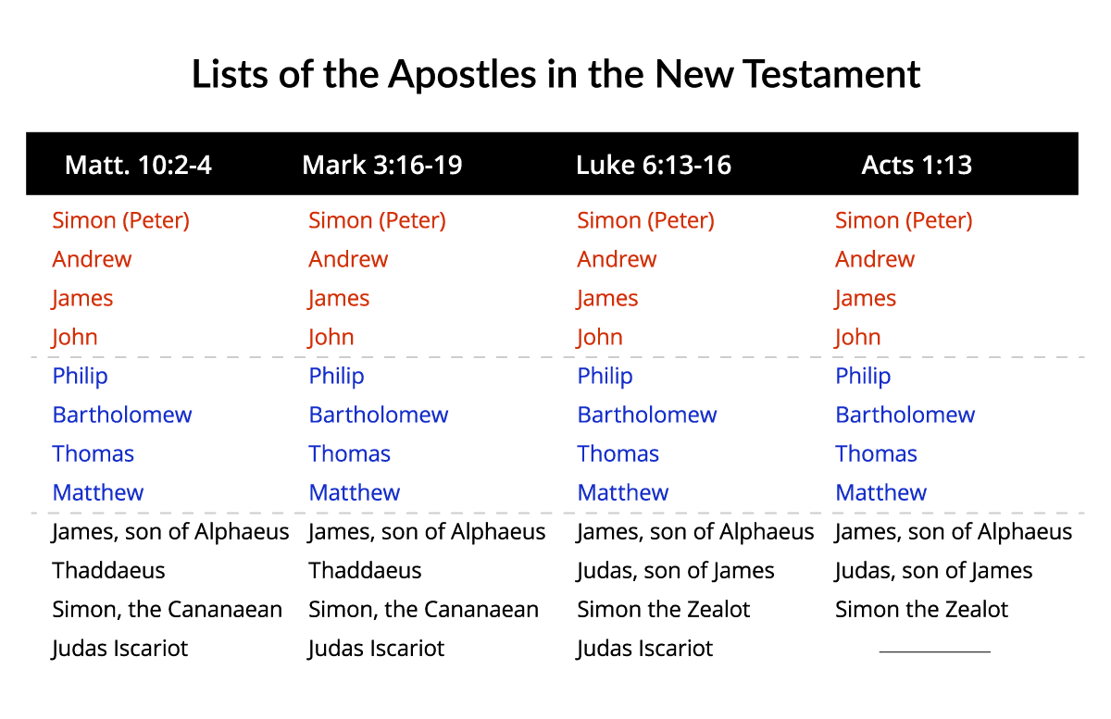

The First Group of the Disciples/Apostles — Peter, Andrew, James, and John
The first group of four apostles was Jesus’ inner group. They became His followers shortly after the beginning of His ministry. John 1.35-42 records the occasion on which they responded to Jesus by believing that He was the promised Messiah. Jesus asked them to follow Him three times. On that occasion they finally left everything and followed Jesus. At least three of them were invited to join Jesus when He raised Jairus’ daughter from the dead (Mark 5.37-43). Jesus also invited only Peter, James, and John to join Him on the Mount of Transfiguration (Matthew 17.1-13). All four privately asked Jesus questions on the Mount of Olives (Mark 13.1-8). Peter, James, and John were asked to wait for Jesus while He prayed in the Garden of Gethsemane (Matthew 26.36-37). Lastly, Peter and John were in discussion with Jesus prior to His departure to heaven (John 21.12-23). John was the disciple Jesus asked to care for His mother (John 19.26-27). It should be noted that James and John had the same father, Zebedee (Matthew 10.2) and Peter and Andrew were brothers (Matthew 10.2). These men were part of Jesus’ inner group.

Peter
Simon Peter, son of Jonas, was a fisherman who lived in Bethsaida and Capernaum. He did evangelistic and missionary work among the Jews, going as far as Babylon. He was a member of the Inner Circle and authored the two New Testament epistles which bear his name. Tradition says he was crucified, head downward, in Rome.
In every apostolic list, the name Peter is mentioned first. However, Peter had other names. At the time of Christ, the common language was Greek, and the family language was Hebrew. So his Greek name was Simon (Mark 1.16, John 1.40, 41). His Hebrew name was Cephas (1 Corinthians 1.12, 3.22, 9.5 and Galatians 2.9). The Greek meaning of Simon is rock. The Arabic meaning of Cephas is also rock.
By trade, Peter was a fisherman. He was a married man (1 Corinthians 9.5) and his home was Capernaum. Jesus probably made His headquarters there when He visited Capernaum. Peter was also a Galilean as was typical of many of the other disciples. Josephus described the Galileans this way, They were ever fond of innovation and by nature disposed to change and delighted in sedition. They were ever ready to follow the leader and to begin an insurrection. They were quick in temper and given to quarreling and they were very chivalrous men. The Talmud says this of the Galileans, They were more anxious for honor than for gain, quick-tempered, impulsive, emotional, easily aroused by an appeal to adventure, loyal to the end.
Peter was a typical Galilean. Among the twelve, Peter was the leader. He was the older of the two brothers and the only married disciple (Luke 4.38). His wife was known to travel with him when he was on mission (1 Corinthians 9.5). His assignment was to bring the Gospel to the circumcised (Galatians 2.7). He stands out as a spokesman for all the twelve Apostles. It is he who asked the meaning of the difficult saying in Matthew 15.15. It is he who asked how often he must forgive. It is he who inquired about the reward for all of those who follow Jesus. It is he who first confessed Jesus and declared Him as the Son of the Living God. It is he who was at the Mount of Transfiguration. It is he who saw Jairus' daughter raised to life. Yet it is he who denied Christ three times after Christ was arrested. He was an Apostle and a missionary who laid down his life for his Lord. It is true Peter had many faults, but he had always the saving grace of the loving heart. No matter how many times he had fallen and failed, he always recovered his courage and integrity.
Peter was martyred on a cross. Peter requested that he might be crucified head downward for he was not worthy to die as his Lord had died. He died a martyr’s death in Rome during the reign of Nero. Some speculate around the same time as Paul was being beheaded. His apostolic symbol is a cross upside down with crossed keys.

Andrew
Andrew was the brother of Peter, and a son of Jonas. He lived in Bethsaida and Capernaum and was a fisherman before Jesus called him. Originally, he was a disciple of John the Baptist (Mark 1.16-18). Andrew brought his brother, Peter, to Jesus (John 1.40). He is the first to have the title of Home and Foreign Missionary. He is claimed by three countries as their Patron Saint: Russia, Scotland and Greece. Many scholars say that he preached in Scythia, Greece and Asia Minor.
Andrew introduced others to Jesus. Although circumstances placed him in a position where it would have been easy for him to become jealous and resentful, he was optimistic and well content in second place. His main purpose in life was to bring others to the master.
According to tradition, it was in Achaia, Greece, in the town of Patra that Andrew died a martyr. When Governor Aepeas' wife was healed and converted to the Christian faith, and shortly after that the Governor's brother became a Christian. Aepeas was enraged. He arrested Andrew and condemned him to die on the cross. Andrew, feeling unworthy to be crucified on the same-shaped cross as his Master, begged that his be different. So, he was crucified on an X-shaped cross, which is still called Saint Andrew's cross, and which is one of his apostolic symbols. A symbol of two crossed fish has also been applied to Andrew, because he was formerly a fisherman.

James
James, the Elder, Boanerges (Son of Thunder along with his brother John), son of Zebedee and Salome, brother of John the Apostle; a fisherman who lived in Bethsaida, Capernaum and Jerusalem. He preached in Jerusalem and Judea. He was a member of the Inner Circle, so called because they were accorded special [advantages]. The New Testament tells us very little about James. His name never appears apart from that of his brother, John. They were an inseparable pair (Mark 1.19-20; Matthew 4.21; Luke 5.1-11).
He was a man of courage and forgiveness, a man without jealousy, living in the shadow of John, a man of extraordinary faith. He was the first of the twelve to become a martyr. He was beheaded by Herod, AD 44 (Acts 12.1,2). His symbol is three shells, the sign of his pilgrimage by the sea.

John
John Boanerges (Son of Thunder along with his brother James), son of Zebedee and Salome, brother of James, the Apostle. He was known as the Beloved Disciple. A fisherman who lived in Bethsaida, Capernaum and Jerusalem, he was a member of the Inner Circle. He wrote the Gospel of John, I John, II John, III John and Revelation. He preached among the churches of Asia Minor. Banished to the Isle of Patmos, he was later freed and died a natural death. John was one of the prominent Apostles. He is mentioned in many places in the New Testament. He was a man of action; he was very ambitious; and a man with an explosive temper and an intolerant heart. He and his brother, James, came from a more well-to-do family than the rest of the 12 Apostles. Since his father had hired servants in his fishing business (Mark 1.20) he may have felt himself above the rest. He was close to Peter. They were acting together in the ministry. Peter, however, was always the spokesman for the band.
John mellowed with time. At the latter part of his life, he had forgotten everything, including his ambition and explosive temper, except his Lord's command of love.
It is said that an attempt was made on his life by giving him a chalice of poison from which God spared him. He died of natural causes. A chalice with a snake in it is his apostolic symbol.

The Second Group of the Disciples/Apostles — Philip, Bartholomew, Thomas, and Matthew
The second group of four apostles included two men who were into details. That is, they appear to have been analytical men: Thomas and Matthew. Thomas is known as Didymus (John 21.2) and Doubting Thomas because He questioned that Jesus had actually returned to life (John 20.26-29). He wanted to place his finger into Jesus’ wounds to confirm that the wounds were real. Matthew was a tax collector for the Roman Empire. These two men were probably technically oriented. It appears from John 1.35-51 that Philip and Bartholomew believed in Jesus Christ as their Messiah on the same day that Peter, Andrew, James, and John did. Bartholomew was also known as Nathanael.

Philip
Tradition says that disciple Philip preached in Phrygia. Philip came from Bethsaida, the town from which Peter and Andrew came (John 1.44). The likelihood is that he, too, was a fisherman. Although the first three Gospels record his name (Matthew 10.3; Mark 3.18; Luke 6.14; Acts 1.13), it is in the Gospel of John that Philip becomes a living personality.
Scholars disagree on Philip. In Acts 6.5, we have Philip as one of the seven ordained deacons. Some say this is a different Philip. Some believe this is the Apostle. If this is the same Philip, then his personality came more to life because he had a successful campaign in Samaria. He led the Ethiopian eunuch to Christ (Acts 8.26). He also stayed with Paul in Caesarea (Acts 21.8) and was one of the major figures in the missionary enterprise of the early church.
The Gospel of John shows Philip as one of the first to whom Jesus addressed the words, "Follow Me." When Philip met Christ, he immediately found Nathanael and told him that "we have found him, of whom Moses … and the prophets, did write." Nathanael was skeptical. But Philip did not argue with him; he simply answered, "Come and see." This story tells us two important things about Philip. First, it shows his right approach to the skeptic and his simple faith in Christ. Second, it shows that he had a missionary instinct.
Philip was a man with a warm heart and a pessimistic head. He was one who would very much like to do something for others, but who did not see how it could be done. Yet, this simple Galilean gave all he had. In return God used him. It is he that stressed the cross as a sign of Christianity and victory. It is said that he died by hanging at Hierapolis. While he was dying, he requested that his body be wrapped not in linen but in papyrus for he was not worthy that even his dead body should be treated as the body of Jesus had been treated. The symbol of Philip is a basket, because of his part in the feeding of the five thousand.

Bartholomew or Nathanael
Bartholomew Nathanael, son of Talmai, lived in Cana of Galilee. Tradition says he was a missionary in Armenia. A number of scholars believe that he was the only one of the 12 disciples who came from royal blood, or noble birth. His name means Son of Tolmai or Talmai (2 Samuel 3.3). Talmai was king of Geshur whose daughter, Maacah, was the wife of David, mother of Absolom.
Bartholomew's name appears with every list of the disciples (Matthew 10.3; Mark 3.18; Luke 6.14; Acts 1.13). This was not a first name, however; it was his second name. His first name probably was Nathanael, whom Jesus called An Israelite indeed, in whom there is no guile (John 1.47).
The New Testament gives us very little information about him. Tradition indicates he was a great searcher of the Scripture and a scholar in the law and the prophets. He developed into a man of complete surrender to the Carpenter of Nazareth, and one of the Church's most adventurous missionaries. He is said to have preached with Philip in Phrygia and Hierapolis, also in Armenia. The Armenian Church claims him as its founder and martyr. However, tradition says that he preached in India, and his death seems to have taken place there. He died as a martyr for his Lord. He was flayed alive with knives. His apostolic symbol is three parallel knives.

Thomas Didymus
Thomas Didymus lived in Galilee. Tradition says he labored in Parthia, Persia, and India, suffering martyrdom near Madras, at Mt. St. Thomas, India.
Thomas was his Hebrew name and Didymus was his Greek name. At times he was called Judas. Matthew, Mark and Luke tell us nothing about Thomas except his name. However, John defines him more clearly in his Gospel. Thomas appeared in the raising of Lazarus (John 11.2-16), in the Upper Room (John 14.1-6) where he wanted to know how to know the way where Jesus was going. In John 20.25, we see him saying unless he sees the nail prints in Jesus' hand and the gash of the spear in His side he will not believe. That's why Thomas became known as Doubting Thomas.
By nature, Thomas was a pessimist. He was a bewildered man. Yet, he was a man of courage. He was a man who could not believe until he had seen. He was a man of devotion and of faith. When Jesus rose, he came back and invited Thomas to put his finger in the nail prints in his hands and in his side. Here, we see Thomas making the greatest confession of faith, "My Lord and my God." Thomas' doubts were transformed into faith. By this very fact Thomas' faith became great, intense and convincing. It is said that he was commissioned to build a palace for the king of India, and he was killed with a spear as a martyr for his Lord. His symbol is a group of spears, stones and arrows.

Matthew or Levi
Matthew, or Levi, son of Alpheus, lived in Capernaum. He was a publican or tax collector. He wrote the Gospel that bears his name.
The call of Matthew to the apostolic band is mentioned in Mark 2.14, Matthew 9.9 and Luke 5.27-28. From these passages, we learn that Matthew also was called Levi. It was a common custom in the Middle East at the time of Christ for men to have two names. Matthew's names mean "a gift of God." The name Levi could have been given to him by Jesus. It is likely that James the lesser, who was one of the twelve Apostles, was Matthew's brother, also the son of Alpheus. Although we know little about Matthew personally, the outstanding fact about him is that he was a tax collector. The King James Version calls him a publican, which in Latin is Publicanus, meaning engaged in public service, a man who handled public money, or a tax gatherer.
Of all the nations in the world, the Jews were the most vigorous haters of tax gatherers. To the devout Jew, God was the only one to whom it was right to pay tribute in taxes. To pay it to anyone else was to infringe on the rights of God. The tax collectors were hated not on religious grounds only but because most of them were notoriously unjust.
In the minds of many honest, Jewish men, these tax collectors were regarded as criminals. In New Testament times they were classified with harlots, Gentiles and sinners (Matthew 18.17; Matthew 21.31, 33; Matthew 9.10; Mark 2.15,16; Luke 5.30). Tax collectors had been known to assess duty payable at impossible sums and then offer to lend the money to travelers at a high rate of interest. Such was Matthew. Yet, Jesus chose a man all men hated and made him one of His men. It took Jesus Christ to see the potential in the tax collector of Capernaum.
Matthew was unlike the other Apostles, who were mostly fishermen. He could use a pen, and by his pen he became the first man to present to the world, in the Hebrew language, an account of the teaching of Jesus. It is clearly impossible to estimate the debt that Christianity owes to this despised tax gatherer. The average man would have thought it impossible to reform Matthew, but to God all things are possible. Matthew became the first man to write down the teachings of Jesus. He was a missionary of the Gospel, who laid down his life for the faith of his Master. He died a martyr in Ethiopia. The apostolic symbol of Matthew is three money bags which reminds us that he was a tax collector before Jesus called him.

The Third Group of the Disciples/Apostles — James, Thaddaeus, Simon, and Judas
We know very little about the third group of four apostles. We know almost nothing about James the son of Alphaeus from the Bible other than that his father’s name was Alphaeus, and the name of Matthew’s father was also Alphaeus (Matthew 9.9; Mark 2.14). So they may have been brothers. The only information we have about Thaddaeus is that he was an apostle (Matthew 10.3; Mark 3.18). Simon the Cananaean was also called Simon the Zealot (Matthew 10.2; Acts 1.13). The Zealots were anti-Rome and were politically motivated. One wonders how Simon felt about Matthew, who would have been considered a traitor by the Jews because he was a tax-collector for Rome. The Bible reveals nothing significant about this apostle. Judas Iscariot was the traitor (Matthew 10.4) who later hung himself (Matthew 27.3-6) and was therefore not listed with the disciples in the book of Acts.
James the Lesser or the Younger
James, the Lesser or Younger, son of Alpheus, or Cleophas and Mary, lived in Galilee. He was the brother of the Apostle Jude.
According to tradition he wrote the Epistle of James, and preached in Palestine and Egypt. James was one of the little-known disciples. Some scholars believe he was the brother of Matthew, the tax collector. James was a man of strong character and one of the most fiery type. He was said to be crucified in Egypt. Another tradition says that he died as a martyr and his body was sawed in pieces. The saw became his apostolic symbol.

Jude or Thaddeus
Jude, Thaddeus, or Lebbeus, son of Alpheus or Cleophas and Mary. He was a brother of James the Younger. He was one of the very little-known Apostles and lived in Galilee. Tradition says he preached in Assyria and Persia and died a martyr in Persia.
Jerome called Jude "Trinomious" which means a man with three names. In Mark 3.18 he is called Thaddeus. In Matthew 10.3 he is called Lebbeus. His surname was Thaddeus. In Luke 6.16 and Acts 1.13 he is called Judas the brother of James. Judas Thaddeus also was called Judas the Zealot.
By character he was an intense and violent Nationalist with the dream of world power and domination by the Chosen People. In the New Testament records (John 14.22 NIV) he asked Jesus at the Last Supper, But Lord, why do you intend to show yourself to us and not to the world? Judas Thaddeus was interested in making Christ known to the world. Not as a suffering Saviour, however, but as ruling King. We can see plainly from the answer Jesus gave him, that the way of power can never be substituted for the way of love.
It is said that Jude went to preach the gospel in Edessa near the Euphrates River. There he healed many and many believed in the name of the Master. Jude went from there to preach the Gospel in other places. He was killed with arrows at Ararat. The chosen symbol for him is the ship because he was a missionary thought to be a fisherman.

Simon the Zealot
Simon, the Zealot, one of the little-known followers called the Canaanite or Zelotes, lived in Galilee. Tradition says he was crucified.
In two places in the King James Version he is called a Canaanite (Matthew 10.4; Mark 3.18). However, in the other two places he is called Simon Zelotes (Luke 6.15; Acts 1.13).
The New Testament gives us practically nothing on him personally except that it says he was a Zealot. The Zealots were fanatical Jewish Nationalists who had heroic disregard for the suffering involved and the struggle for what they regarded as the purity of their faith. The Zealots were crazed with hatred for the Romans. It was this hate for Rome that destroyed the city of Jerusalem. Josephus says the Zealots were reckless persons, zealous in good practices and extravagant and reckless in the worst kind of actions.
From this background, we see that Simon was a fanatical Nationalist, a man devoted to the Law, a man with bitter hatred for anyone who dared to compromise with Rome. Yet, Simon clearly emerged as a man of faith. He abandoned all his hatred for the faith that he showed toward his Master and the love that he was willing to share with the rest of the disciples and especially Matthew, the Roman tax collector.
Simon, the Zealot, the man who once would have killed in loyalty to Israel, became the man who saw that God will have no forced service. Tradition says he died as a martyr. His apostolic symbol is a fish lying on a Bible, which indicates he was a former fisherman who became a fisher of men through preaching.

Judas
Judas Iscariot, the traitor, was the son of Simon who lived in Kerioth of Judah.
Judas, the man who became the traitor, is the supreme enigma of the New Testament because it is so hard to see how anyone who was so close to Jesus, who saw so many miracles and heard so much of the Master's teaching could ever betray him into the hands of his enemies.
His name appears in three lists of the 12 Apostles (Matthew 10.4; Mark 3.19; Luke 6.19). It is said that Judas came from Judah near Jericho. He was a Judean and the rest of the disciples were Galileans. He was the treasurer of the band and among the outspoken leaders.
It is said that Judas was a violent Jewish Nationalist who had followed Jesus in hope that through Him his nationalistic flame and dreams might be realized. No one can deny that Judas was a covetous man and at times he used his position as treasurer of the band to pilfer from the common purse. There is no certain reason as to why Judas betrayed his master; but it is not his betrayal that put Jesus on the cross-it was our sins. He betrayed Jesus for thirty pieces of silver and afterwards hanged himself (Matthew 26.14,16). His apostolic symbol is a hangman's noose, or a money purse with pieces of silver falling from it.

How the Disciples/Apostles Died
The Bible does not tell us how each apostle died. It records the death of only two apostles. Therefore, we must depend upon historical information for the other apostles in order to answer the question, How did the twelve apostles die? But it is important to note that there are multiple conflicting traditions about how some apostles died.
So, which tradition is correct? For example, tradition claims that Peter died in A.D. 64-68 during Nero’s persecution of the Christians , and that he was crucified upside down on a cross (John 21.18-19). Tradition also states that Andrew was crucified on a cross that today we call the St. Andrews cross. The cross has the shape of an “X.” He was not nailed to the cross but was tied. It took several days before he died. It is said that he preached while hanging on the cross. The apostle James died in A.D. 44 after he was beheaded by King Herod I who had launched a new persecution of Christians (Acts 12.1-3). He was the first martyr from among the twelve apostles. One tradition says John was on the Isle of Patmos (Revelation 1.9) before he was released and went to Ephesus where he died (A.D. 100-105).

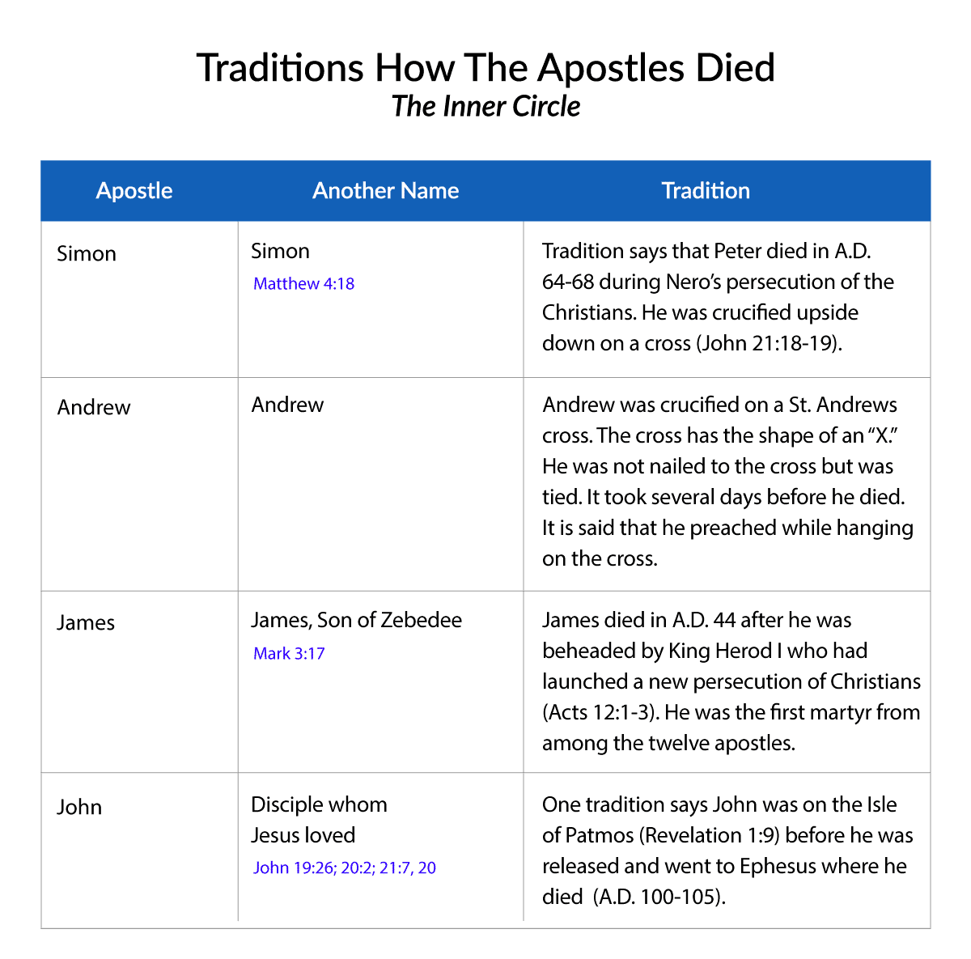
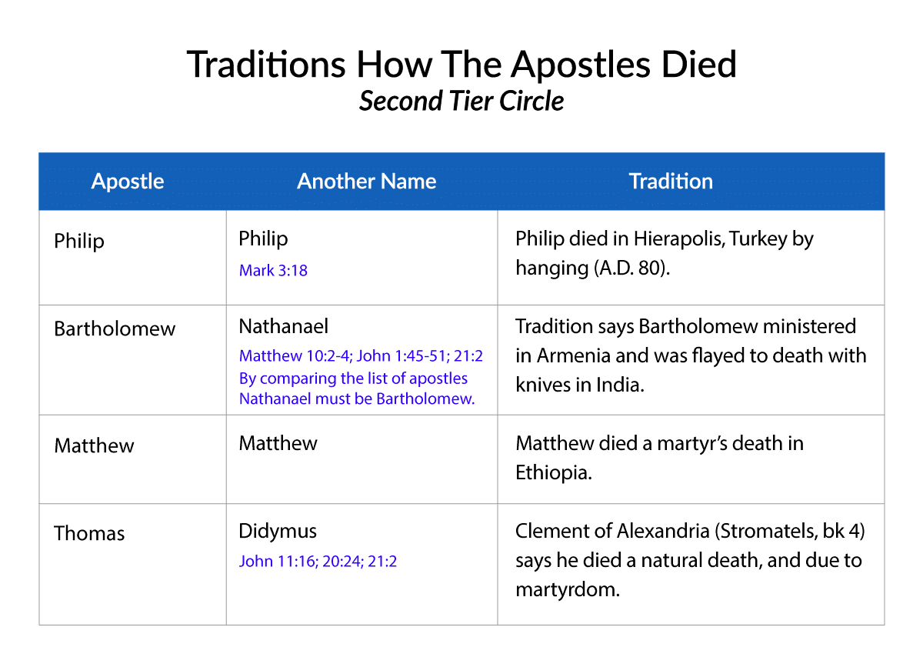
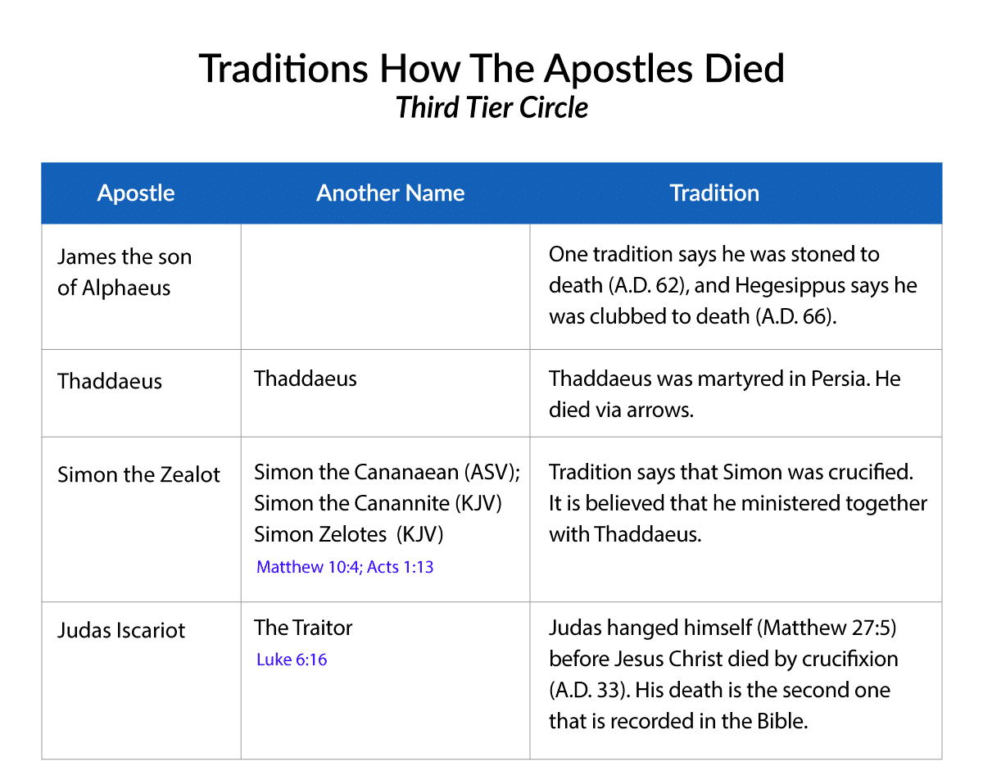
Who replaced Judas Iscariot?
Judas Iscariot, who betrayed Jesus, was replaced as one of the twelve apostles by Matthias (see Acts 1.20–26). Some Bible teachers view Matthias as an invalid choice because it appears that instead of waiting in the upper room, the disciples/apostles had made undue criteria for whom to appoint to “replace” Judas and lots were cast and Matthias was chosen, but the Bible is sparse on additional details relating to Matthias. It does say that Matthias was with Jesus since His baptism until his resurrection. Besides the book of Acts, Matthias isn’t mentioned anywhere else in the Bible. According to historical sources Matthias lived until 80 A.D. and spread the gospel on the shores of the Caspian and Cappadocia.

Paul's Unique Calling
A few chapters later, we see that Paul was God’s choice to replace Judas Iscariot as the twelfth apostle.

But the Lord said to him (Ananias), Go, for this man is a chosen vessel to Me, to bear My name before the Gentiles, and kings, and the children of Israel; For I will show him what great things he must suffer for My name (Acts 9.15 - 16).

After Paul was baptized in Damascus, he began to powerful preach that Christ was the Son of God (Acts 9.20 - 22). Death threats from Jews living in the city, who rejected his message, drove him to flee to Arabia. During his three years of exile in Arabia he was personally taught by Jesus.

But I (Paul) certify to you, brethren, that the gospel that was preached by me is not according to man; Because neither did I receive it from man, nor was I taught it by man; rather, it was by the revelation of Jesus Christ . . .

But when it pleased God, Who selected me from my mother’s womb, and called me by His grace, to reveal His own Son in me, in order that I might preach Him as the gospel among the Gentiles, I did not immediately confer with flesh and blood,

Nor did I go up to Jerusalem to those who were apostles before me; but I went away into Arabia and returned again to Damascus (Galatians 1.11 - 12, 15 - 17, see also Acts 9.20 - 25).

Paul, at this point in his life, fulfilled the same basic criteria the original disciples did in regard to being considered an apostle.

Additional Biblical evidence exists that shows, and reaffirms, his calling as being unique. In Acts 13 the church in Syrian Antioch is told by God to separate both Barnabas and Saul to Me for the work to which I have called them (Acts 13.2). The church soon lays hands on the two men and sends them out to evangelize (verses 3 - 4). After this event Luke, the writer of the book of Acts, labels both men as apostles (Acts 14.14).

Paul himself, in many of his writings, asserts his right to his special calling (1Corinthians 1.1, 2 Corinthians 11.5, Galatians 1.1, Colossians 1.1, 1Timothy 1.1, etc.). He writes the following defending his unique calling to the churches in the Roman province of Galatia.

Paul, an apostle, not sent from men nor made by man, but by Jesus Christ and God the Father . . . But I certify to you, brethren, that the gospel that was preached by me is not according to man; Because neither did I receive it from man, nor was I taught it by man; rather, it was by the revelation of Jesus Christ . . . (Galatians 1.11 - 12).

Flexible Requirements

The Greek word apostolos (Strong's Concordance #G652) is used eighty-one times in the original language of the New Testament. The word, which many times in the King James is translated as apostle or its plural, simply means a delegate, an ambassador of the gospel, or one that is sent. Surprisingly, the Bible does not limit the use of this term to Jesus' innermost twelve followers or even to Paul.

As stated previously, Barnabas was also given this designation by Luke. Paul, defending himself against those critical of his ministry, asserts to the Corinthians that both he and Barnabas have the same right to be financially supported as the other apostles (1Corinthians 9). Barnabas was considered "one sent" by God to preach the gospel even though Scripture does not state he was personally taught by Christ or saw him after his resurrection.

Were there Other Apostles?

Biblical evidence suggests Apollos (1Corinthian 4.6, 9), Silvanus and Timothy (1Thessalonians 1.1, 2.6), as well as Andronicus (a possible distant relative of Paul's) and a person named Junia were also apostles (Romans 16.7). Paul referred to James, the Lord's physical half-brother, as also possessing this calling.

But other of the apostles saw I none, save James the Lord's brother. (Galatians 1:19).

Conclusion
It is amazing that we know so little about the men who turned the world upside down. Jesus had prepared them, and God used them in a powerful way to alert the world to His good news that Jesus Christ had come into the world to save sinners. These men gave their lives and died so that all could hear the good news that the forgiveness of sins is free to anyone who believes in Jesus Christ and accepts Him as Lord and Savior.

Taken from https://www.neverthirsty.org/bible-qa/qa-archives/question/how-did-the-apostles-die/ and https://www.crosswalk.com/faith/bible-study/who-were-the-12-disciples-and-what-should-we-know-about-them.html.
Jesus asked them to follow Him three times (see https://www.neverthirsty.org/bible-studies/ministry-in-galilee-mid-a-d-31/the-third-call/) The first time was after they believed (see https://www.neverthirsty.org/bible-studies/preparation-for-ministry-a-d-29/jesus-first-believers/). The second time occurred when they were fishing (Mark 1.14-20) (see https://www.neverthirsty.org/bible-studies/ministry-in-galilee-mid-a-d-31/the-second-call/) and the third time occurred after another time of fishing (Luke 5.1-11) (see https://www.neverthirsty.org/bible-studies/ministry-in-galilee-mid-a-d-31/the-third-call/)
Mostly from https://www.biblestudy.org/question/was-paul-really-an-apostle.html

