Revelation 2.12-17 – **Church of Pergamos: OVERCOME FALSE TEACHINGS or LOSE THE REWARDS of STANDING for CHRIST in OPPOSITION to them**

**12** And to the angel of the church in Pergamos write; These things saith he which hath the sharp sword with two edges;

**13** I know thy works, and where thou dwellest, even where Satan’s seat is: and thou holdest fast my name, and hast not denied my faith, even in those days wherein Antipas was my faithful martyr, who was slain among you, where Satan dwelleth.

**14** But I have a few things against thee, because thou hast there them that hold the doctrine of Balaam, who taught Balac to cast a stumblingblock before the children of Israel, to eat things sacrificed unto idols, and to commit fornication.

**15** So hast thou also them that hold the doctrine of the Nicolaitans, which thing I hate.

**16** Repent; or else I will come unto thee quickly, and will fight against them with the sword of my mouth.

**17** He that hath an ear, let him hear what the Spirit saith unto the churches; To him that overcometh will I give to eat of the hidden manna, and will give him a white stone, and in the stone a new name written, which no man knoweth saving he that receiveth it.

Subject Sentence: Jesus comes with a sword – His Word – to fight those who hold false doctrine causing others to stumble. (Jesus put you here to do this, but if **you** won’t, **He WILL!** You will miss the reward of the overcomer.)

Aim: This passage would cause me to ***not*** *allow false doctrines of things He hates to be a stumblingblock to His children and for me* ***not*** to *allow that without fighting against it.*

12. And unto the angel of the church in Pergamos (*castle/tower*) write; These things saith he which hath the sharp sword with two edges; (Word of God = sharper than a 2-edged sword! Piercing to dividing of soul and spirit and is a discerner of the thoughts and intents of the heart!)

I. I know your works, where you dwell (even where Satan’s seat is), and you **hold fast** My Name and haven’t denied My faith – even amongst a martyr slain among you.

13a. I know thy works, and where thou dwellest, even where Satan’s seat is:

13b. and thou holdest fast my name, and hast not denied my faith, even in those days wherein Antipas was my faithful martyr, who was slain among you, where Satan dwelleth.

Summary: I know your works and tribulation and poverty (but you’re rich) and I know the blasphemy of them which say they’re Jews but aren’t – they’re of the synagogue of Satan

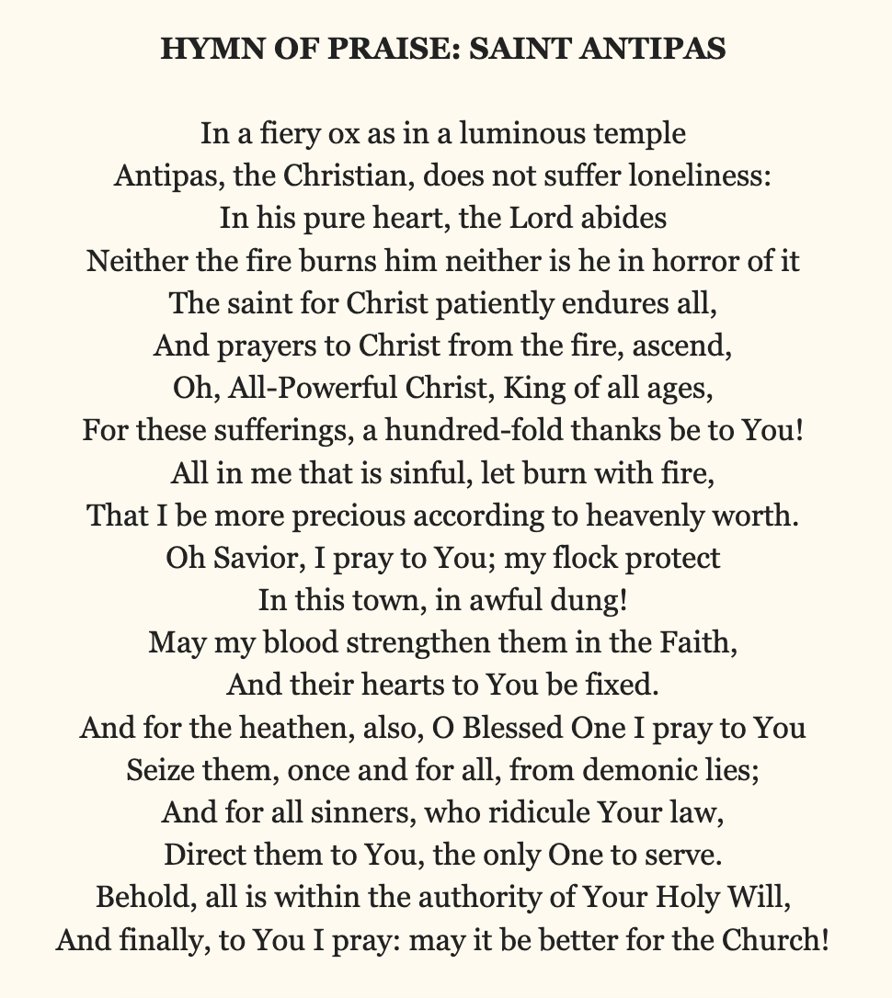

Application Questions:

1. Have I *held fast* the Name of Jesus? ***How*** in the face of opposition?

2. Have I kept *faith* in Christ – believing without seeing? ***How*** in the face of opposition?

3. What persecution have I had to endure for Christ?

4. Have I prayed for others through it and patiently endured as Antipas?

5. What *works* have I shown to demonstrate my faith?

6. What *tribulation* have I endured?

II. I have a few things against you: (1) you have them that hold doctrine of Balaam who taught Balac to cast a skandalon (#4625 = offense/stumblingblock) to eat things sacrificed to idols and commit fornication, and you hold the doctrine of the Nicolaitans which I hate!)

14. But I have a few things against thee, because thou hast there them that hold (#2902 **krypteo,** *strength, power***)** the doctrine of Balaam, who taught (#1799 *in the face of the children of Israel*) Balac to cast a stumblingblock (scandalon) before the children of Israel, to eat things sacrificed unto idols, and to commit fornication.

15. So hast thou also them that hold (**krateo *=*** *strength/power*) the doctrine of the Nicolaitans, which thing I hate.

Application Questions:

1. Is there *anything* that can be held against me by my Lord in opposition to **His Word and calling?**
2. What false doctrines are there in the face of Christian that are causing people to stumble, and have I just allowed those things without exposing and speaking out against them?

III. Repent! Or I’ll come to you quickly and fight against them (those that cast stumblingblocks that we have ***allowed***) (1) doctrine of Balaam... idols, fornication, idolatry; & (2) Nicolaitans **allowing them** to have **power** over God’s children!! Repent! Or I’ll do the work without you with the sword of My mouth (that I gave YOU to use against those that are taking power over God’s children!)

(1 Corinthians 16.9 – *For a great door and effectual is opened unto me and there are many adversaries (opposing.*)

16. Repent; or else I will come unto thee quickly, and **will fight against them** with the sword of my mouth.

(Deuteronomy 29.29 *The secret things belong to the Lord, but things revealed belong to us and our sons forever...* *that we may observe all the words of the law...* Amos 3.7; John 15.15; Eph 1.9; Dan 2.22; Prov 25.2; Eph 3.5; Col 1.26.)

**Amos 3:7** Surely the Lord GOD will do nothing, but he revealeth his secret unto his servants the prophets.

**John 15:15** Henceforth I call you not servants; for the servant knoweth not what his lord doeth: but I have called you friends; for all things that I have heard of my Father I have made known unto you.

**Eph. 1:9** Having made known unto us the mystery of his will, according to his good pleasure which he hath purposed in himself:

**Dan. 2:22** He revealeth the deep and secret things: he knoweth what is in the darkness, and the light dwelleth with him.

**Prov. 25:2** It is the glory of God to conceal a thing: but the honour of kings is to search out a matter.

**Eph. 3:5** Which in other ages was not made known unto the sons of men, as it is now revealed unto his holy apostles and prophets by the Spirit;

**Col. 1:26** Even the mystery which hath been hid from ages and from generations, but now is made manifest to his saints:

Application Questions:

1. Have I *fought against* those that cast stumblingblocks?
2. Have I allowed false doctrines to have power over God’s children without doing anything to oppose it?
3. Does my holding back from revealing truth require Christ to work *without me* or am I faithful to preach the Truth in the face of it?

IV. Overcome (subdue) to receive the HIDDEN MANNA and a white stone of INTIMACY, a REWARD for conquest and the victory. To him that overcomes will I give to eat of the hidden manna (the *revealed sustenance from heaven!!*), and I will give him a white stone and in the stone a new name written which no man knows saving he that receives it.

17. He that hath an ear, let him hear what the Spirit saith unto the churches; To him that overcometh will I give to eat of the hidden manna, and will give him a white stone, and in the stone a new name written, which no man knoweth saving he that receiveth it.

White stone:

1. In ancient courts, condemned defendants received black stone with their name on it but if acquitted you receive a white stone!
2. In Greek Olympic games a white stone was given to the winners for their perseverance. We’re saved through faith alone – yet we serve God with works that demonstrate our faith.
3. The new name = promise of intimacy. In that day guests would have a white stone at their seat with a private message from the host underneath so the host could share an intimate thought with each one.

The stones show our (1) acquittal; (2) reward for accomplishing the good works God prepared for us to do; for *overcoming* the obstacles; (3) intimacy with our Lord.

Application Questions:

1. Have I *overcome* by not allowing false teachings in the Church?
2. Have I *overcome* (subdued) by exposing and not allowing false teachings to ME?
3. Have I received the *hidden manna* and white stone of INTIMACY as a reward for speaking against doctrines that come against the Word of God?
4. Have I gotten the victory of serving God and NOT MAN?
5. Have I eaten of the revealed sustenance from heaven vs. the false ideas of men?
6. Have I been given a new name by God?
7. Have I received all the white stone represents: acquittal from neglecting my responsibility from standing up for the Word of God vs. the false teachings of men? The white stone of VICTORY for my perseverance and demonstration of my faith in the Word and Truth of God? My new name and notes from my Savior because He can share intimate thoughts with me at His table?