If You Need More Than the Gospel, It Ain’t the Gospel
There is a line in Scripture that does not bend.
It does not adapt. It does not evolve. It does not make room for additions.
“But even if we, or an angel from heaven, preach any other gospel to you… let him be accursed.” (Galatians 1:8–9, NKJV)
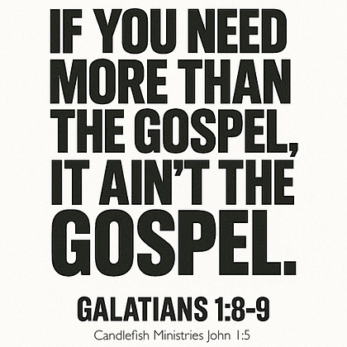
That’s not gentle language.
That’s a boundary.
The Gospel Is Not Incomplete
The moment someone says:
- “Yes, but you also need…”
- “The Gospel is good, but…”
- “That’s the foundation, now add…”
They’ve already crossed the line.
Because the Gospel is not:
- a starting point
- a partial system Robert Rousseau
- a base layer for something bigger (@candlefish)
It is the full, finished message of salvation in Christ.
What Gets Added?
History is full of it:
- Works added to grace
- Ritual added to faith
- Systems added to Scripture
- Authority added above Christ
And it always sounds reasonable.
It always sounds “helpful.”
It always claims to be:
“deepening” or “clarifying”
But Paul doesn’t say:
“Be careful, this might be slightly off”
He says:
It is another gospel.
Another Gospel Is Not a Small Error
This is where modern thinking fails.
People treat doctrine like preference:
- different flavors
- different expressions
- different traditions
But Scripture does not.
There is one Gospel.
Not:
- one plus additions
- one plus tradition
- one plus system
Just one.
Even an Angel Doesn’t Get a Pass
Let that sink in.
Paul doesn’t say:
- “If a false teacher says this…”
He says:
“If WE… or an angel from heaven…”
That means:
- authority doesn’t matter
- charisma doesn’t matter
- reputation doesn’t matter
If the message changes—
it’s rejected.
Why This Matters Right Now
Because today the Gospel is constantly being:
- softened
- expanded
- redefined
- merged with other ideas
And most people don’t even notice.
Because it sounds close enough.
But “close enough” is not truth.
Candlefish Reflection
The Gospel does not need help.
It does not need improvement. It does not need protection from offense. It does not need human systems to complete it.
It needs to be believed and proclaimed exactly as it is.
Final Line
If you need more than the Gospel, it ain’t the Gospel.
And if someone brings you more—
You don’t receive it.

