Supplement to Revelation Bible Study
Prophecies of Daniel

The Beast of Revelation–The Anti-Christ and his Kingdom
[Why Study Daniel While Studying the Book of Revelation?] Much of what we know about the anti-Christ or man of lawlessness comes from the book of Daniel and the book of Revelation. This post is not meant as an exhaustive study on the man the anti-Christ, but it is meant as a tool to equip you to study on your own, while providing some basic historical facts and discussion of commonly used symbols. The book of Revelation cannot be separated from its close counterpart—the book of Daniel.
There can be no question that one of the most important portions of the Bible with regard to the subject of the end-times is the Book of Daniel. Its primary focus and emphasis is the final conflict between the Antichrist, the followers of the Antichrist and the people of God who are ultimately delivered by the coming of the Messiah.” Virtually every chapter in Daniel deals with some element of this final clash. It addresses the geography from which the Antichrist’s empire will emerge, the timing of the Antichrist’s emergence, the nature of the Antichrist’s persecutions against God’s people, the motivations of the Antichrist, and even the theology or belief system of the Antichrist. Of course, the Book of Daniel also discusses the character, the perseverance and the faith of the overcomers from among God’s people as well as the ultimate victory of the Messiah over the Antichrist and the Messianic Kingdom that follows.
See last page of this Supplement (after the endnotes) for complete exegetical study of these grave and viable considerations and for links to more complete studies on Daniel’s prophecies than we can possibly review inside of a class on the Book of Revelation!
To study the book of Daniel is expansive and beyond the time we have. This Supplement will serve as a resource, an overview, and a reference to outside sources to continue your study of the book of Daniel should you choose.
There are a few other handouts which I will have available online if you are interested in further study.
3_‘DANIEL UNSEALED’ WRAP-UP 6 Crucial Lessons Tim Buck
4_Daniel-Chapter-2-Misinterpreted
6_War Over Jerusalem Zechariah 12-14
7_The Final Generation - by Randy Kay - A Walk with Jesus
To get them, go to www.karenbudzinski.com and click on the Blog, Media and Interviews tab. I put the link to the handouts under the Video of each Lesson. They are available to see there, or to download. https://karenbudzinski.com/blogs/

Who is Daniel?
Daniel was among the young men taken into Babylonian captivity during the first deportation of Jews by King Nebuchadnezzar in 605 B.C. He belonged to the tribe of Judah and was likely of noble or royal descent (Daniel 1:3-4). The Babylonian king sought young men who were intelligent, handsome, and capable of serving in his palace. Daniel, along with his three friends—Hananiah, Mishael, and Azariah—were chosen for this purpose.
Daniel served under five kings during his time in Babylon: Nebuchadnezzar, Evil-merodach, Belshazzar, Darius the Mede, and Cyrus the Great. Each of these rulers played a significant role in the history of Babylon and Daniel's experiences there.
We will be looking at the prophecies of Daniel but a brief overview of Daniel’s life may be helpful in that regard.

Rulers in Babylon During Daniel's Time
See Endnote for list of kings Daniel served under during his time in Babylon. Cyrus is missing because Daniel served under him a short time when Daniel was approximately 81 years old.

Book of Daniel Overview
In order to understand the significance of the symbols which John saw in the book of Revelation, we need to first become familiar with some of the things which Daniel was shown pertaining to Gentile dominion and the time of the end. The two main passages which deal with the sequence of kingdoms leading to the second return of Christ are found in
- Daniel 2, Nebuchadnezzar’s dream, (Daniel 2.31-45) and
- Daniel 7, Daniel’s night vision of four vicious beasts which arise from the sea (Daniel 7.1-28).
Daniel received a series of visions over the course of his time as an exile away from his homeland. He was also known by the governments in power as a man who could interpret dreams.

God’s Sovereignty
In the whole book of Daniel, we see the main message Daniel was giving us: God is sovereign over everything! He does and will continue to work all things toward establishing His kingdom (overall and specifically for His people).
This sovereignty of God can be seen from the very onset of the book.
Daniel 1:1 “In the third year of the reign of Jehoiakim king of Judah, Nebuchadnezzar king of Babylon came to Jerusalem and besieged it.” Nebuchadnezzar besieged Jerusalem, but God was sovereignly at work because it immediately states: “And the Lord handed Jehoiakim king of Judah over to him…” (Daniel 1:2) (See 2 Chronicles 36:5-8). This should give us confidence and reassurance that God is sovereign over each of us even when it seems like He’s not working to our benefit! Like Psalm 103:19 says, “The Lord has established His throne in the heavens, And His sovereignty rules over all.”
We also see God’s sovereignty clearly in all of the book of Daniel. See Endnote for a listing.

Daniel 2 Overview
Nebuchadnezzar’s Dream Daniel 2
In Daniel 2, in the second year of the reign of Nebuchadnezzar (about 604 BC), [the King] dreamed a dream and couldn’t sleep. [The King] saw a great statue, dazzling to the eye, consisting of an image made up of differing metals. He called the magicians, astrologers, sorcerers and Chaldeans to show him what his dreams meant, but he couldn’t remember what the dreams even were. The king was furious that they couldn’t tell him the dream and interpretation and put forth a decree that they should be slain and so should every other man considered one of his wise men in the kingdom. When Daniel heard, he asked why the decree was so hasty from the king, and he asked the king to give him time and said he would show him the interpretation. Daniel asked his friends Hananiah, Mishael and Azariah to pray for him. The secret was revealed to Daniel in a night vision. Daniel blessed the Lord (with a beautiful prayer you can read through in endnote .
Daniel received the interpretation of this dream from God which explained that the segments of the statue were great kingdoms on the earth and their succession of power. Daniel also had dreams and visions with similar interpretations, which we will look at in Daniel 7 and 8. The difference between the dreams was that in Daniel 7 and 8, these kingdoms were described as beasts rather than segments of a glorious, towering statue.

To Nebuchadnezzar, his kingdom was beautiful and glorious like the statue. In Daniel 7 and 8, Daniel saw these same kingdoms from God’s perspective—vile beasts that oppressed God’s people and rejected God’s leadership.

In Nebuchadnezzar’s dream, interpreted by God through Daniel, an image made of various metals representing a series of kingdoms is described. Significantly, the dream includes the vision of a stone cut without hands which strikes the image resulting in the various metals being crushed. The imagery here is violent, sudden and dramatic (the exact opposite of the gradual worldwide conversion which postmillennialists expect to be the fruit of the gospel spreading across the earth.)
When these two passages are compared, it becomes evident that they represent two different perspectives on the same subject: four major world kingdoms which constitute the times of the Gentiles during which Israel will be precluded from full control of her land and her promised blessing in the Messianic (Millennial) Kingdom. Each of the passages begins with a description of the Babylonian kingdom of which Daniel was currently a captive (having been deported from Jerusalem, Daniel 1.1-6) and closes with the final Gentile kingdom being destroyed and replaced by God’s kingdom on earth.

Gentile Kingdoms (from Charting the End Times by Tim LaHaye and Thomas Ice)
Kingdom | Beautiful Statue  (Seen by Nebuchadnezzar: Man’s Perspective)  Daniel 2:31-35 | Vicious Beast  (Seen by Daniel: God’s Perspective)  Daniel 7:1-28
Babylon (Daniel 2:38). | Head of gold (Daniel 2:32, 37). | Like a lion with eagle’s wings (Daniel 7:4, Revelation 13.2)
Medo-Persia (Daniel 2:39). | Chest and arms of silver (Daniel 2:32). | Like a bear with three ribs (Daniel 7:5, Daniel 8.20, Revelation 13.2)
Greece (Macedonian, Daniel 2:39). | Belly and thighs of bronze (Daniel 2:32). | Like a leopard with four wings and four heads (Daniel 7:6, 8.21-22, 10.20, 11.2-4, Revelation 13.2)
Rome (traditional); Islamic Caliphate meets all criteria more. See notes in Supplement on Daniel’s Prophecies with this lesson. (Daniel 2:40). | Legs of iron (Daniel 2:33). | A unique beast dreadful and terrible (Daniel 7:7, 19-20, 23-25, 9.26)
Rome or Islamic Caliphate divided and dispersed (Daniel 2:41-43). | Feet party of iron and partly of clay, [ten] toes (Daniel 2:33, 41). | Ten horns, a little horn, slain (Daniel 7:8, 11; Revelation 19:20).
Millennial Kingdom (Daniel 2:44-45).⁹ | Stone cut without hands, strikes image, fills entire earth (Daniel 2:32). | Son of Man (Daniel 7:13-14, 18, 22, 26).

In comparing the related passages, we see several things:
- Perspective - Nebuchadnezzar’s dream describes the series of kingdoms from man’s perspective. They appear as a beautiful image comprised of various metals, some precious. Daniel’s Chapter 7 night vision describes the same kingdoms from God’s perspective. They appear as a series of vicious beasts. One Bible teacher put it succinctly: How sobering a thought that God sees the nations of the earth as wild beasts.
- Downward Trend - In both passages, the sequence shows a downward trend. In Nebuchadnezzar’s dream, the head of the image is gold, the chest and arms of silver, the belly and thighs of bronze, the legs of iron, and the feet of iron and partly clay. The value of each metal reduces as the kingdoms advance. At the same time, the strength of each metal grows stronger with each kingdom until the last kingdom which contains two extremes: the strength of iron and the weakness of clay. In Daniel’s Chapter 7 night vision, the last beast is uniquely terrible compared with the preceding beasts and much additional information is given concerning this last beast.
- Broken by God - Both the image and the last beast are destroyed directly by God. This tells us that the kingdoms represented by the series of precious metals and the ferocious beasts spans from Daniel’s time until God’s kingdom comes on earth.
Most conservative interpreters, who believe the book of Daniel to be inspired,* interpret the four metals and four beasts as representing the kingdoms of Babylon, Medo-Persia, Greece, and Rome. Others lean towards the fourth kingdom/beast being the Islamic Caliphate for reasons which we will look at when we study the book of Daniel and the statue in Chapter 2 and the Beasts in Chapter 7.
*Matthew 24:15 When ye therefore shall see the abomination of desolation, spoken of by Daniel the prophet, stand in the holy place, (whoso readeth, let him understand:)
Mark 13:14 But when ye shall see the abomination of desolation, spoken of by Daniel the prophet, standing where it ought not, (let him that readeth understand,) then let them that be in Judaea flee to the mountains:...
Tim Buck, from Focus on the End Times puts it like this:
For quite some time, it was believed and taught that Antichrist would emerge from a revived Roman Empire. I was taught this view in seminary and had no reason to doubt it until I dug deeper into the prophesies of Daniel.
One of the main reasons for accepting the ‘revived Roman Empire’ theory is because Rome follows Greece in the historical sequence of empires. This leads to the false assumption that the 4th empire in Daniel chapters two and seven must be Rome.
But that assumption is not accurate based on the details in the text and over the last few decades, the revived Roman Empire theory has been reconsidered and is increasingly rejected by Bible scholars.
The rise to prominence of the Islamic countries like Turkey, Syria, Iran, Iraq, and Saudi Arabia in the middle of the 20th century, along with Israel’s rebirth as a nation in 1948, has cast increasing doubt on the “European Antichrist” theory.
Daniel Chapter 8, which prophesies the rise and fall of the Greek Empire (330-63 B.C.) is crucial [to understand this]. See Handouts, Daniel 2 Prophesy Signs.
Israel’s Expectation: The Mountain Peaks of Prophecy
The nation is now dispersed. The Shekinah glory has departed from the temple. There is no Jewish King on David’s throne. And if you were in Israel’s shoes you would want to know, “How long O Lord?” How long until the Messiah comes? How long until the nation Israel is restored? How long until the time of Gentile suppression and domination ends? The answer to those questions are about to be revealed in a mysterious dream. It seems God loves revealing divine mysteries to his people. He has revealed many to us, but he has not yet revealed all. There are some great mysteries yet to be revealed.
Daniel’s Vision of the Statue Representing the Times of the Gentiles
Daniel’s vision of the statue describes “The Times of the Gentiles.” This period of time begins with the Babylonian captivity in 586 B.C. and encompasses the 70 weeks (490 years) of Daniel, to the end of the age. The dream depicts a period of time when no divinely appointed Jewish king from the tribe of Judah and family of King David would be ruling over Israel. Instead, the holy city of Jerusalem and the Temple Mount, the place of God’s home on earth, would be under Gentile control. (This vision also includes an unspecified period of time between the 69th and 70th week. This period of time between the first coming and the second coming during the church age is called the “Diaspora” or the dispersion.) Daniel’s vision of “the times of the Gentiles” is pictured in a statue, a Colossus, which focuses on four world empires, which would dominate and persecute Israel, from Daniel’s time on. All these empires will be pagan and worship false gods. God tells us that there will be four future world empires. But a fifth will arise from the fourth, which will be the final empire of the Antichrist. Daniel’s vision focuses on the “Times of the Gentiles” which will end when Daniel’s 70th week is complete, and not before (Luke 21:24 ²⁴ And they shall fall by the edge of the sword, and shall be led away captive into all nations: and Jerusalem shall be trodden down of the Gentiles, until the times of the Gentiles be fulfilled.)
[Note: Islam arose over 600 years after the close of the biblical canon, meaning its eschatological claims are not original but reactive. It borrows from, distorts, and weaponizes key biblical themes, not as divine revelation, but as a deliberate theological opposition to the Gospel.]
Daniel went in to the king to tell him the dream and the interpretation, which we find in Daniel 2.27-45.
[Note: Rome did not utterly destroy, it assimilated. Caliphate annihilated its enemies, total geographical, culture, language etc. destruction. The final Beast Empire will be a multinational coalition of nations whose goal is to destroy Israel.
Note that the image diminishes in value and purity and absolute authority; Gold is more valuable than silver, which is more valuable than brass, which is more valuable than iron, which is more valuable than iron mixed with clay. Nebuchadnezzar was an absolute single monarch; Medo-Persia was made up of two entities. Greece was divided among Alexander’s four generals. What many to believe Rome was a form of democracy, [and what many to believe is the Islamic Caliphate began less valuable than Greece]. Ultimately, Antichrist’s final kingdom will be made up of ten nations. But each of these four empires appears to increase in strength. It seems each empire is willing to decrease their values in order to increase their strength. In Daniel 7 we will learn that each of these empires become more “beastly” in nature than the previous empire.
The Statue (Final Beast Empire) Will Be Destroyed – Millennial Kingdom of Jesus Christ
Daniel 2.34-35 While you were watching, a rock was cut out, but not by human hands. It struck the statue on its feet of iron and clay and smashed them. (The rock or stone will strike the image on its feet and the entire colossus will collapse destroying the statue and the gentile empires.) ³⁴Then the iron, the clay, the bronze, the silver and the gold were broken to pieces at the same time and became like chaff (like fine dust that will be blown away) on a threshing floor in the summer. The wind swept them away without leaving a trace. But the rock (King Jesus, in this case the smiting stone, also called the stumbling stone, the corner stone, which will smite this image representing gentile world power.) that struck the statue became a huge mountain (Jesus the stone will become a great mountain, the kingdom of God, a reference to the future Millennial kingdom.) and filled the whole earth. (Daniel prophesies the ultimate triumph and reign of Christ over the whole earth.) (Matthew 3.12)
The Interpretation of the Dream – Four Consecutive Kingdoms...
Babylon: The Head of Gold
Daniel 2:36 –38 ‘This was the dream, and now we will interpret it to the king. (The dream depicts events that will occur during a period of time called by the Lord the times of the Gentiles. See Luke 21:24) ³⁷ You, O king, are the king of kings. The God of heaven has given you dominion and power and might and glory; ³⁸ in your hands he has placed mankind and the beasts of the field and the birds of the air. Wherever they live, he has made you ruler over them all. You are that head of gold. (Nebuchadnezzar reigned over Babylon 606 – 562 B.C. ~43 years. Nebuchadnezzar conquered Israel, destroyed the Temple, killed and plundered the people and took back captives to Babylon. But more than that, his soldiers captured King Zedekiah as he fled the city by a secret passage. See Jeremiah 39:4-5. They forced the King to watch as his two sons were slain before his eyes. It would be the last image the king would see, for then his eyes were plucked out, and he was taken to Babylon in chains. See Jeremiah 39:7. Zedekiah, to this very hour, is the last Davidic king to have ruled over Israel. His sons were slain but descendants of King David still remained. Thus began the times of the Gentiles when no Jewish kings from the lineage of King David were on the throne.)
Medo-Persia: The Chest and Arms of Silver
Daniel 2:39a After you (These kingdoms will come in sequence), another kingdom will rise, inferior to yours,... (Medo-Persia is the second empire that ruled over the earth during the times of the Gentiles from 538 – 333 B.C. Their army surrounded the city of Babylon, and by diverting the waters of the Euphrates river which ran under the walls of the city, the Persians gained entrance to the city on the dry riverbed and defeated the Babylonians in one night. The Book of Esther finds its setting during this empire when wicked Haman, the prime minister sought to annihilate all the Jews within the vast 127 provinces of the Persian Empire. See Esther 3:12-14.)
Greece: The Belly and Thighs of Brass
Daniel 2:39b ...next, a third kingdom, one of bronze, will rule over the whole earth (Greece and Alexander the Great is the third empire ruled during the Times of the Gentiles from 336 – 333 B.C. In the fourth century B.C., in one of the greatest military campaigns in history, the Greeks defeated the Persians and they, in turn, ruled over Israel. Following Alexander’s death at 33, his empire was divided among four of his generals. Two of these generals, and the dynasties they established, are prophetically important. Ptolemy controlled the area of Egypt, and Seleucid, the area of greater Syria. In the year 168 B.C., Antiochus Epiphanes of the Seleucid dynasty marched his army against Israel. Antiochus Epiphanes ruled over Syria and he was a great persecutor of Israel. He was responsible for sacrificing a pig on the altar, desecrating the rebuilt temple and murdering a large numbers of Jews (Daniel 11:31). He attempted to outlaw the observance of the Mosaic covenant with all its practices. And he substituted worship of the true God for the worship of the Grecian god Zeus/Jupiter. Syria represents the Grecian empire of the Colossus.)
You cannot disregard that Scriptures tells us The Fourth Kingdom Must Crush the Previous Three
Daniel 2:40 states that the fourth kingdom “will crush and break all the others.” This implies that the fourth beast must dominate the regions of the previous three kingdoms: Babylon (Mesopotamia), Medo-Persia (Persia and beyond), and Alexander’s Empire (the Hellenistic world). Rome, however, never achieved this. While Rome eventually controlled parts of the eastern Mediterranean, including Judea and Egypt, its legions did not extend into the heartlands of the previous empires. Mesopotamia was briefly occupied by Trajan in 116 AD but was quickly abandoned, and Persia remained under Parthian and later Sassanid control. Rome’s influence was largely confined to the Mediterranean, not the eastern territories of Babylon, Persia, or Alexander’s Empire.
Some proponents of the Roman interpretation argue that Rome’s military might and long-lasting dominion make it a fitting candidate for the fourth kingdom/beast. However, this view overlooks the specific geographical and historical requirements of the prophecy. Rome’s strength was undeniable, but its failure to “crush” the eastern regions of the previous empires undermines its claim as the fourth kingdom/beast.

See Endnote for a sequence of maps demonstrating these conquests.

The Legs of Iron
Daniel 2:40-41 Finally, there will be a fourth kingdom (Rome [has been said to be] the fourth and final beast empire that will rule over Israel during the period of the Times of the Gentiles. However, there too many reasons why Rome doesn’t fit well. See Endnote for a more extensive look at the problems with identifying Rome as fulfilling Daniel 2.40.)
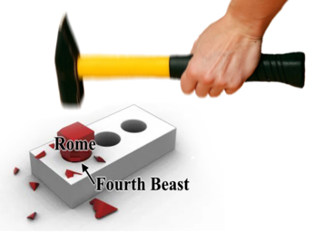
strong as iron--for iron breaks and smashes everything--and as iron breaks things to pieces, so it will crush and break all the others. (The Islamic empire would be very powerful and aggressive: Iron Represents Harsh Crushing Power — Matching Islamic Caliphates.) ⁴¹Just as you saw that the feet and toes were partly of baked clay and partly of iron (it will be a mixture of empires that are not totally united), so this will be a divided kingdom.
Historically, the Islamic Caliphate was known for:
• rapid, overwhelming military expansion
• crushing the opposition
• destroying previous cultures archaeology
• absorbing nations into a unified caliphate
• ruling from Spain to India
• dominating the entire Middle East for 1300+ years
• being diverse as a Political, Military, Religious and Social order controlling every aspect of life.
Rome was more administrative and legalistic, not universally “crushing or diverse.” Islam perfectly fits the prophetic image of irons multi-faceted strength.
Rome was NOT initially divided. Daniel’s legs are two legs, symbolizing a continual division. Rome did divide, but:
• It was not a sudden prophetic event
• It did NOT represent two separate kingdoms in succession (Ancient Rome and a Revived Rome, the EU)
• AND the split occurred LONG after Rome’s expansion, not at its rise (Rome split under Emperor Theodosius I in 395 AD creating the Eastern Empire centered in Constantinople, formerly Istanbul, and the Western Empire centered in Rome, Italy). The two legs better symbolize a kingdom that was dual by nature immediately upon rising, such as:
✔ Medo-Persia (two arms)
✔ The Islamic Caliphate’s northern & southern branches (Sunni and Shia)
Antichrist’s Final Empire is the Feet and 10 Toes of Iron and Clay
Daniel 2:42-44 As the toes were partly iron (strong) and partly clay (fragile), so this kingdom will be partly strong and partly brittle. (A separate explanation is given is given of the feet and toes. These 10 toes are 10 kings of the future reconstituted Beast empire.
Iron + Clay Mixture Matches Islamic Civilization
Daniel says the last phase (feet & toes) is:
• Iron mixed with clay
• Strong + brittle
• Will not adhere together (Shia/Sunni internal division)
Islamic civilization is a perfect match:
Iron (Strength)
• military power
• unified caliphate
• Sharia law enforcement
• central authority
• conquest-driven expansion
Clay (Weakness / brittleness)
• ethnic divisions (Arab, Turk, Persian, Kurdish)
• denominational divisions (Sunni, Shia)
• tribal and regional rivalries
• recurring internal collapse
Rome does NOT have a two-substance identity. Islam ALWAYS has.
The Ten Toes Match the Ten Kingdoms of the Last Middle Eastern Empire Daniel 2 and Daniel 7 both describe: a ten-part division emerging from the final kingdom in the Middle East Islamic history is filled with regional divisions:
• Caliphates
• Sultanates
• Emirates
• Kingdoms
Later the breakup of the Ottoman Empire into exactly ten major Islamic nations centered around the Middle East.
Rome, again, divided west–east (Rome, Italy in the west and the Byzantine empire in the east), and not into ten kingdoms.
Islam Replaced the Empire that Replaced Greece The Bible’s sequence must be: Babylon → Persia → Greece → Fourth Kingdom
Historically, the kingdom that immediately replaced Greece’s eastern territories was the Seleucid Empire, which was later replaced by the Parthian and Sassanian Empires, both eastern, Persian-centered kingdoms.
What kingdom conquered the Sassanian Empire and assumed its territory? Islam (the Islamic Caliphate). Rome never did this. Rome replaced Greece only in the west, not in the biblical heartland.
Islam is the direct successor of Greece’s Middle Eastern empire.
The Fourth Kingdom Must Exist Until Christ’s Return The stone strikes:
• the feet and toes (final phase)
• in the days of “those kings” (discussed later)
• before the kingdom of God fills the whole earth beginning at Jesus’ second coming The Roman Empire is long gone. Islam is still here—and ever expanding. Can you say Dearborn, MI? The iron kingdom must:
• survive into the end times
• still be influencing the Middle East
• still be fractured but presently ONLY ISLAM FITS THIS REQUIREMENT!
Islam Matches the Beast Kingdom of Daniel 7 and Revelation
When you overlay Daniel 2, Daniel 7, and Revelation 13 & 17:
The final empire has a Middle Eastern geography
• It has ten kings
• It arises from the region of the Leopard (Greece), Bear (Persia), Lion (Babylon)
• It is religious and political
• It oppresses the saints
• It blasphemes the God of heaven (Islam claims that God has no Son)
This describes Islamic empires precisely. The Roman Empire does not match the description of the final beast kingdom!
Daniel 7:23-25 Thus he said, The fourth beast shall be the fourth kingdom upon earth, which shall be diverse from all kingdoms, and shall devour the whole earth, and shall tread it down, and break it in pieces. ²⁴And the ten horns out of this kingdom are ten kings that shall arise: and another shall rise after them; and he shall be diverse from the first, and he shall subdue three kings. ²⁵And he shall speak great words against the most High, and shall wear out the saints of the most High, and think to change times and laws: and they shall be given into his hand until a time and times and the dividing of time.
Daniel 2.43 ⁴³And just as you saw the iron mixed with baked clay, so the people will be a mixture and will not remain united, any more than iron mixes with clay. (Iron and clay do not mix well. This represents of mixture of people who will not be united. There will be a common element, that they are part of the Islamic Caliphate: they may share a common Islamic faith, but there will be tremendous disunity in Antichrist’s kingdom. See Daniel 11:40.)
The Kingdom Will Be “Mixed”
Another very interesting hint regarding the ethnic base of the final phase of the fourth kingdom is found in Daniel 2:43 (above). This particular verse is one that interpreters have wrestled to understand, largely due to its fairly enigmatic, riddle-like nature: As you saw the iron mixed with soft clay, so they will mix with one another in marriage, but they will not hold together, just as iron does not mix with clay.
Three times, this verse uses the same word translated above as “mixed,” “mingle” and “mix.” It is the Aramaic word `arab. My initial reaction when I discovered this was to disregard it, considering it to be too reminiscent of “Bible code” scholarship. But this is not a case of finding a word that means something in English and something different in the original language. In Aramaic, the word for “mixed” is simply Arab. In the ancient Middle East, the Arabs were viewed as the mixed desert peoples. In Hebrew, the word is `ereb and in Aramaic `arab. Because the various descendants of Ishmael and Esau had so intermarried among the various desert pagan tribes, they had essentially become known collectively as “the mixed ones.” The first reference to the eastern desert peoples as the mixed ones is found in the Book of Nehemiah. After the Book of the Law had been rediscovered in the Temple, all Israel gathered together to hear the word read publicly:
Nehemiah 13:1-3 On that day they read in the book of Moses in the audience of the people; and therein was found written, that the Ammonite and the Moabite should not come into the congregation of God for ever; ² Because they met not the children of Israel with bread and with water, but hired Balaam against them, that he should curse them: howbeit our God turned the curse into a blessing. ³ Now it came to pass, when they had heard the law, that they separated from Israel all the mixed multitude (`ereb).
After reading the Law, the Jews realized that it was forbidden for them to take wives from the mixed pagan peoples of the desert. Specifically mentioned are the Ammonites and the Moabites who lived in what is today the Hashemite Kingdom of Jordan. Essentially, the verse is saying that, “When the people heard this law, they excluded from Israel all who were of Arab descent.” Again, in the ancient near east, the word mixed and Arab were synonymous. The very name Arab in its etymological origins refers to the mixed people that lived primarily to the east of Israel. If one were to simply read Daniel 2:43, a literal translation could read as follows:
Daniel 2:43 And whereas thou sawest iron mixed with miry clay, they shall mingle themselves with the seed of men: but they shall not cleave one to another, even as iron is not mixed with clay.
- (6151. עֲרַב ʿarab, ar-ab´; (Aramaic) corresponding to 6148; to commingle: from 6148. עָרַב ʿarab, aw-rab´; a primitive root; to braid, i.e. intermix; technically, to traffic (as if by barter); also or give to be security (as a kind of exchange):—engage, (inter-)meddle (with)...
As you saw iron mixed with ceramic clay, they will be Arab; and will thus not remain united, just as iron does not mix with clay.
The riddle-like nature of this verse, seemingly pointing to the primary peoples from which the fourth empire would arise is very reminiscent of another episode in Daniel 5, where Daniel interpreted the writing on the wall as pointing to the fall of the Babylonian Empire to the Medes and the Persians:
Daniel 5:26-28 This is the interpretation of each word. MENE: God has numbered your kingdom, and finished it; TEKEL: You have been weighed in the balances, and found wanting; PERES: Your kingdom has been divided, and given to the Medes and Persians."
In the Aramaic of Daniel 5:28, “divided” (pĕres) was interpreted to indicate that the “Persian” (Paras) peoples would conquer the Babylonian Empire. Likewise, it is not at all unreasonable to consider that in the Aramaic of Daniel 2:43, the word “mixed” (`arab) could also be understood to mean that the “Arab” (`arab) peoples would be the primary representatives of the fourth and final kingdom.
Adding to this identification is the fact that Daniel is only shown four beasts prior to the kingdom being given to the Son of Man (Daniel 7:11-14 above). [Some say this last kingdom of the end is a continuation of Rome, but that is a forced piece in today’s world as far as I can see, and merits further study by those who want God to continue to speak through His Word without ascribing our own ideas into the end times.]
One Bible teacher notes:
When I take all of these things into consideration, there is only one legitimate candidate for the fourth kingdom of the last days. The legs of iron mixed with clay will be the Iron Kingdom of a revived Islamic Empire. While the European Union is weakening and disintegrating, Islam remains the fastest growing religious ideology in the world and remains a formidable force in the Middle East and around the world.
The Millennial Kingdom is the Stone That Strikes the Statue
Daniel 2.44 In the time of those kings (The final 10 kings represented by the 10 toes will exist when God sets up His Millennial Kingdom), the God of heaven will set up a kingdom (the Millennial Kingdom will be set up by Jesus at His Second Coming and it will mark the end of the times of the Gentiles) that will never be destroyed, nor will it be left to another people. It will crush all those kingdoms and bring them to an end, but it will itself endure forever. (Some believe this is a reference, not to a future kingdom, but to the Kingdom of God Jesus Christ established during Roman rule. It is true the Kingdom of God now is the rule of Christ in our hearts. It is true the Mystery of the Holy Spirit dwells in His people because of faith in Jesus Christ. “But the prophetic revelation makes clear that the kingdom from heaven is not a spiritual kingdom which by spiritual processes will gradually conquer the earth, but rather a catastrophic judgment from heaven destroying the political kingdoms of the Gentiles… The destruction of the Gentile world powers is an event, not a process and will be fulfilled by Christ in the Second Coming.”)
Daniel 2.45 Forasmuch as thou sawest that the stone was cut out of the mountain without hands, and that it brake in pieces the iron, the brass, the clay, the silver, and the gold; the great God hath made known to the king what shall come to pass hereafter: and the dream is certain, and the interpretation thereof sure.
(The stone was cut out of the mountain without hands is Jesus [in some versions Stone is even capitalized], and at the second coming He will smite the image on its feet and the entire colossus, the Beast empire, will come tumbling down, very quickly, to be replaced immediately by the Messiah’s kingdom). Interestingly, when the image falls, all 4 empires will fall at the same time and the Son of God will establish His kingdom). [See Daniel 7:11-14.]
As we have already seen, in Supplement to Revelation Bible Study The Beast, the Lion, Bear, and Leopard represent the three empires of Babylon, Medo-Persia and Greece. The fourth beast of Daniel’s vision is the same beast we are considering here. This beast is a combination of the Lion (Babylon), Bear (Medo-Persia), and Leopard (Greece). Following the Greek Empire, the only empires to have emerged in that part of the world are the Parthian Empire, the Roman Empire and the Islamic Caliphate. No other cohesive empires have arisen in this region that we might consider as candidates to fill the role of the dreadful fourth beast empire.
The Parthians, as we previously discussed, should be viewed as a living extension the Persian Empire. Beyond this, the Parthians were not uniquely possessed by the telltale anti-Semitic or anti-Christian spirit of the six previous beast empires. It never attempted to destroy the Jewish people as each previous satanic empire has done. Nor did it ever directly control Jerusalem or the land of Israel. If one were to combine the “bodies” of Greece, Babylon and Medo-Persia, what empire would we have? Would it look like the Roman Empire or the Islamic Empire? The answer is obvious to anyone with an understanding of the geography of the region.
That we have here in Revelation 13:1, 2 a composite kingdom is clear from the ‘seven heads.’ Note that in Daniel 7 the first, second and fourth kingdoms are not said to have more than one head, but the third has ‘four heads’ (Daniel 7:6). Thus the beasts of Daniel 7 have: three of them with one head each, and the third one with four heads, or seven in all; which tallies perfectly with Revelation 13:1. . . . the four kingdoms of Daniel 7 are to be restored, and play their final parts immediately before the Millennium.
...Daniel 2, which is parallel with Daniel 7 - the ‘image in its four parts’ (the head, the breast and arms, the belly and thighs, the legs and feet) corresponding with the four beasts - it will be found that when we come to Daniel 2:45, which speaks of Christ (under the figure of ‘the Stone cut out of the mount without hands’ returning to earth to destroy the forces of evil, and then set up His kingdom, we discover that the Stone ‘brake in pieces the iron (Rome/Islamic Caliphate), the brass (Greece), the clay (apostate Israel), the silver (Medo-Persia), and the gold (Babylon).’ ...[N]ote particularly is that the Stone strikes not only the iron, but the brass, clay, silver, and gold; in fact, Daniel 2:35 tells us, expressly, they shall be ‘broken to pieces together!’

Daniel 2.35 Then was the iron, the clay, the brass, the silver, and the gold, broken to pieces together, and became like the chaff of the summer threshingfloors; and the wind carried them away, that no place was found for them: and the stone that smote the image became a great mountain, and filled the whole earth.
Daniel 2:45 “...it broke in pieces the iron, the bronze, the clay, the silver, and the gold.”

If, then, they are destroyed together, they must all be on the scene at the time of Christ’s return to earth to inaugurate His millennial reign, and if so, each of them must have been revived and restored!! When the stone representing the Messianic kingdom strikes the image of Nebuchadnezzar’s dream, all the metals of the image are demolished together:
Thus, attributes of all the kingdoms are found in this last beast.
The characteristics of the first three beasts in Daniel’s night vision contribute to this beast of the end (Daniel 7:4-6). (Because the leopard, lion, and bear in Revelation 13:2 are also used in Daniel 7 to depict nations, the interpreter is alerted to the fact that John is employing symbolic language. Thus, the leopard, lion, and bear also represent nations in Revelation 13 just as they did in Daniel 7.” The fourth terrible beast seen by Daniel is not mentioned because this Beast is the embodiment of that terrible beast at the time of the end. The mention of the leopard, bear, and lion in connection with the Beast arising from the sea is in concert with what Daniel was shown concerning the continuation of Babylon, Medo-Persia, and Greece and their contribution to the final form of world government.
Daniel 7:12 “As for the rest of the beasts, they had their dominion taken away, yet their lives were prolonged for a season and a time.”
It is a composite of the four beasts of Daniel’s vision (Daniel 7) and must be related to them. Daniel wrote from the standpoint of the Jewish people, whose fate under the Gentile empires to come would effect the First Coming of Messiah. Revelation, written under the fourth and last of these empires, presumably after the Jewish commonwealth had been crushed, takes this picture of Gentile world power from Daniel and combines these four empires onto the picture of the future world-state. The magnificence of Babylon, the vastness of Medo-Persia, the dominating culture of Greek Macedonia, and the organizing might of [the fourth kingdom whether Rome or Islamic Caliphate] are united in one state that will aspire to world domination and that will achieve it.
The order in which the attributes are listed, leopard then bear then lion, are reversed from what Daniel saw. This reflects John’s different vantage point. Daniel, living in the days of the lion beast (Babylon), looked forward in time to see the rise of the bear (Medo-Persia), and then the leopard (Greece). John, writing in the time of the first phase of the terrible beast (Rome [or Islamic Caliphate, as the case may be]), looked backward in time to see them in reverse order.
Depending on which way you take the fourth kingdom and the obvious truth that the four beasts Daniel sees are represented in this beast with seven heads, many still believe it is still unlikely that the seven heads on the beast correspond exactly with the seven heads of Daniel’s four beasts. For a discussion of some of the reasons some cannot reconcile who the 7 heads are, follow link found in Endnote .
Because of the significant hurdles some find in defining the 7 heads, [some teachers] teach that it seems better to take the seven heads, which are found upon both the Beast and upon the Dragon, as denoting seven historic kingdoms under the sway of Satan:
Luke 4:5-7 [emphasis added] Then the devil, taking Him up on a high mountain, showed Him all the kingdoms of the world in a moment of time. And the devil said to Him, “All this authority I will give You, and their glory; for this has been delivered to me, and I give it to whomever I wish. Therefore, if You will worship before me, all will be Yours.”
Many understand this final kingdom to be a “revived Rome.” This view is based on continuity expressed in Nebuchadnezzar’s dream. The ten toes of the image are on its feet which are partly of iron (which was said to symbolize Rome).
[Note: predominately this was the view and teaching of the fourth kingdom/beast but if you look closely at Scripture Rome does not ‘fit’ as perfectly into the descriptions given, but the Islamic Caliphate does. I have included a good study with the Supplement for this lesson on Daniel’s prophecies to consider.

Be it as it may, whether Rome or the Islamic Caliphate or some other ‘kingdom’ is not laid out certainly but described implicitly and although it is important to understand what the last kingdom/beast represents from the standpoint of being alert and watching lest you be beguiled, it is more important to understand the seasons and to seek the Lord on what His Word says about it rather than accepting variant teachings with variant motives.]

Whereas you saw the feet and toes, partly of potter’s clay and partly of iron, the kingdom shall be divided; yet the strength of the iron shall be in it, just as you saw the iron mixed with ceramic clay.
Daniel 2:41-44 ⁴¹And whereas thou sawest the feet and toes, part of potters’ clay, and part of iron, the kingdom shall be divided; but there shall be in it of the strength of the iron, forasmuch as thou sawest the iron mixed with miry clay. ⁴² And as the toes of the feet were part of iron, and part of clay, so the kingdom shall be partly strong, and partly broken. ⁴³ And whereas thou sawest iron mixed with miry clay, they shall mingle themselves with the seed of men: but they shall not cleave one to another, even as iron is not mixed with clay. ⁴⁴ And in the days of these kings shall the God of heaven set up a kingdom, which shall never be destroyed: and the kingdom shall not be left to other people, but it shall break in pieces and consume all these kingdoms, and it shall stand for ever.

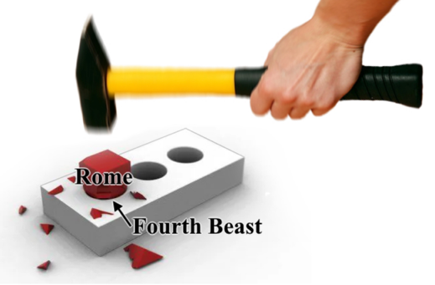

The final world empire has been postulated as a revival of the Roman Empire (which conjecture came about when Rome was the empire to watch, but considering other Scriptures it could be any number of other kingdoms). (The iron legs and ten toes of the statue in Daniel 2) but will far exceed it both in power and extent. It will be much more than a European confederacy; it will cover the entire world. [This is a case in point where the Islamic Caliphate today fits the Scriptural descriptions far more than Rome does today. [See Endnote link for all Scriptural considerations to this postulation of The Mid-East Beast: The Scriptural Case for an Islamic Antichrist.]
It is also clear that all the previous kingdoms contribute to its characteristics. One Bible scholar, notes that when John is told “one [kingdom] is” (Revelation 17:10), it is Rome which is in view—[and then] the next kingdom “has not yet come” [is also said to be Rome]. He wonders how Rome can be both.
[Note: A closer examination of Daniel’s prophecies reveals significant inconsistencies with the Roman interpretation. As I delved deeper into the Book of Daniel, applying principles of hermeneutics and studying the historical context of the ancient Near East, I found that Rome does not fulfill all aspects of the prophecy. It was like trying to fit a square peg into a round hole. Instead, I propose that the Seleucid Empire, a Hellenistic successor to Alexander the Great’s empire, aligns more closely with Daniel’s description of the fourth beast. [See Endnote link to an article which will explore the first three beasts, outline three critical problems with Rome as the fourth beast, present the case for the Seleucid Empire, and address the broader implications of this reinterpretation for understanding Daniel’s prophetic vision. ]
Yet the continuity [if not similarity] between Rome of John’s day and the form of kingdom represented by the rise of the Beast is strongly inferred by the continuance of Daniel’s fourth beast until the time of the end, when it is predicted “to devour the whole earth” (Daniel 7:23). Moreover, in the famous prophecy of Daniel’s seventy weeks, Daniel was told that the “people of the prince who is to come shall destroy the city and the sanctuary” (Daniel 9:26). This prophecy was partially fulfilled in the destruction of Jerusalem and the temple in A.D. 70 by Rome. Thus, the prince to come has been said to have a Roman origin. Because of this, many try to force these passages argue for some form of continuity between Rome and the initial beast kingdom of the end.
After examining a broad sampling of evidence from both ancient historians as well as the most cutting-edge modern scholarship, we may very confidently conclude that the “Roman” soldiers in the Eastern provinces that destroyed Jerusalem and the Temple were in fact Eastern peoples—the inhabitants of Asia Minor, Syria, Arabia, and Egypt. Again, they were the ancestors of the modern day inhabitants of the Middle East. When we look to the prophecy of Daniel 9:26, we can certainly understand how a hasty or perfunctory reading of this prophecy would lead one to conclude that the followers of the Antichrist would be Europeans, but having now done proper due diligence, completed our homework and examined the evidence, it is clear that the reality is quite different from what has been commonly and popularly understood. (p. 112)
In conclusion, the overwhelming evidence from both ancient historians and modern day scholarship, points us to the ethnic identity of the “Roman” peoples that destroyed Jerusalem and the Temple: They were the ancestors of the Muslim peoples that dominate the entire region today. This is where the passage is pointing us. The primary followers of the Antichrist, “the prince to come” will be the peoples of the Middle East. As we have already noted, the European Antichrist theory finds its most significant support in this one verse of Daniel 9:26. And as we have now seen, the European Antichrist theory is built on a foundation of vapor. In the end, the passage that most have looked to as the strongest support for a European Antichrist in fact is pointing once again to the Middle East, just like every other passage throughout the prophets. (pp. 117-118)
See Endnote link to entire Chapter 7 Daniel 9:26: The People Of The Prince To Come, pp. 103-118.
As we progress in this chapter, we will see God sovereignly grant permission for this beastly empire to attain authority by way of empowerment from the Dragon. Hosea was shown these beasts and how they would be used to “tear” Israel to cause her to turn back to God:
Hosea 13:6-11 [emphasis added] When they had pasture, they were filled; they were filled and their heart was exalted; therefore they forgot Me. So I will be to them like a lion; like a leopard by the road I will lurk; I will meet them like a bear deprived of her cubs; I will tear open their rib cage, and there I will devour them like a lion. The wild beast shall tear them. O Israel, you are destroyed, but your help is from Me. I will be your King; where is any other, that he may save you in all your cities? And your judges to whom you said, ‘Give me a king and princes’? I gave you a king in My anger, and took him away in My wrath.
The lion, bear, leopard, and wild beast . . . correspond to the world empires among which Israel is to be scattered and persecuted (Daniel 7) during the time that she is in Dispersion until she will be regathered by her covenant-keeping LORD (Ezekiel 37:1-28; Matthew 24:31; Romans 11:26).

Remember: You Cannot Disregard That The Fourth Beast Must Crush the Previous Three
For a complete exegetical study of this grave and viable consideration, see Endnote link .

As we have already seen, in Daniel 7, the Lion, Leopard and Bear represent the three empires of Babylon, Greece and Medo-Persia. [Note: This paragraph, the maps and the following paragraph are repeated in Supplement to Revelation Bible Study The Beast because of its application to both places.]

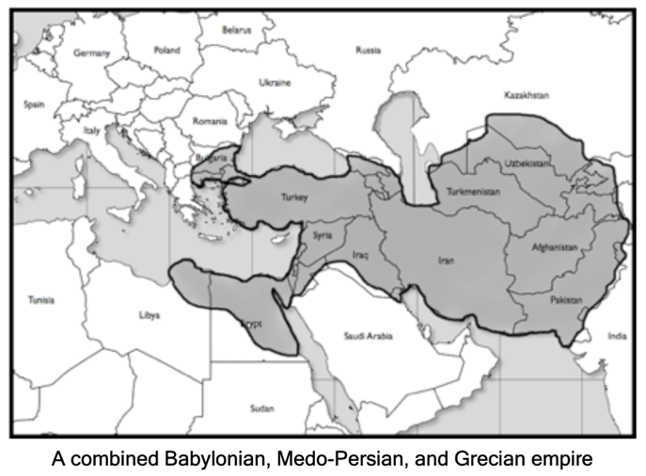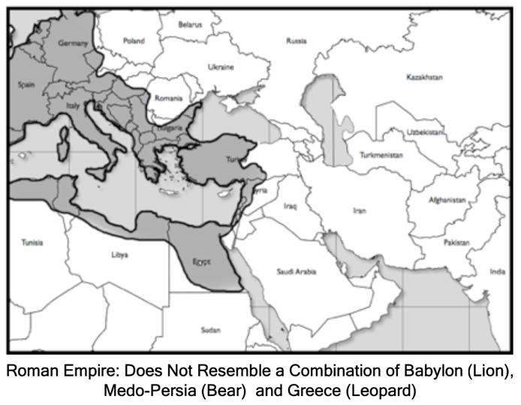

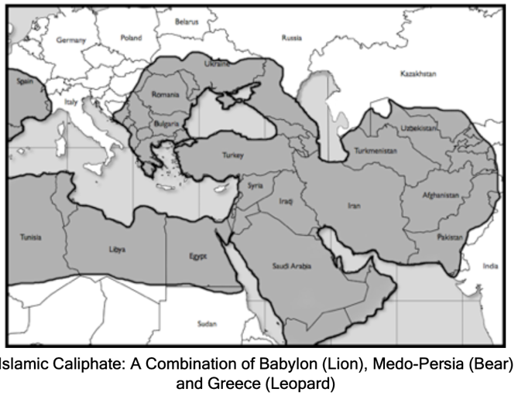
The Roman Empire, with its uniquely Western/European orientation simply doesn’t come close to lining up with the geography of a Babylonian-Persian-Greek empire. As we have seen, for the overwhelming majority of its existence, the Roman Empire’s borders remained roughly 500 miles west of Babylon. The Islamic Empire however, as we saw “crushed” all of these regions in an unqualified and absolute manner. The Islamic Caliphate has come to dominate all of the land holdings of all three of these previous empires and far more. So once again, when considering a combination Greek, Babylonian and Medo-Persian Empire, the Roman Empire doesn’t come close to fulfilling this description, but the Islamic Caliphate fulfills it perfectly.
The Reward Given to Daniel
Daniel 2.46-48 Then King Nebuchadnezzar fell prostrate before Daniel (Nebuchadnezzar is overwhelmed and treats Daniel as a god!) and paid him honor and ordered that an offering and incense be presented to him. ⁴⁷The king said to Daniel, ‘Surely your God is the God of gods (Father) and the Lord of kings (Son) and a revealer of mysteries (Holy Spirit), for you were able to reveal this mystery.’ (A remarkable confession from this worshipper of false gods.) ⁴⁸Then the king placed Daniel (he is only 18 years old) in a high position and lavished many gifts on him. He made him ruler over the entire province of Babylon and placed him in charge of all its wise men. ⁴⁹Moreover, at Daniel's request the king appointed Shadrach, Meshach and Abednego administrators over the province of Babylon, while Daniel himself remained at the royal court. (Daniel and his friends are promoted and Daniel is appointed as the chief of the Wise Men, the Magi.)

Daniel 7 Overview
Daniel’s Vision of the Beasts
In the first year of Belshazzar's reign (about 553 BC, 51 years after King Nebuchadnezzar’s dream), Daniel had a dream:
Daniel 7.2-28 ²Daniel spake and said, I saw in my vision by night, and, behold, the four winds of the heaven strove upon the great sea. ³And four great beasts came up from the sea, diverse one from another.* ⁴The first was like a lion, and had eagle’s wings: I beheld till the wings thereof were plucked, and it was lifted up from the earth, and made stand upon the feet as a man, and a man’s heart was given to it. ⁵And behold another beast, a second, like to a bear, and it raised up itself on one side, and it had three ribs in the mouth of it between the teeth of it: and they said thus unto it, Arise, devour much flesh. ⁶After this I beheld, and lo another, like a leopard, which had upon the back of it four wings of a fowl; the beast had also four heads; and dominion was given to it. ⁷After this I saw in the night visions, and behold a fourth beast, dreadful and terrible, and strong exceedingly; and it had great iron teeth: it devoured and brake in pieces, and stamped the residue with the feet of it: and it was diverse from all the beasts that were before it; and it had ten horns. ⁸I considered the horns, and, behold, there came up among them another little horn,** before whom there were three of the first horns plucked up by the roots: and, behold, in this horn were eyes like the eyes of man, and a mouth speaking great things. ⁹I beheld till the thrones were cast down, and the Ancient of days did sit, whose garment was white as snow, and the hair of his head like the pure wool: his throne was like the fiery flame, and his wheels as burning fire. ¹⁰A fiery stream issued and came forth from before him: thousand thousands ministered unto him, and ten thousand times ten thousand stood before him: the judgment was set, and the books were opened. ¹¹I beheld then because of the voice of the great words which the horn spake: I beheld even till the beast was slain, and his body destroyed, and given to the burning flame. ¹²As concerning the rest of the beasts, they had their dominion taken away: yet their lives were prolonged for a season and time. ¹³I saw in the night visions, and, behold, one like the Son of man came with the clouds of heaven, and came to the Ancient of days, and they brought him near before him. ¹⁴And there was given him dominion, and glory, and a kingdom, that all people, nations, and languages, should serve him: his dominion is an everlasting dominion, which shall not pass away, and his kingdom that which shall not be destroyed. ¹⁵I Daniel was grieved in my spirit in the midst of my body, and the visions of my head troubled me. ¹⁶I came near unto one of them that stood by, and asked him the truth of all this. So he told me, and made me know the interpretation of the things. ¹⁷These great beasts, which are four, are four kings, which shall arise out of the earth. ¹⁸But the saints of the most High shall take the kingdom, and possess the kingdom for ever, even for ever and ever. ¹⁹Then I would know the truth of the fourth beast, which was diverse from all the others, exceeding dreadful, whose teeth were of iron, and his nails of brass; which devoured, brake in pieces, and stamped the residue with his feet; ²⁰And of the ten horns that were in his head, and of the other which came up, and before whom three fell; even of that horn that had eyes, and a mouth that spake very great things, whose look was more stout than his fellows.*** ²¹I beheld, and the same horn made war with the saints, and prevailed against them; ²²Until the Ancient of days came, and judgment was given to the saints of the most High; and the time came that the saints possessed the kingdom. ²³Thus he said, The fourth beast shall be the fourth kingdom upon earth, which shall be diverse from all kingdoms, and shall devour the whole earth, and shall tread it down, and break it in pieces.**** ²⁴And the ten horns out of this kingdom are ten kings that shall arise: and another shall rise after them; and he shall be diverse from the first, and he shall subdue three kings. ²⁵And he shall speak great words against the most High, and shall wear out the saints of the most High, and think to change times and laws: and they shall be given into his hand until a time and times and the dividing of time. ²⁶But the judgment shall sit, and they shall take away his dominion, to consume and to destroy it unto the end. ²⁷And the kingdom and dominion, and the greatness of the kingdom under the whole heaven, shall be given to the people of the saints of the most High, whose kingdom is an everlasting kingdom, and all dominions shall serve and obey him. ²⁸Hitherto is the end of the matter. As for me Daniel, my cogitations much troubled me, and my countenance changed in me: but I kept the matter in my heart.

*The beasts, or kingdoms, that appeared on the earth from earliest to latest are as follows: Babylon, Mede-Persia, Greece, and the last many believe to be Rome, however all Scripture descriptions could be more accurately describing the Islamic Caliphate (see study found above and why Rome is most likely not the fourth kingdom/beast referred to [albeit namelessly and only by sheer conjecture of past Bible teachers without substantiation or at least with serious holes] in the Scriptures).
Even as we saw in Daniel 2, so also here the Roman Empire only finds itself aligning with the descriptions within the text with great difficulty. The Islamic Caliphate however, fits the descriptions precisely. In conclusion, the following identification and correlation of the four beasts is as follows:
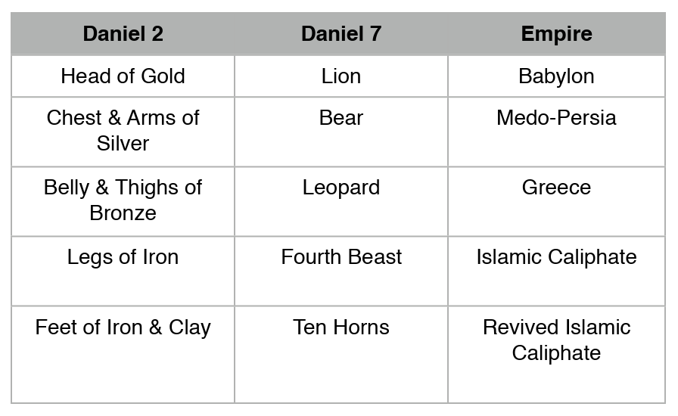

**The “little horn” (Daniel 7:8, 24) that will arise is the anti-Christ. The anti-Christ will supplant three of the ten kings that will arise in the future fourth kingdom. He will speak boastfully, blaspheming God.
The popular notion that Antichrist and his coming empire will rise from Europe, in the form of a revived Roman Empire, is misleading and unfortunate as it has led millions of prophecy students away from Daniel and Revelation’s geographical path of a coming Middle Eastern Empire.
The result is a lack of clarity about what drives the evil nature of the coming empire and what exactly it will look like and a complete disregard for the Islamic nature of Antichrist’s empire which is like forcing a square peg in a round hole.
Only an understanding of the Islamic link to end-time prophecy will bring consistency to interpreting Daniel and Revelation. Without that connection, it’s pure guesswork which is why we see so much confusion on this crucial topic.
The “little horn” in Daniel 7:8 is also referenced in Daniel 8:9. This second reference describes the little horn as a king who will arise from the kingdom of Greece. Historically, this was partially fulfilled by the Greek king Antiochus IV Epiphanes. However, the full fulfillment will be in the anti-Christ.
[Note: Rome and “revived Rome” has been caught, taught and referenced to be the fourth kingdom/beast without substance, with more conjecture than Scripture. Daniel never names Rome anywhere — but he names Persia & Greece explicitly. Daniel names the next two kingdoms after Babylon: Persia (Daniel 8:20) and Greece (Daniel 8:21). Then Daniel says the fourth kingdom comes from Greece’s successors (Daniel 8:22–23). That means:
✔ The fourth kingdom emerges after one of the Greek divisions
✘ Not out of Europe
✘ Not out of Rome
Rome is never named in the Prophetic Scriptures. Rome did not arise from Greece. Rome did not inherit Greek territory east of the Euphrates River.

*** Symbols of Kingdoms; Seven Heads and Ten Horns
To take in the “big picture” concerning the various beasts, heads, and horns seen by John in the book of Revelation, see Endnote for a wonderful but complex diagram and breakdown illustrating the major symbols in the visions given to Daniel and John concerning the beasts, heads, and horns which contribute to an understanding of the book of Revelation.
There is an intentional correlation between the horns of Daniel’s night vision and the feet and toes of the image in Nebuchadnezzar’s dream (Daniel 2:22-34, 41-42):
- Both horns and toes are ten in number.
- Both are outgrowths of the last Gentile kingdom (Daniel 2:41-42; 7:8; Revelation 17:12).
- Both are destroyed by the arrival of God’s kingdom on earth, the Millennial Kingdom (Daniel 2:34; Revelation 17:14 cf. Revelation 16:14).
[Note: In the book of Daniel, all we find mentioned in relation to the sequence of kingdoms is the four beasts and the corresponding four metals of Nebuchadnezzar’s dream. There, we find that the fourth beast has ten horns, but nowhere is there explicit mention of seven heads. We do find one helpful bit of information related to our topic because the ten horns were said to be on the head of the fourth beast. This is helpful when we come to the book of Revelation because it hints at a correlation between beasts and heads and indicates that the ten horns are found upon the head of the last beast, not distributed across several heads. When Daniel sees his vision, the duration of all four beast/kings is yet future. Daniel makes the number less than in Revelation; but he started with his own times, and looked only down the stream.
Daniel sees these four beasts in his night vision in the first year of the reign of Belshazzar (Daniel 7:1-28). Daniel’s vision pertains to the future, not the past, and so the first of the four beasts he is shown represents Babylon, the kingdom within which he found himself captive at the time of the vision. Daniel is shown a sequence of beasts with differing characteristics culminating in a unique and particularly terrible final fourth beast. The four beasts of Daniel’s vision appear to represent four major kingdoms which dominate the history of the Jews from Daniel’s day until the time Messiah sets up His kingdom (Daniel 2:34-35, 44-45). The four beasts are said to originate from the sea (Daniel 7:2). They are also said to be four kings which arise out of the earth (Daniel 7:17). Each king represents a kingdom. The four beasts of Daniel’s night vision correspond to the four metals of the image in Nebuchadnezzar’s dream (Daniel 2:32-45).
The lion represented the Babylonians, the bear represented the Medo-Persians, and the leopard represented the Greeks. In Revelation 13.2, they're reversed, in reverse order, probably because John is looking back there. (Revelation 13.2 And the beast which I saw was like unto a leopard, and his feet were as the feet of a bear, and his mouth as the mouth of a lion: and the dragon gave him his power, and his seat, and great authority.)
The four beasts Daniel sees are a subset of the seven heads which John sees throughout Revelation (Revelation 12:3; 13:1; 17:3, 7, 9). Three of the beasts/kings shown to Daniel had already fallen by the time John saw his vision. These three beasts/kings, along with two other kings which predate Daniel’s vision, form the five fallen kings shown John (Revelation 17:10).In Revelation, the account looks backward as well as forward. Thus, Daniel was shown four beasts, which are said to be “four kings which arise out of the earth” (Daniel 7:17).
[The lion] which is first in Daniel is [listed] third in Revelation, and that which is [listed] sixth in Revelation [which many say is revived Roman empire; and others say is revived Caliphate empire; and still others say it is a type of revived Greek empire] is the fourth beast (dreadful and terrible) in Daniel. Only in the commencing point is there any difference. The visions of Daniel and the visions of John are of the same Divine Mind, and they perfectly harmonize, only that the latest are projected as the amplest in each.]
Because of the varying interpretations of the kingdoms, by scholars who have dedicated most of their lives to interpreting them, and because it is difficult to go into each possible interpretation, I have posted some of the considerations we should consider while looking into this part of the prophecies of Daniel and John as observations made from various viewpoints. It is recommended that you hear from the Holy Spirit and go to the Scriptures themselves because men cannot teach what God, whose ways are so much higher than our ways, has put together, so I have never been able to find something totally without flaws outside Scripture.
God is opening up an understanding of Bible prophecy today as never before and releasing the secrets to His end time church. In fact, the closer we get to the coming of the Lord the more understanding God seems to be pouring out. We see a hint of this promised in the prophet Daniel,
Daniel 12.4 But you, Daniel, keep this prophecy a secret; seal up the book until the time of the end, when many will investigate the prophesies, and knowledge will increase.”
This verse promises that God will unseal prophecy as the end time approaches so that people will search for answers concerning the troubling events in the world and discover increased knowledge of understanding from God’s Word!
There are certain prophecies concerning the end times that could only be understood and interpreted by those who are living in the season of the end times. For example, see the intriguing example in the Handout for this Lesson: Handout Babylon Rising.
We find more examples in the book of Revelation where there are several remarkable predictions that in John’s day were both impossible to occur and impossible to understand. They could only be understood and implemented in our generation. There are numerous examples in Revelation of prophesies that could not happen until more recent times. Many of them would have seemed bizarre to first century believers.
See handout on Knowing the Times.
- The five kingdoms of the past are the ones who have persecuted God’s people (Egypt, Eze. 29-30; Nineveh or Assyria, Nah. 3:1-19; Babylon, Isa. 21:9 and Jer. 50-51; Persia, Daniel 10:13 and 11:2; Greece, Daniel 11:3-4). At that time, Rome was persecuting God’s people, so the angel’s clarifying word to John about the seven heads [Revelation 17:9-11] spanned essentially the entire history of Gentile world empires.
- Five empires ruled the known world in succession before John the Apostle wrote his book of Revelation. The empires of Egypt, Assyria, Babylon, Media-Persia and Greece each ruled the known world. . . The Roman Empire ruled in John’s day.
- The view which takes Egypt as the first kingdom is based, in part, on understanding the seven heads as Gentile kingdoms and the context of Revelation 17 as favoring a Jewish/Gentile distinction. Evidence for such an emphasis can be found in the broader context of Revelation, especially chapters 7, 11-12, and 14. It also recognizes the well-documented opposition each of these kingdoms represented to God’s people. But limiting the kingdoms to only those which existed after the calling of Abraham, the father of the Jews, has the weakness of being unable to account for the full history of the Harlot. If it can be shown that she predates the Jewish nation, then upon what head can she be said to have ridden upon prior to Egypt and the events of the Exodus?
- Taking the first two kingdoms to be Egypt and Assyria does not seem to do full justice to the description of the Harlot who sits on the seven heads which are the seven kings (Revelation 17:7-10). She is given the name Babylon and is identified as the “mother of harlots and of the abominations of the earth” (Revelation 17:5). In order to be the mother of harlots and abominations (which denote spiritual idolatry), she would have to be the source from which her daughter harlots were born. Thus, it seems best to see the Harlot as having ridden upon the Beast, sitting upon its seven heads, throughout history. This would be supportive for understanding the five fallen kingdoms as stretching back beyond Egypt to the time of the construction of the first major city recorded in Scripture: Babel (Gen. 11:1-9).
- Cush begot Nimrod; he began to be a mighty one on the earth. He was a mighty hunter before the LORD; therefore it is said, “Like Nimrod the mighty hunter before the LORD.” And the beginning of his kingdom was Babel, Erech, Accad, and Calneh, in the land of Shinar. From that land he went to Assyria and built Nineveh, Rehoboth Ir, Calah, and Resen between Nineveh and Calah (that [is] the principal city). (Gen. 10:8-12) [emphasis added]
- The view that Babel is the first kingdom has the advantage of providing a head for the Harlot to sit upon all the way back to the initial rebellion of mankind manifested by the great city: Babel.
  - [I]n the land of Shinar. Nimrod began the work in the spirit of Anti-christ: his object being to build a city, and make for his people a name, so that they might not be scattered. Babylon [Babel] was founded in rebellion against God.
  - This would accord with the identification of the Harlot as “that great city which reigns over the kings of the earth” [emphasis added] (Revelation 17:18). To be sure, there is a sense in which the kingdom of Babel (under Nimrod) and the kingdom of Babylon (under Nebuchadnezzar) share identity for they are in the same region and much that became Babylon undoubtedly originated in Babel.
  - Some believe the Harlot in Revelation 17 differs from the city Babylon in Revelation 18; others believe the Harlot and the city are one and the same. For purposes of this study we are sticking with the Harlot and city being one and the same.
See commentary on Revelation 17:10.
- Some see the seven heads and ten horns as representing the original ten kings of the time of the end, three of which are overcome by the little horn leaving seven (Daniel 7:8). Others believe it is better to understand the heads and horns as representing different entities rather than different numbers (phases) of the same group of kings. They believe the seven heads represent seven sequential kingdoms of history while the ten horns represent the ten contemporaneous kings which emerge from the final kingdom (Daniel 7:7).
- Despite the fact that much of the Christian Church has viewed the final kingdom of the Antichrist to be a European kingdom, many of the Jewish rabbis and sages have long understood the final ten horn kingdom to be an Arab or Middle Eastern kingdom. From Ezekiel, A Commentary Anthologized from Talmudic, Midrashic and Rabbinic Sources, we read:
The Midrash comments that these ten horns symbolize ten kings of the Fourth Kingdom, and the eleventh horn is the final king whom Israel will confront. All these kings, the Midrash stresses, are to be descendants of Esau. The implication is that the king and initiator of the campaign against Israel will be from Esau-Edom.
- Both Daniel and John are given important information concerning the identity of various symbols employed in the book of Revelation. In his night vision, Daniel sees four beasts, one of which has ten horns (Daniel 7.1-28). In John’s vision, he sees two beasts, one of which has seven heads and ten horns (Revelation 13.1; 17.3, 7) and another which has a single head with two horns (Revelation 13.11). Although the fact that both Daniel and John saw beasts and horns does not necessarily mean their visions are related: there are a number of other characteristics concerning their visions which indicate that God was showing each of them different aspects of the same kings and kingdoms related to Gentile dominion throughout history and the final form of Gentile power at the return of Messiah (Daniel 7.13-14, 26-27; Revelation 19.11-20).
- Perhaps the single most difficult aspect for interpreters of passages involving the beasts, heads, and horns is accounting for their differences while at the same time appreciating their similarities. In various passages, all three symbols—beasts, heads, and horns—are said to be “kings” (Daniel 7.14, 24; Revelation 17.10). In addition, sometimes kings represent sequential rulers and their representative kingdoms and other times contemporaneous kings within a single kingdom (Daniel 7.6; 8.8; Revelation 17.10). And if that were not enough, the distinction between an individual king and the kingdom which he represents is not always readily discerned.

****One of the key phrases in this passage is diverse from all kingdoms (also translated “different from the earlier ones”). The anti-Christ will be different from any king that had risen before him. His kingdom will be different from all the former kingdoms. As we learn about the beast, we must keep in mind that the [fourth kingdom/beast] under the control of the anti-Christ will not look like anything we have ever seen or heard about before, although it will have elements of many former kingdoms and characteristics of some former rulers.
REMEMBER!: Prophecy is given not to satisfy curiosity but to prepare the Church. If the Islamic Antichrist theory is correct, then much of what the world is experiencing today is not random but part of a demonic strategy. Islam is not simply another religion; it is a rival gospel, one that denies the Son, nullifies the cross, and points people to a counterfeit savior. Christians must be vigilant, rooted in Scripture, and ready to recognize the false signs and wonders of a system that presents itself as righteous but is empowered by the enemy of God.
Conclusion
The Islamic Antichrist theory does not elevate Islamic sources but exposes them for what they are: distortions and perversions of truth meant to deceive. The Mahdi and Isa are not merely religious figures; they are, in form and function, counterfeits of the true Christ and His prophets. If this theory is correct, the final enemy of God will not rise from secular Europe, but from the very lands that once housed the original enemies of Israel, and he will come cloaked in religious authority that mimics righteousness but denies the Gospel.
See Endnote for further study of the counterfeit nature of Islamic Eschatology, summarized above.

Important Distinctions
- Daniel’s dream and visions record yet another abrupt transition. Prior to the judgment in favor of the saints, the horn was making war against the saints, and prevailing against them. This passage describes events immediately prior to the coming of God’s kingdom on earth. This coming of God’s kingdom is something which Jesus instructed His disciples and by extension, all believers throughout the ages to pray for (Matthew 6.10). Did the kingdom come in this sense at the crucifixion and resurrection of Jesus? No. We know this from the conditions which the Lord set forth in the prayer: “Your kingdom come. Your will be done On earth as it is in heaven.” Until God’s will is being done on earth as it is in heaven, the kingdom of God has not come in the sense Jesus would have us pray for, nor in the way the previous passages describe.
- The Amillenialists (one of the four beliefs of the end times) believe we are presently living in the Millenium, making the reign of Christ a spiritual rather than a physical reign, between His first and second coming. They say Satan is bound in the sense of being unable to deceiving nations completely. This presents some problems solved by spiritualizing the text rather than taking it literally:
  - They believe: The first resurrection is the spiritual regeneration of believers’ souls reigning with Christ in heaven. This view is held by Augustine and many Reformed traditions, emphasizing the Church as God’s kingdom now.
  - This belief: has Satan bound as in a physical Millenium, so contradicts Peter’s warning in 1 Peter 5.8 that your adversary the devil walks about like a roaring lion, seeking whom he may devour. If Satan is bound so he could deceive the nations no more as in Revelation 20.3, how is the deception that abounds today existent?
  - In this belief, the promises to Israel of earthly kingdom restoration remains unfulfilled.
- Idealists interpret these passages as symbolizing spiritual conflict rather than physical conflict whereas preterists tend to see these passages as hyperbolic descriptions of first-century events. A spiritual interpretation leaves everything open to a spiritual rather than literal meaning and opens the door to all kinds of false doctrine opposing Scripture and God’s faithfulness to fulfill every promise exactly as stated.
- But literal interpretation and the many passages indicating that the earth will reject the knowledge of God (Matthew 24:10-12; 2 Thessalonians 2:3; 1Timothy 4:1-3; 2 Timothy 3:1-9; 2 Peter 2:3-7) indicate that Christianity will not gradually subsume the social and political institutions of earth resulting in a “Golden Age.” Rather, the world system is predicted to eventually reject and intensely persecute the people of God. It is only by the direct intervention of God and by His own hand that peace and justice will prevail. We will be looking more at this as we progress through Revelation.

The Beast
The Beast is probably the most confusing entity in a consideration of the symbols representing kingdoms and individuals of the visions given to both Daniel and John. This confusion stems from several overlapping aspects of the revelation concerning the Beast:
- The term “beast” is used by Daniel to describe several kings (Daniel 7:17). Of these four, the last is unique and especially terrible.
- The term “beast” is used both to denote the final kingdom and the final king which leads the kingdom among the ten horns (Daniel 7:11; Revelation 16:10; 17:11-13).
- The revival of the Beast makes him both a ruler of the seventh kingdom (Revelation 16:10) and the final eighth head. The Beast is said to have seven heads and ten horns, yet he is also “of the seven” heads and “himself also an eighth” (Revelation 17:11 And the beast that was, and is not, even he is the eighth, and is of the seven, and goeth into perdition.).
- Sometimes the term “beast” denotes a kingdom (Daniel 7:7, 11, 19; Revelation 13:1-2). Other times an individual (Revelation 11:7; 13:4, 12-14, 17-18; 16:10, 14; 19:19-20). Elsewhere, the same individual is represented as a horn (Daniel 7:8) and a head (Revelation 17:11).
- John sees two “beasts,” one rising from the sea (Revelation 13:1) and another from the earth (Revelation 13:11). The first, more prominent beast is the one whom we describe here. We refer to the second beast from the earth using his alternate title as the False Prophet.
Because of these complexities, any diagram of Symbols of Kingdoms is necessarily imprecise in some aspects because it is nearly impossible to accurately capture all the relationships between the various symbols which denote the Beast and his kingdom in a diagram. [The] Seventh King, Beast, and Little Horn [are believed to] denote different aspects of the reign of the same individual: Antichrist.
The Beast has seven heads and ten horns (Revelation 13:1; 17:3, 7). In this characteristic, he is identical with the dragon who gives him his power, throne and authority (Revelation 13.2-4; 16.10. This empowerment likely also includes the healing of the fatal wound resulting in the Beast’s rise from the Abyss to be marveled at by the world (Revelation 13:3; 17:8). He also is identified closely with the dragon in that he and the dragon both receive worship (Revelation 13:4).
The beast is, “like a leopard, his feet were like the feet of a bear, and his mouth like the mouth of a lion” (Revelation 13:2). The leopard denotes attributes of the leopard beast, the bear denotes attributes of the bear beast, and the lion denotes attributes of the lion beast (Daniel 7:12; Revelation 13:2). Two aspects should be noted:
- Terrible Beast Missing - In Revelation 13, no mention is made of the terrible beast which followed these three beasts in Daniel’s vision (Daniel 7:2-7). This is an indication that the Beast is an embodiment of that final terrible beast—consisting of the revival of the seventh king from his fatal wound out of the abyss (Revelation 13:3; 17:8, 11, 14). The Beast ascends from the Abyss both temporally and physically.
- Sequence of Beasts Reversed - In Daniel’s vision of the four beasts which are said to be kings, the sequence is first lion, then bear, then leopard, and finally the terrible beast. John relates the first three in opposite order. This reflects the different vantage points of Daniel and John. In Daniel’s day, the lion, bear, and leopard had not yet fallen. In John’s day, they have all fallen, but contribute to the final Beast. Daniel looks forward in time, whereas here John looks back and forward.
The Beast is said to have ten horns, which are ten kings, but will rule over them: they are of one mind and give their authority to the beast (Revelation 17:12-13, 17). The ruler of this final beastly kingdom was seen by Daniel as a little horn (Daniel 7:8). The description of the Beast is remarkably similar to the little horn.
This is because the Beast is the final eighth head (kingdom) and the little horn is the prominent horn (king) of the time of the end. The final kingdom is ruled by the prominent king of the end:

Daniel’s Little Horn versus The Beast of Revelation
Characteristic | Daniel’s Little Horn | Beast of Revelation
Mouth | Speaks pompous words (Daniel 7:8, 11, 20, 25; 11:36). | Blasphemes against God, His name, His tabernacle, and those who dwell in heaven (Revelation 13:6).
Duration of Authority | Saints given into his hand for time, times, and half a time (Daniel 7:25). | Given authority for 42 months (Revelation 13:5).
Persecutes the Saints | Prevails over saints (Daniel 7:21, 25). | Overcomes saints (Revelation 12:11; 13:7, 15; 20:4.
Global Rule | Daniel 7:21-25 | Revelation 13:7
A King | Daniel 7:24 | Revelation 17:10-11
A Man | Eyes like a man (Daniel 7:8, 20). | The number of a man (Revelation13:18).
Destined for Perdition | Daniel 7:11 | 2Th. 2:3; Revelation 17:8, 11; 19:20; 20:10
Time of Destruction | When saints receive kingdom (Daniel 7:26-27). | When saints receive kingdom (Revelation 20:4-6).

A key difference between what John sees concerning the Beast and what Daniel is shown about the little horn is the relationship between the Beast and the False Prophet (or second beast from the earth, Revelation 13:11). The Beast supports the False Prophet and apparently is the source of his power (ultimately derived from the dragon). Scripture mentions that the False Prophet “exercises all the authority of the first beast in his presence” [emphasis added] (Revelation 13:12a).
When destroyed, he is bound for perdition. (Also repeated in Supplement to Revelation Bible Study The Beast.)
Daniel 7:11 I beheld then because of the voice of the great words which the horn spake: I beheld even till the beast was slain, and his body destroyed, and given to the burning flame.
Daniel 7:26 But the judgment shall sit, and they shall take away his dominion, to consume and to destroy it unto the end.
Daniel 8:25 And through his policy also he shall cause craft to prosper in his hand; and he shall magnify himself in his heart, and by peace shall destroy many: he shall also stand up against the Prince of princes; but he shall be broken without hand.
Daniel 9:27 And he shall confirm the covenant with many for one week: and in the midst of the week he shall cause the sacrifice and the oblation to cease, and for the overspreading of abominations he shall make it desolate, even until the consummation, and that determined shall be poured upon the desolate.
Daniel 11:25 And he shall stir up his power and his courage against the king of the south with a great army; and the king of the south shall be stirred up to battle with a very great and mighty army; but he shall not stand: for they shall forecast devices against him.
2Thessalonians 2:3 Let no man deceive you by any means: for that day shall not come, except there come a falling away first, and that man of sin be revealed, the son of perdition; ⁴ Who opposeth and exalteth himself above all that is called God, or that is worshipped; so that he as God sitteth in the temple of God, shewing himself that he is God. ⁵ Remember ye not, that, when I was yet with you, I told you these things? ⁶ And now ye know what withholdeth that he might be revealed in his time. ⁷ For the mystery of iniquity doth already work: only he who now letteth will let, until he be taken out of the way. ⁸ And then shall that Wicked be revealed, whom the Lord shall consume with the spirit of his mouth, and shall destroy with the brightness of his coming:
Revelation 17:8 The beast that thou sawest was, and is not; and shall ascend out of the bottomless pit, and go into perdition: and they that dwell on the earth shall wonder, whose names were not written in the book of life from the foundation of the world, when they behold the beast that was, and is not, and yet is.
Revelation 17:11 And the beast that was, and is not, even he is the eighth, and is of the seven, and goeth into perdition.
Revelation 19:20 And the beast was taken, and with him the false prophet that wrought miracles before him, with which he deceived them that had received the mark of the beast, and them that worshipped his image. These both were cast alive into a lake of fire burning with brimstone.
Revelation 20:10 And the devil that deceived them was cast into the lake of fire and brimstone, where the beast and the false prophet are, and shall be tormented day and night for ever and ever.

III. Daniel 8

Daniel chapter 8 describes a vision of a ram and a goat, symbolizing the Medo-Persian and Greek empires, respectively. This vision is often linked to the Book of Revelation through themes of prophecy and the rise and fall of empires, particularly in relation to the end times and the figure of the Antichrist.

Daniel 8 Overview

The Vision of the Ram and the Goat
In Daniel 8, the prophet Daniel has a vision featuring a ram with two horns and a goat with a prominent horn. The ram represents the Medo-Persian Empire, with the higher horn symbolizing Persia's dominance. The goat represents Greece, and its large horn is identified as Alexander the Great. The goat attacks the ram, signifying Greece's conquest over Persia.
Key Symbols
Symbol | Description | Interpretation
Ram | Two horns, one higher than the other | Kings of Media and Persia
Goat | A large horn between its eyes | Greece and Alexander the Great
Little Horn | Emerges after the goat's horn is broken | Often interpreted as Antiochus IV Epiphanes or a future Antichrist figure

Relation to the Book of Revelation
Themes of Power and Persecution
Both Daniel 8 and the Book of Revelation address themes of power, conflict, and divine sovereignty. Daniel's vision of the ram and goat foreshadows the rise and fall of empires, similar to the apocalyptic visions in Revelation that depict the ultimate battle between good and evil.

The Little Horn and the Antichrist
The "little horn" in Daniel 8 is often linked to the Antichrist in Revelation. This figure represents opposition to God and persecution of His people. Revelation expands on this theme, detailing the final confrontation between Christ and the forces of evil.
Prophetic Fulfillment
The visions in both books serve as warnings and encouragement to believers. They highlight God's control over history and the assurance of eventual victory over evil, culminating in the establishment of God's eternal kingdom.

Daniel 8:17 So he came near where I stood, and when he came I was afraid and fell on my face; but he said to me, ‘Understand, son of man, that the vision refers to the time of the end.’
The Fog Is Lifting: Prophecies that once seemed far-fetched, even impossible to understand, are now easily understood.
The eighth chapter of Daniel features an astounding vision of a male sheep and a male goat. What did this vision represent, and is it relevant for us today?
The vision recorded in Daniel 8 came to the prophet in the third year of the reign of King Belshazzar of Babylon (553-554 B.C.). This was just two years after Daniel’s vision of four beasts and a little horn recorded in Daniel 7.
As was the case with the previous vision, Daniel didn’t fully understand the significance of what he was seeing (Daniel 7:19, 28). This vision concludes with Daniel saying, “I was astonished by the vision, but no one understood it” (Daniel 8:27). [See, we are not alone in seeing things we don’t quite always understand fully! But as we seek God He will open up these things more and more. Often when God communicates His secrets with His people they didn’t understand... “How can it be?” Mary asked. Gideon asked, “O my Lord, how can I save Israel? Indeed my clan is the weakest in Manasseh, and I am the least in my father’s house.” Abraham asked, after being promised the land, "Lord God, whereby shall I know that I shall inherit it?" Over and over God spoke His Word over His peoples’ heads. But they pressed through til they got answers. Even on the road to Emmaus, the resurrected Christ was walking side by side with His disciples and they were overcome with their own emotions too much to know it was Him. It took Jesus to expound the Scriptures and open their eyes til they realized, looking back at the situation and acknowledging, “Weren’t we excited when he talked with us on the road and opened up the meaning of the Scriptures for us?” (Luke 24.32)
Daniel didn’t understand it in the sixth century B.C.:
Daniel 12.4 But thou, O Daniel, shut up the words, and seal the book, even to the time of the end: many shall run to and fro, and knowledge shall be increased.
Daniel 12.8-10 ⁸ And I heard, but I understood not: then said I, O my Lord, what shall be the end of these things? ⁹ And he said, Go thy way, Daniel: for the words are closed up and sealed till the time of the end. ¹⁰ Many shall be purified, and made white, and tried; but the wicked shall do wickedly: and none of the wicked shall understand; but the wise shall understand.
If Daniel didn’t understand it in the sixth century B.C., can it be understood today? The answer is YES and the reason is that the prophesies of Daniel have now been unsealed. Many of the prophecies of Scripture have been sealed until “the time of the end” (Daniel 12:9).
As we approach that time, the fog is lifting. Students of Bible prophecy today can look back over history and see the significance of much of what Daniel and other prophets predicted in God’s Word. For those with ears to hear and eyes to see (Revelation 13:9), the signs are everywhere.
As the fog lifts, the scenery is beautiful because it reminds us that God is working out His plan precisely as He said He would.
Daniel 12:9 indicates that the closer we get to the coming of the Lord, the more understanding God will release to the final generation! That’s us! The last generation! So read and study and ask the Lord for understanding and rejoice because Jesus is coming soon!

Daniel 9 Overview
Daniel’s 70 Weeks

Another period set forth by the OT which involves a time of calamity with Jewish focus is the 70th week of Daniel (Daniel 9:24-27). This prophecy was introduced to Daniel by Gabriel as follows:
Daniel 9:24 - Seventy weeks are determined for your people and for your holy city, to (1) finish the transgression, to (2) make an end of sins, to (3) make reconciliation for iniquity, to (4) bring in everlasting righteousness, to (5) seal up vision and prophecy, and to (6) anoint the Most Holy.
Notice that the entire period is determined for Daniel’s people and Daniel’s holy city. These are none other than the Jews and Jerusalem. The entire scope of this prophecy pertains to the Jews. While it is beyond our purposes here to deal with the entire prophecy in all its detail, we pause to note that at least two aspects of the introduction infer a fulfillment yet future even to our own day:

- To finish the transgression: If this refers to a specific transgression, (and some believe it does because the noun translated ‘the transgression,’ חַטָּאת [ḥaṭṭāṯ], is singular), that transgression involves the rejection of her Messiah by the Jewish nation. Since the majority of Jews still are opposed to the notion of Jesus Christ as their Messiah, this has not yet happened.
- To seal up vision and prophecy: Neither has this been completed. Sealing does not mean that all vision and prophecy would simply not need be necessary to be delivered to the saints any more (e.g., the close of the canon), but that all vision and prophecy will have found fulfillment. Prophecy is still a legit gift of the Holy Spirit operating in the New Testament Church.

Daniel 9:25-27 Know therefore and understand, that from the going forth of the commandment to restore and to build Jerusalem unto the Messiah the Prince shall be seven weeks, and threescore and two weeks: [7 weeks and 62 weeks = 69 Weeks]; the street shall be built again, and the wall, even in troublous times.❣️ ²⁶ And after threescore and two weeks shall Messiah be cut off,* but not for himself: and the people of the prince that shall come shall destroy the city and the sanctuary; and the end thereof shall be with a flood, and unto the end of the war desolations are determined. ²⁷ And he shall confirm the covenant with many for one week: and in the midst of the week he shall cause the sacrifice and the oblation to cease,** and for the overspreading of abominations he shall make it desolate, even until the consummation, and that determined shall be poured upon the desolate.***

❣️
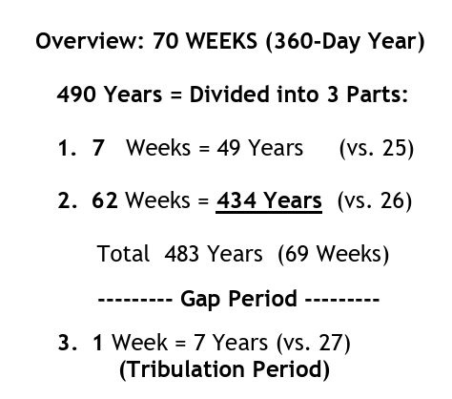
- The 70 weeks (490 years) are divided into three parts: 7 weeks (49 years), 62 weeks (434 years), and the 70th week (final 7 years before Jesus returns). There is an approximate 2,000-year gap after the 69 weeks, before the 70th week begins. Each date points to a time when significant events occur—Jerusalem restored, Messiah’s first coming, Jerusalem destroyed, Antichrist activity of seizing the temple and stopping the sacrifices.
- The START: Command to Rebuild – The timeline of the 70 Weeks begins with the decree of Persian King Artaxerxes for Nehemiah to return to rebuild Jerusalem – 445 BC
- First Segment: 7 Weeks (49 Years) - King Artaxerxes reigned 40 years (464-424 BC)—it included the days of Ezra and Nehemiah (Ezra 7:1, 7). He also gave Ezra permission to go to Jerusalem (Ezra 7:11-26). The completion of Ezra and Nehemiah’s rebuilding work in Jerusalem is the significant development that occurred in the first 49-year period
- Second Segment: 62 Weeks (434 Years) – Runs from when the work on Jerusalem was completed and ends precisely with Christ’s Triumphant Entry into Jerusalem
- Daniel 9:25 says that after the first two time-segments are complete, “Messiah the Prince” would arrive in Israel. Messiah was to come 483 years after the initial command to restore Jerusalem (445 BC). His arrival took place precisely 173,880 Days after King Artaxerxes Decree in 445 BC, ending the 69 Weeks on Palm Sunday!
- Luke 19.37-38 ³⁷ As He came near… the whole multitude began to rejoice and praise God with a loud voice ³⁸saying:“ ‘Blessed is the King who comes in the name of the LORD!’

*The prophetic clock for Israel stopped when Jesus was “cut off”—rejected and crucified at the end of the 69 weeks of years. Israel’s prophetic clock will resume when the beast makes a “firm covenant with the many” in Daniel 9:27. At that point Daniel’s clock restarts and will run for another seven years, at which time the seventy weeks prophecy of Daniel 9:24-27 will be fulfilled completely. God has appointed times and boundaries (Acts 17:26 - And hath made of one blood all nations of men for to dwell on all the face of the earth, and hath determined the times before appointed, and the bounds of their habitation;), and Jesus’ position of being granted all authority ensures that the ultimate outcome of these end-time conflicts is certain.

**(See endnote for description of times in the Bible and an extensive study on the calendar and days of weeks and weeks of years.)

***Daniel 9:27, says “in the middle of the week” the desolation Jesus spoke of will come. Thus, this will mark the beginning of the “great tribulation.” It also indicates that God’s people will have the opportunity to be protected during that time if they heed the sign and flee.
In Scripture, the wilderness is often a place of both trial and divine provision. We can think of Israel’s wandering after the Exodus (Exodus 16-17), where they were in a desolate place but were miraculously provided for. We can also think of Elijah’s refuge by the brook Cherith (1 Kings 17:2-6) during a time of drought, where God fed him using ravens.
Here, again, God prepares a sanctuary for His people during a time of duress. It may require the leading of the Holy Spirit for God’s people alive at the time of the “abomination of desolation” to recognize the time as well as the way of escape. However, Jesus indicates that it is observable (Matthew 24:15).
The wilderness might be figurative. We will see in Revelation 13 that the beast will prohibit the buying and selling of goods without taking his mark and will kill all who will not worship him (Revelation 13:15-17). It might be that God will provide an alternate means of provision in such an economic wasteland that will be something like the provision of Israel in the wilderness.
What we know is that believers alive at that time need to recognize the “abomination of desolation” and flee immediately. It might also be that the wilderness passage is literal. Zechariah 14:5 encourages the people of Israel to flee “by the valley of My mountains.” This is in the day when Jesus returns a second time. He will land on the Mount of Olives which will then split in two (Zechariah 14:4). This occurs at a time when Jerusalem has been captured (Zechariah 14:2).
We see, then, in Revelation 12.6 how the woman fled to a place prepared by God where she is nourished 1,260 days and how that correlates to the urgent warnings Jesus gave: “let those who are in Judea flee to the mountains” (Matthew 24:16). In the overarching timeline, once the abomination of desolation (Daniel 9:27) is set up, God’s chosen nation is forced to seek divine protection. The presence of Satan in Revelation 12:3-4 indicated that the dragon is seeking to destroy Israel, but God has already made provision.
We looked at the wording prepared by God in Revelation 12.6: a reminder that every part of this sequence of tribulation is under the divine orchestration introduced in Revelation 4-5. The scroll with seven seals, the throne room, and the sovereign rule of God remind us that He is never absent or unsure of His next move.
This reflects a major theme of Revelation: God is on the throne. Even in the darkest times, the 1,260 days or three-and—a—half years of the great tribulation, He provides the protection and resources for His people. However, it is required that the people recognize and flee in order to gain benefit. We will see that many believers will die for their faith during this time of severe persecution.
New Testament believers this side of the great tribulation can make a personal application of the wilderness period. While many of Revelation’s prophecies pertain specifically to Israel, contemporary believers can find themselves in a wilderness season. This can be a time of testing, trial, or persecution. The book of Revelation urges believers to live as faithful witnesses regardless of loss, rejection, or even death. Revelation begins with a promise of a great blessing for anyone who heeds the words of this prophecy (Revelation 1:3). In scripture, times of high-impact ministry are often preceded by times of preparation in the wilderness.
The great promise of reward goes to believers who “overcome” even as Jesus overcame (Revelation 3:21). Jesus in the wilderness being tempted by Satan serves as one picture of what it means to “overcome.” Fortunately, each believer can have confidence that God will not ask them to endure any temptation beyond what they are able (1 Corinthians 10:13).
God prepares what is necessary to sustain us. Though the context in verse 6 is specifically about Israel’s future, the principle remains—God’s sovereign hand is at work, setting boundaries and authorizing events across all history. God’s created beings will make choices that are real and have true impact. But, although those choices are real, outcomes are in the hands of God. God’s plan to ultimately redeem His creation will not be thwarted.
It is common for prophecies to have multiple fulfillments. The earlier fulfillments are similar to the birth pangs leading up to the final birth. Although birth pangs resemble and precede the time of the birth, they are not the birth. In the case of these prophecies about the destruction of Jerusalem and the abomination of desolation, there have been at least two premonitions of what is to come, or “birth pangs” that precede the actual fulfillment that is yet to come (as of the writing of this commentary).
A foreshadowing of an abomination of desolation occurred during the reign of Antiochus Epiphanes. He ruled a part of the Greek empire that included the territory of Israel during the second century BC. He erected a statue of Zeus and sacrificed a pig on the altar in the temple in Jerusalem as a part of his campaign to extinguish Jewish religious practice. Antiochus Epiphanes was miraculously defeated by a Jewish uprising led by the Maccabees.
This defiling of the temple and attempt to eliminate Jewish religious practice foreshadowed the abomination of desolations, but it could not have been a complete fulfillment of Daniel’s prophecy, since over a century later Jesus spoke of a future fulfilment in Matthew 24:15.
The destruction of Jerusalem in 70 AD might be another foreshadowing. That event would fit the description of the Gentiles treading underfoot the holy city, as described in Revelation 11:2. This great destruction was predicted by Jesus; He said that not one stone of the temple would be left standing upon another (Matthew 24:2).
Even to this day, only the platform that is the foundation upon which the temple stood remains. Excavations have revealed massive stones that were thrown down from the stone platform that cover the temple mount, just as Jesus predicted.
But neither the desecration of the second century BC nor the destruction of Jerusalem in 70 AD fulfill the predictions of Daniel 9, Matthew 24, and Revelation. It certainly did not “bring in everlasting righteousness” as predicted in Daniel 9:24. That will take place at the end of the age, as will be revealed in the last chapters of Revelation.
Further, the 70 AD event was not global, as the events predicted by Jesus in Matthew 24 and here in Revelation will be. As the following quote from Jesus indicates, the event that will follow the time of “great tribulation” would end all life if not cut short:
“For then there will be a great tribulation, such as has not occurred since the beginning of the world until now, nor ever will. Unless those days had been cut short, no life would have been saved; but for the sake of the elect those days will be cut short.” (Matthew 24:21-22)
The temple destruction in 70 AD was confined to the territory of Judea. Roman leaders used the wealth gained from sacking the Jewish temple to build the Roman colosseum; so for them it was a time of prosperity rather than tribulation. Yet, the sacking of Jerusalem still mirrored some of the events that are to come, so it can reasonably be considered a foreshadowing.
After the destruction of Jerusalem, the Roman Emperor Hadrian established a new colony upon the ruins of Jerusalem and called it “Aelia Capitolina.” He dedicated the new city built on the ruins of a desecrated Jerusalem to the Roman god Jupiter Capitolinus as a means of further desecration.
Hadrian renamed the area formerly known as Judea/Israel “Syria Palaestina” after the traditional enemy of Israel, the Philistines, as a further act of humiliation. He banned the Jewish practice of circumcision as well as banning any Jews from entering the city. These actions of Emperor Hadrian might be considered another birth pang and foreshadowing of the “abomination of desolation which was spoken of by Daniel the prophet” spoken by Jesus in Matthew 24:15.

What About Daniel 9.26?
I believe it is time we cast aside the idea that the Antichrist will emerge from a revived Roman Empire and begin to read the writing on the wall, and more specifically of the Biblical prophets. Entire doctrines of eschatology have been crafted around a Roman Antichrist and a revived Roman Empire, but the Scriptures paint an entirely different picture. If we aren’t willing to take off our “western lenses” and look at Biblical prophecy through Israel-centric lenses, we will miss the whole impetus of the Biblical narrative.
WHAT About Daniel 9:26?
If there has been one verse of Scripture universally accepted that supposedly makes the case for a Roman Antichrist in the last days, it is Daniel 9:26-27 [see above quoted in Daniel’s 70 Weeks, p. 32]. This one obscure verse has been used as a proof text to promote an end-times scenario that when examined more closely, just doesn’t add up. By taking a deeper look at this verse and combining it with some basic world history, I will show that the final end-times kingdom of the beast is not a revived Roman Empire, but actually a revived Islamic Caliphate.
A.D. 70
Before I can deconstruct the idea that Rome will be the revived kingdom of the Antichrist, I need to explain why so many have taught this concept over the years. The [faulty reasoning] goes something like this …
- Daniel 9:26-27 says that the people of the prince to come will destroy the city (Jerusalem), and the sanctuary (the Temple).
- In A.D. 70, the Romans, under General Titus, destroyed Jerusalem and the 2nd Temple, partially fulfilling the prophecy of Daniel 9.
- Therefore, the future Antichrist, or “prince to come,” must arise from a revived Roman Empire in the last days, ultimately fulfilling the prophecy.
Now on the surface, this argument seems to work. History does indeed prove that the Roman Empire sent legions of soldiers to siege and destroy Jerusalem in A.D. 70, killing nearly 1.5 million Jews in the process. But once you drill down a little deeper and read it within the greater historical context of the Biblical narrative, Rome becomes quite implausible as the kingdom of the Antichrist.
The Surrounding Nations
To say that the Biblical prophets place a concerted emphasis on the nations surrounding Israel is a gross understatement. Nearly every passage that describes an alliance of armies coming against Israel in the last days leading up to the Day of the LORD, specifically identifies the nations and peoples immediately surrounding Israel. The prophets invoke vivid imagery of God’s future judgment on Israel’s enemies, naming the likes of Edom, Moab, Midian, Arabia, Egypt, Assyria, Babylon, Persia, Cush, Put, Lud, Libya, Tyre etc …
This coming future battle will culminate in the Valley of Decision [Joel 3], when Jerusalem will become a “cup of staggering to all the surrounding peoples” [Zechariah 12:2] and when “the LORD will go out and fight against those nations as when he fights on a day of battle” [Zechariah 14:3].
Jesus says in Luke 21:20, “But when you see Jerusalem surrounded by armies, then know that its desolation has come near,” and Revelation 19:19 depicts this great end-times war saying, “the beast and the kings of the earth with their armies gathered to make war against him who was sitting on the horse and against his army.”
While there is no shortage of these prophetic passages, it is essential to understand that all of the nations surrounding Israel today are overwhelmingly Muslim nations, who share a common disdain and hatred for the Jews. It only makes sense that the nations that eventually will unite under the Antichrist in the last days will most certainly be a revival of the Islamic Caliphate. After the death of Mohammed, Islam rapidly conquered the Middle East through force and terror. Eventually the Ottoman Empire dominated the Middle East for more than 600 years [A.D. 1299-1923]. It is much more apparent that a form of this Ottoman Empire, not the Roman Empire, is the empire that will be revived under the Antichrist.
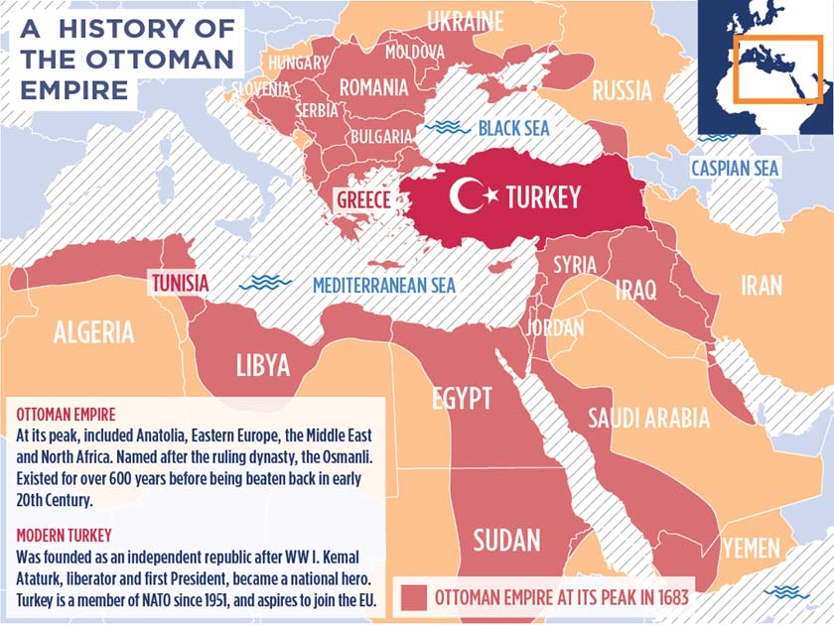

THE PEOPLE OF THE PRINCE TO COME
But what about Rome? Look at the information above in Daniel 2, beginning at 2. Surely Rome must have some role in the Biblical end-times scenario, right? Many scholars are determined that the same Romans who destroyed the temple in A.D. 70 will once again lead an alliance of armies against Jerusalem in the last days.
How can history help us answer these questions? By taking a look at the details of the events surrounding the destruction of Jerusalem in A.D. 70, you may be surprised to discover which “people” really trampled the city and the sanctuary.
Roman Provincial Army in A.D. 70
It is easy to assume that because Rome was the conquering empire in power during the siege of Jerusalem in A.D. 70, it must have been an army of Italians, or Europeans, who leveled the city and burned the temple to the ground. But history reveals a different story altogether. Rome conquered many different provinces and people groups during its expansion and was forced to recruit these “provincials” to man their armies.
By the time of A.D. 70, Italian soldiers were reserved for the elite Pretorian Guard, but the rest of Rome’s armies consisted of people from various other ethnic groups on the fringes of the empire. The “provincialization” of the army was true for all of the Roman legions of this time period, and this specifically was the case with regard to the Eastern legions that were used to attack Jerusalem.
Author Joel Richardson points out that the Roman legions had been stationed in Judea, Syria and Egypt and that there was also “a strong contingent of Arabs, who hated the Jews” who accompanied the soldiers. Jewish historian Flavius Josephus confirms this.
“Malchus also, the king of Arabia, sent a thousand horsemen, besides five thousand footmen, the greatest part of which were archers; so that the whole army, including the auxiliaries sent by the kings, as well horsemen and footmen, when all were united together, amounted to sixty thousand”
(Flavius Josephus, The Complete Works of Josephus, The Wars of the Jews or The History of the Destruction of Jerusalem, Book III, Chapter 4, Paragraph 20).
History reveals that over 55,000 soldiers during the siege of Jerusalem were Eastern peoples. As Richardson has said, “that would mean that there was a maximum of one Western European soldier to every eleven Middle Eastern soldiers. Eleven to one! Yet in all likelihood, the ratio was much higher; perhaps closer to twenty to one.”
Furthermore, according to Josephus, it was not the Roman General Titus who ordered the destruction of the Temple, but rather the Middle Eastern provincials under his command who determined to exact their hatred on the Jews. As a matter of fact, these provincial soldiers directly disobeyed the orders of Rome in burning down the temple.
“Titus supposing what the fact was, that the house itself might yet he saved, he came in haste and endeavored to persuade the soldiers to quench the fire…yet were their passions too hard for the regards they had for Caesar, and the dread they had of him who forbade them, as was their hatred of the Jews, and a certain vehement inclination to fight them, too hard for them also…And thus was the holy house burnt down, without Caesar’s approbation”
(Josephus, Wars of the Jews, Book 6, Chapter 4).
Based on the historical record, we must determine that the “people of the prince to come” spoken of by the prophet Daniel were not Italians from Europe, but rather they were Syrians, Egyptians, and Arabians — provincial soldiers under Roman command — who hated the Jews and delighted in destroying their most holy city. Once we have an accurate view of history, Daniel 9:26 makes complete sense and fits perfectly into the greater Biblical narrative.
The ethnic people groups who destroyed Jerusalem and the temple in A.D. 70 are the same people groups who are surrounding Israel today in Muslim majority nations. It only stands to reason that the Antichrist will establish his 10 king coalition from these Muslim nations and revive the ancient Islamic Caliphate of the Ottoman Empire. The stage is set and the pieces are in place for the right leader to unite these nations under the same evil spirit of antichrist that already is at work in the world.

- If the treading of the holy city by the Gentiles is taken to be simultaneous with their authority over the outer court, then it occurs while the Jews are allowed to worship in the temple and sacrifice on the altar. This would be the first half of the final week—before sacrifices are brought to an end in Daniel 9.27 and the two witnesses are overcome by the beast in Rev 11.3.
- If the treading is taken to follow the possession of the outer court by the Gentiles, then the forty-two months could denote the last half of the week: after the Antichrist has violated his covenant, the Abomination of Desolation occurs (Matthew 24:15, Daniel 11:31, Daniel 12:11), the Antichrist exerts his global authority (Daniel 7:25; 12:7, 11-12; Revelation 13:5-8), and the Jews flee to the wilderness where they are protected by God (Matthew 24:16-20; Revelation 12:6, 14).
The last half of the week is probably in view so that the termination of the forty-two months corresponds to the end of the “times of the Gentiles” as inferred in Luke 21:24 (²⁴ And they shall fall by the edge of the sword, and shall be led away captive into all nations: and Jerusalem shall be trodden down of the Gentiles, until the times of the Gentiles be fulfilled.), with the arrival of Christ and the introduction of the Millennial Kingdom (the thousand-year reign of Christ on earth, centered at Jerusalem). Jeremiah prophesied the restoration which would follow Jacob’s Trouble and the Great Tribulation:
Jeremiah 30:6-9 Ask ye now, and see whether a man doth travail with child? wherefore do I see every man with his hands on his loins, as a woman in travail, and all faces are turned into paleness? ⁷ Alas! for that day is great, so that none is like it: it is even the time of Jacob’s trouble; but he shall be saved out of it. ⁸ For it shall come to pass in that day, saith the LORD of hosts, that I will break his yoke from off thy neck, and will burst thy bonds, and strangers shall no more serve themselves of him: ⁹ But they shall serve the LORD their God, and David their king, whom I will raise up unto them.
Jeremiah explains the reason the times of the Gentiles will come to an end is so that the nation of Israel will be free to serve God under the Messianic economy of the Millennial Kingdom (which we will look at in depth when it is mentioned in Revelation 20). It is God’s jealousy over His chosen nation which will bring this about. Woe to the nations who will fail to appreciate God’s zeal for Israel!
Jeremiah 30:10-11 Therefore fear thou not, O my servant Jacob, saith the LORD; neither be dismayed, O Israel: for, lo, I will save thee from afar, and thy seed from the land of their captivity; and Jacob shall return, and shall be in rest, and be quiet, and none shall make him afraid. ¹¹ For I am with thee, saith the LORD, to save thee: though I make a full end of all nations whither I have scattered thee, yet will I not make a full end of thee: but I will correct thee in measure, and will not leave thee altogether unpunished.
Remember that the entire period is determined for Daniel’s people and Daniel’s holy city. These are none other than the Jews and Jerusalem. The entire scope of this prophecy pertains to the Jews.

Events in the Gap After the 69th Week
Messiah Killed, Jerusalem Destroyed, Church-Age
- Gabriel described events that occurred after the 69 weeks (9:26). Jesus was killed and Jerusalem destroyed. Verse 26 focuses on tragic events related to Jesus’ first coming. And after the sixty-two weeks [69 Weeks total] Messiah shall be cut off [crucified], but not for Himself [for us]; And the people of the prince [Antichrist] who is to come will destroy the city and the sanctuary [70 AD]. The it shall be with a flood (wars and genocide of the Jews), and till the end of the war [70 AD] desolations are determined. (Dan. 9:26)
- After 62 weeks: Gabriel said that “62 weeks,” or 434 years, after Jerusalem was restored, two momentous events would occur—Messiah’s death and Jerusalem’s destruction (AD 70). [Remember Daniel 9.25 clarifies 7 weeks + 62 weeks = 69 weeks or 483 years.]
- Shall be cut off: Being cut off is an idiom for being killed—cut off in death (Gen. 9:11; Ex. 31:14; Isa. 53:8; Jer. 11:19). Imagine how shocking it must have been for Daniel to hear that the Son of Man (7:13-14) would be cut off. When Jesus was killed, God’s “prophetic time clock,” or calendar, was put on pause for about 2,000 years, until Israel would be back in the land with a temple.
- Destruction of Jerusalem and the temple: Israel’s rejection of Jesus led to Jerusalem’s destruction by the Roman army and the Jewish people being driven out of the land and scattered all over the world for nearly 2,000 years.
- The people of the prince: Gabriel introduced another prince called “the prince who is to come.” The prince here is Antichrist who makes a covenant in 9:27. The people of the prince are identified as the local Middle Eastern and Arab militias who served in the Roman army and saw an opportunity to take out their hatred of the Jewish people by destroying Jerusalem and the temple in AD 70. Despite Rome’s commands not to destroy Jerusalem and the temple, the long-time, Jewhating locals who served for Rome in the militias of the Roman army surrounded Israel, slaughtered over 1 million innocents, burned Jerusalem and demolished the temple, just as prophesied by Jesus. (Math. 24:1-2) Then Jesus went out and departed from the temple, and His disciples came up to show Him the buildings of the temple. 2 And Jesus said to them, “Do you not see all these things? Assuredly, I say to you, not one stone shall be left here upon another, that shall not be thrown down.”
- The end of Jerusalem: The end of “it”—Jerusalem under Jewish leadership—came with a flood of destruction and brought desolation to Jerusalem and the temple.
- Daniel 9.26 - The end of it shall be with a flood (wars and devastation), and till the end of the war [70 AD] desolations are determined.

Events of the 70th Week of Daniel
Daniel 9.27 Then he [Antichrist] shall confirm a covenant [Peace Treaty] with many for one week [7-years]; But in the middle of the week [3.5 years] he shall bring an end to sacrifice and offering [Antichrist controls temple]. And on the wing of abominations shall be one who makes desolate [Antichrist defiles temple], even until the consummation, which is determined, is poured out on the desolate [Antichrist destroyed].
- 2,000-year gap: The gap begins at the end of the 69th week and lasts until the start of the 70th week. Many messianic prophecies often see a gap of 2,000+ years between Jesus’ first and second comings (Isa. 9:6-7; 42:2-4; 61:1-2; Zech. 9:9-10; Mal. 3:1-2; Lk. 3:16-17).
- One week: The future Tribulation will last “one week” or 7-years and is referred to as “Daniel’s 70th week.” It begins by signing a covenant and ends with the 2nd Coming.
- Confirm a covenant with many: Antichrist will lead the final Beast Empire to confirm an international covenant between Israel and the Palestinians with “many” Gentile nations. The covenant will be a political alliance to divide Israel and supposedly to bring peace and safety (1 Thes. 5:3). It is the primary political event that signals the start of the final seven years and brings the wrath of God on the world for 7 years. For when they say, “Peace and safety!” then sudden destruction [Tribulation] comes upon them, as labor pains upon a pregnant woman. And they shall not escape. (1 Thes. 5:3)
- The Temple & the Sacrifices: Central to this covenant is the implied promise that Israel will be allowed to rebuild their temple (Rev. 11:1-2) on the Temple Mount, in a sharing relationship with the Muslim holy sites. Then begin daily sacrifices. Israel’s religious leaders view the temple as essential to the coming of Messiah. By invading the land, Antichrist will take control of the temple, stop the sacrifices & convert the temple to a mosque. This action is referred to as the “abomination of desolation” (Mt. 24:15) which Jesus warned of.
- Middle of the week: The middle of the week speaks of the 3½-year mark when Antichrist gains control of the temple. At this point the great persecution of Israel begins resulting in 2/3 of Israel being killed (Zech. 13:8-9) by the end of the Tribulation when Christ returns to rescue the remnant and when “all Israel is saved” (Rom. 11:25).
- Antichrist will cause great desolations (9:27). He will do this in various ways, including defiling the temple and killing those who resist him. This will result in the mass death and devastation described in the later part of the verse:
- Daniel 9:27 “On the wing of abominations shall be one who makes desolate, even until the consummation, which is determined, is poured out on the desolate.”

The parallels between Revelation and Daniel’s 70th week have not gone unnoticed. Although it is impossible to know with certainty the absolute sequence among all the events recorded by Scripture associated with the final week, the timing of some of the more significant events can be established. ...[P]urposefully excluded [are] events whose relative timing [were] view[ed] to be less certain. A more detailed list could be prepared, but would be more likely to contain errors.

For some incredible charts on the Events of the 70th Week of Daniel, see Endnote .

https://prewrathresources.wordpress.com/2016/06/13/the-beast-of-revelation-the-anti-christ-and-his-kingdom/ (June 13, 2016 / Aaron Eggman)
chrome-extension://efaidnbmnnnibpcajpcglclefindmkaj/https://joelstrumpet.com/wp-content/uploads/2019/02/MIdeast-Beast-Master-File-Joel-Richardson.pdf, page 61
https://bibleask.org/who-was-daniel-in-the-old-testament/
Daniel served under several significant rulers during his time in Babylon. Here are the main kings: King Reign Notable Events Nebuchadnezzar 605–562 BC - Conquered Judah and took Daniel captive. - Known for the fiery furnace incident and his dreams. Evil-merodach 562–560 BC - Released Jehoiachin from prison. - His reign was brief and less documented. Belshazzar 550–539 BC - Last king of Babylon. - Known for the "writing on the wall" incident. Darius the Mede 539–530 BC - Appointed Daniel as an administrator. - Known for the lions' den incident. Daniel also served a short time under Cyrus when he was about 81 years old. Daniel's Service - Daniel was taken to Babylon during the first deportation of Judeans. - He was trained in Babylonian culture and language, serving in the royal court. - His service spanned over several decades, witnessing the rise and fall of these kings. Daniel's experiences highlight his faith and wisdom in navigating the challenges of serving foreign rulers while remaining true to his beliefs.
Chapters 1 & 12 – Chapter 1 shows the captivity of God’s people in history (Babylon) while chapter 12 shows the great liberation of God’s people into His kingdom at the end of the age. Chapters 2, 7, 8, 11 – reveal four great beasts (the earthly kingdoms of Babylon, Medo-Persia, Greece, and Rome) that will be set against God’s people. A final beast will be destroyed and God’s kingdom will be ushered in. Chapters 3 & 6 – explain the false worship that Daniel was confronted with and his faith to withstand. He keeps his allegiance to the only true and living God, revealed in Scripture, who was to be worshiped. (Revelation 13 gives a future glimpse of a coming false worship that will be similar and will try the patience and faithfulness of God’s people.) Chapters 4 & 5 – tell the story of two rulers, Nebuchadnezzar and Belshazzar, whom a sovereign God brought under His judgment. This is a clear foreshadowing of the reality that all will be judged by God’s sovereign hand. There is no hiding from Him who sees all. Chapters 9 & 10 – comfort Daniel when he is reassured of God’s provision and protection of His people. He first is visited by the angel Gabriel who reveals the “70 weeks of Daniel.” Then there is the appearance of a man who reveals to Daniel that God and His angels are in the battle for His people and against the powers of this evil world. Please note: the events of Daniel are not in chronological order. The actual chronology is chapters 1-4, 7-8, 5-6, 9-12. Chapters 5-6 and chapters 7-8 are flip-flopped. You can see the full timeline with known dates and events in The Chronology of Daniel. https://www.4truthministry.org/main-message-daniel/
We also see God’s sovereignty clearly in chapters 2, 7, 8, and 11 when Daniel relates his dreams and visions, and they so carefully predict how the kingdoms of this world will unfold. Many prophecies, written during the sixth-century B.C., find incredibly accurate fulfillment in past history. Some are yet to be fulfilled and God will perfectly carry them out according to Scripture! We see God’s sovereignty in His judgments of Kings Nebuchadnezzar and Belshazzar in chapters 4 & 5. To consider the identity of Belshazzar see: https://biblehub.com/topical/b/belshazzar.htm We see His sovereign protection over His own people in chapters 3 & 6 during two different kingdoms: Babylonian (Nebuchadnezzar) and Medo-Persian (Darius). To consider the identity of Darius the Mede see: https://www.gotquestions.org/Darius-in-the-Bible.html To further research the historical complexities of Belshazzar and Darius the Mede see: https://www.biblehistory.net/newsletter/belshazzar_darius_mede.htm. So even amid trouble, God causes all things to work together for good for those who love Him and are called according to His purpose! (Romans 8:28) Does the book of Daniel reassure you of this? It should. Further, in chapters 9 & 10, Daniel steps out in faith to inquire of God and His provisions for the future of His people. He was not only told of God’s provisions but also God’s protections. God had/has a sovereign plan for Israel as seen in the 70 weeks of Daniel, and God is present and sends help for His own, even via angels, in the midst of every battle that is waged. Can the people of God bring glory to Him in trusting that the provisions and the battle are really His? Can you? And of course, Daniel 12 ends with the perseverance of God’s people at the end of this present evil age and the reality that – God will win in the end! Are you ready? https://www.4truthministry.org/main-message-daniel/
Much of this Supplement is taken from https://www.spiritandtruth.org/teaching/Book_of_Revelation/commentary/htm/intro/parallels.html#2.13.5 and https://prewrathresources.wordpress.com/2016/06/13/the-beast-of-revelation-the-anti-christ-and-his-kingdom/ June 13, 2016 / Aaron Eggman
Daniel 2.19-23 ¹⁹Then was the secret revealed unto Daniel in a night vision. Then Daniel blessed the God of heaven. ²⁰ Daniel answered and said, Blessed be the name of God for ever and ever: for wisdom and might are his: ²¹ And he changeth the times and the seasons: he removeth kings, and setteth up kings: he giveth wisdom unto the wise, and knowledge to them that know understanding: ²² He revealeth the deep and secret things: he knoweth what is in the darkness, and the light dwelleth with him. ²³ I thank thee, and praise thee, O thou God of my fathers, who hast given me wisdom and might, and hast made known unto me now what we desired of thee: for thou hast now made known unto us the king's matter.
Note: We will be diving into the Millennium and the various positions in Revelation Chapter 20 where we find the mention of it.
This sections is taken from https://www.spiritandtruth.org/teaching/Book_of_Revelation/commentary/htm/intro/parallels.html#2.13.5
Donald Grey Barnhouse, Revelation (Grand Rapids, MI: Zondervan Publishing House, 1971), 236.
The preciousness of the metal deteriorates from the top of gold to the clay of the feet, and there is a corresponding lower specific gravity; that is, the gold is much heavier than the silver, the silver than the brass, the brass than the iron, and the clay in the feet is the lightest material of all. The approximate specific gravity of gold is 19, silver 11, brass 8.5, and iron 7.8. . . .While the materials decrease in weight, they increase in hardness with the notable exception of the clay in the feet. The image is obviously top heavy and weak in its feet.”—John F. Walvoord, Daniel: The Key to Prophetic Revelation (Chicago, IL: Moody Bible Institute, 1971), 63.
For more information see 2.4.3 - The Arrival of God’s Kingdom, https://www.spiritandtruth.org/teaching/Book_of_Revelation/commentary/htm/intro/themes.html#2.4.3
https://fotet.org/where-will-antichrist-rise/
https://www.prophecysigns.com/daniel-2
Romans 16:25 Now to him who is able to establish you by my gospel and the proclamation of Jesus Christ, according to the revelation of the mystery hidden for long ages past. 1 Cor. 2:7 No, we speak of God's secret wisdom, a wisdom that has been hidden and that God destined for our glory before time began. 1 Peter 1:10-12 Concerning this salvation, the prophets, who spoke of the grace that was to come to you, searched intently and with the greatest care, [11] trying to find out the time and circumstances to which the Spirit of Christ in them was pointing when he predicted the sufferings of Christ and the glories that would follow. [12] It was revealed to them that they were not serving themselves but you, when they spoke of the things that have now been told you by those who have preached the gospel to you by the Holy Spirit sent from heaven. Even angels long to look into these things.
https://theologyinfive.com/the-islamic-antichrist-theory-a-prophetic-perspective/
Daniel 2:27-45 Daniel answered in the presence of the king, and said, The secret which the king hath demanded cannot the wise men, the astrologers, the magicians, the soothsayers, shew unto the king; ²⁸ But there is a God in heaven that revealeth secrets, and maketh known to the king Nebuchadnezzar what shall be in the latter days. Thy dream, and the visions of thy head upon thy bed, are these; ²⁹ As for thee, O king, thy thoughts came into thy mind upon thy bed, what should come to pass hereafter: and he that revealeth secrets maketh known to thee what shall come to pass. ³⁰ But as for me, this secret is not revealed to me for any wisdom that I have more than any living, but for their sakes that shall make known the interpretation to the king, and that thou mightest know the thoughts of thy heart. ³¹ Thou, O king, sawest, and behold a great image. This great image, whose brightness was excellent, stood before thee; and the form thereof was terrible. [Note: The colossus statue was brilliant, hanging above his bed, causing Nebuchadnezzar to respond with fear.] ³² This image’s head was of fine gold [Note: representing Nebuchadnezzar and Babylonian Empire], his breast and his arms of silver [Note: representing Medo- Persia Empire], his belly and his thighs of brass [Note: bronze. Note also, representing Grecian Empire], ³³ His legs of iron [Note: (representing Roman Empire – Western Division and Eastern Division OR Islamic Caliphate], his feet part of iron and part of clay. ³⁴ Thou sawest till that a stone was cut out without hands, which smote the image upon his feet that were of iron and clay [Note: The Final Empire of Antichrist which will arise from the Roman Empire or Islamic Caliphate.], and brake them to pieces. ³⁵ Then was the iron, the clay, the brass, the silver, and the gold, broken to pieces together, and became like the chaff of the summer threshingfloors; and the wind carried them away, that no place was found for them: and the stone that smote the image became a great mountain, and filled the whole earth. ³⁶ This is the dream; and we will tell the interpretation thereof before the king. ³⁷ Thou, O king, art a king of kings: for the God of heaven hath given thee a kingdom, power, and strength, and glory. ³⁸ And wheresoever the children of men dwell, the beasts of the field and the fowls of the heaven hath he given into thine hand, and hath made thee ruler over them all. Thou art this head of gold. ³⁹ And after thee shall arise another kingdom inferior to thee, and another third kingdom of brass, which shall bear rule over all the earth. ⁴⁰ And the fourth kingdom shall be strong as iron: forasmuch as iron breaketh in pieces and subdueth all things: and as iron that breaketh all these, shall it break in pieces and bruise. ⁴¹ And whereas thou sawest the feet and toes, part of potters’ clay, and part of iron, the kingdom shall be divided; but there shall be in it of the strength of the iron, forasmuch as thou sawest the iron mixed with miry clay. ⁴² And as the toes of the feet were part of iron, and part of clay, so the kingdom shall be partly strong, and partly broken. ⁴³ And whereas thou sawest iron mixed with miry clay, they shall mingle themselves with the seed of men: but they shall not cleave one to another, even as iron is not mixed with clay. ⁴⁴ And in the days of these kings shall the God of heaven set up a kingdom, which shall never be destroyed: and the kingdom shall not be left to other people, but it shall break in pieces and consume all these kingdoms, and it shall stand for ever. ⁴⁵ Forasmuch as thou sawest that the stone was cut out of the mountain without hands, and that it brake in pieces the iron, the brass, the clay, the silver, and the gold; the great God hath made known to the king what shall come to pass hereafter: and the dream is certain, and the interpretation thereof sure.
The breast and arms of this image are of silver and Daniel interprets as follows: ‘And after you shall arise another kingdom inferior to you’. - In my opinion, Daniel is here describing the Median empire. This empire was contemporaneous with the Babylonian empire, but after the death of Nebuchadnezzar in 562 BC it became the stronger of the two, because the power and wealth of Babylon immediately declined. Babylon was still a power, but the scales had tipped in favour of the Medes. Remember that the head of gold symbolizes Nebuchadnezzar, and Daniel says, ‘And after you (Nebuchadnezzar) shall arise another kingdom inferior to you.’ Following the death of Nebuchadnezzar, Media was the major power for at least twelve years until it was united with Persia in 550 BC under the rule of Cyrus. The Median empire did not, however, have the glory and magnificence of Nebuchadnezzar’s Babylon—it was of inferior quality. - It is often objected that the Median empire did not really follow after the Babylonian empire—it was contemporaneous with it. It may be replied, however, that the order of Daniel’s kingdoms is the order of their rise to the height of power and prominence. Daniel does not say that each kingdom exists only from the time of destruction of the preceding kingdom to the time of its own destruction. The order of the kingdoms is not merely the order of their existence—it is the order of their occupation of the seat of supreme power: in other words, the order in which they held the title of ‘top nation’! This is confirmed in the vision of the four beasts, because we learn there that after the fourth kingdom has been destroyed, the first three kingdoms continue to exist for a while together, although their dominion is taken away from them. This clearly indicates that they are to some extent contemporaneous. - The assertion that there was no Median empire between the Babylonian and Persian empires seems to be based on a misconception. This misconception is the idea that Persia succeeded Babylon as dominant world power when it overthrew Babylon in 539 BC. Persia in fact became the dominant world power some years before Babylon fell. Cyrus built up a very large and powerful empire which outstripped the Babylonian empire several years before he got round to conquering the latter empire. If it be admitted, and so it must, that Persia became dominant world power before the actual fall of Babylon, it can also be admitted that Media may have been the dominant world power before Persia. - Babylon and Media were the two great rivals for world power, and after the death of Nebuchadnezzar, it seemed inevitable that Media would overthrow Babylon. This was the state of affairs for a few uneasy years. But suddenly, events took an unexpected turn. Media’s king was overthrown by one of his own vassals, the brilliant Persian king, Cyrus. Cyrus united the Medes and Persians as allies under his own rule; but from this time Persia was on the ascendant. For some years the two peoples held the reins of power together; but the Persians had the edge on the Medes and increased their power until they were completely dominant. - Daniel continues the interpretation as follows: ‘… and yet a third kingdom of bronze, which shall rule over all the earth’. The third kingdom is symbolized by the image’s belly and thighs of bronze and is to ‘rule over all the earth’. The characteristic of this third kingdom is the immense area over which it rules. This is the perfect description of the Persian empire, because the most striking aspect of that empire was the huge area it covered—it was by far the vastest empire the world had seen. The following Greek empire was in fact slightly smaller than the Persian empire. In all regions except Greece and across the Indus river, Alexander’s Greek empire either fell short of or failed to extend beyond the limits of the Persian empire. - Cyrus himself created the largest empire the world had seen up to that time; but his successors continued to push the frontiers outwards until the Persian empire was truly breathtaking in size. In a series of brilliant campaigns Cyrus annexed the entire Median empire, the large and powerful kingdom of Lydia in Asia Minor, much territory in the East—and then the Babylonian empire. His successors added all Egypt, a chunk of Europe and more territory in the East. - Note also the way in which Daniel groups together the second and third kingdoms. The second kingdom is passed over quickly with a brief and belittling remark, possibly indicating that its term of supreme power is comparatively insignificant and short-lived, as well as being inferior in wealth and magnificence. It is grouped with, and closely followed and overshadowed by, the world-ruling third kingdom. The whole description is strongly suggestive of the Medo-Persian situation, because the comparatively insignificant Median empire was absorbed and eclipsed by the subsequently enormous Persian empire only a very short time after it (Media) had itself surpassed Babylon. The description of the second and third kingdoms fits the Median and Persian empires far better than it fits the huge, wealthy, long-lived Persian empire and the rather smaller Greek empire. https://www.thegospelcoalition.org/themelios/article/the-four-kingdoms-of-daniel-2-and-7/
These maps are found https://joelstrumpet.com/wp-content/uploads/2019/02/MIdeast-Beast-Master-File-Joel-Richardson.pdf, pp. 84-89 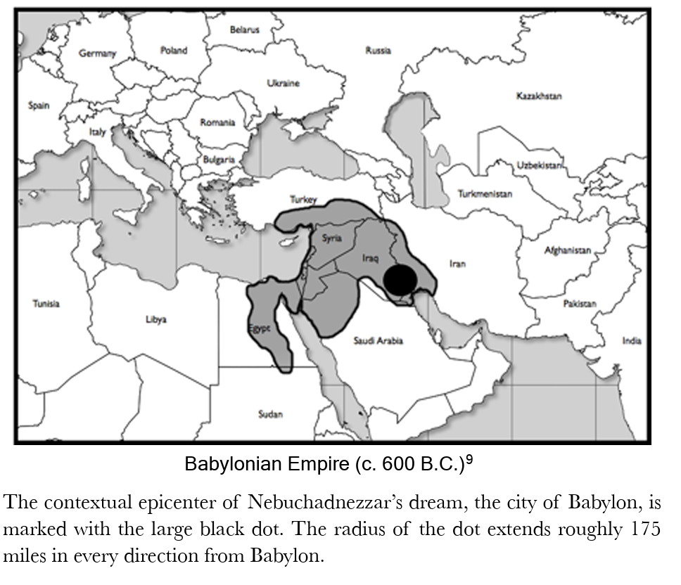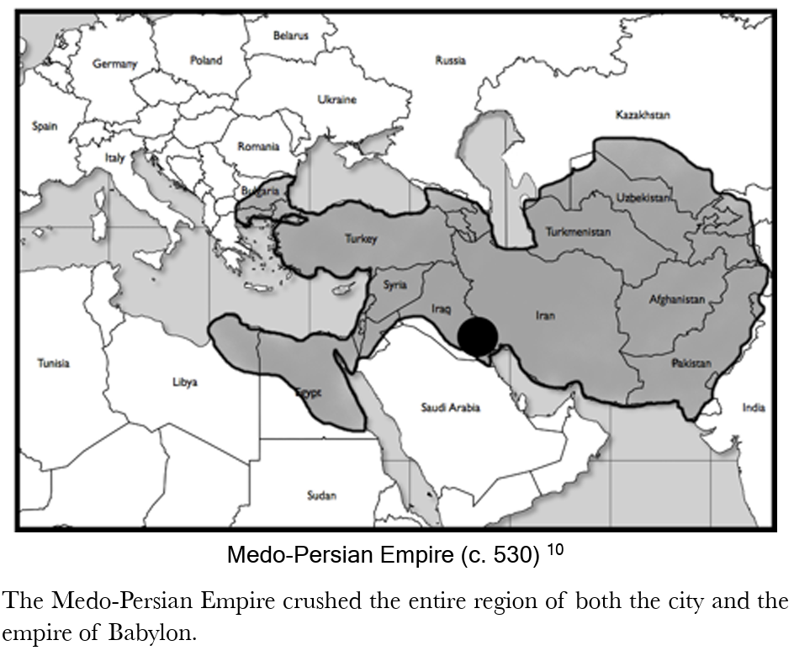 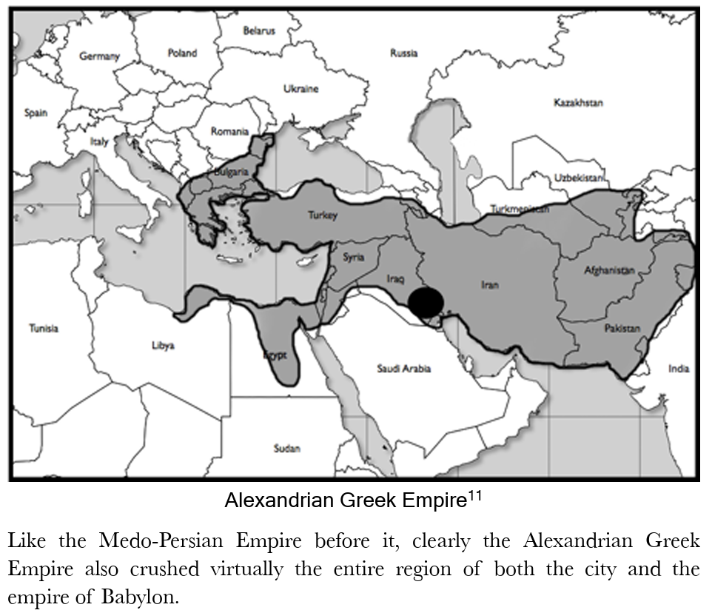 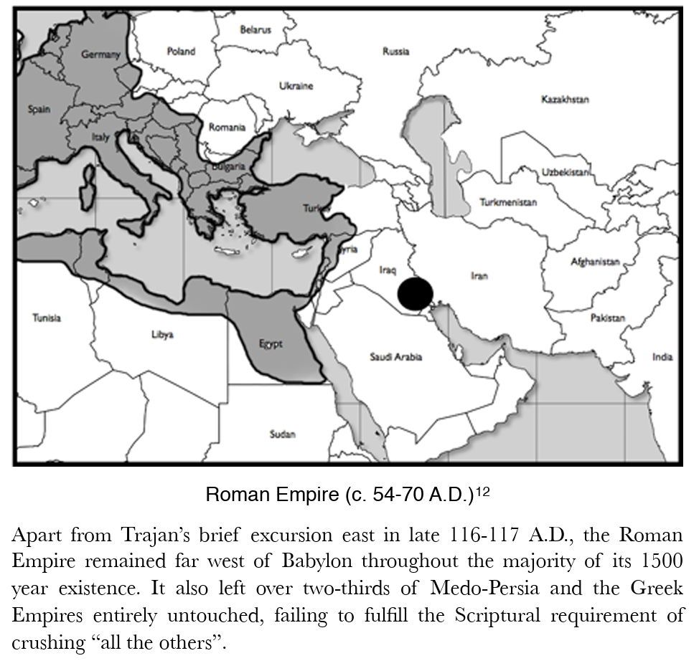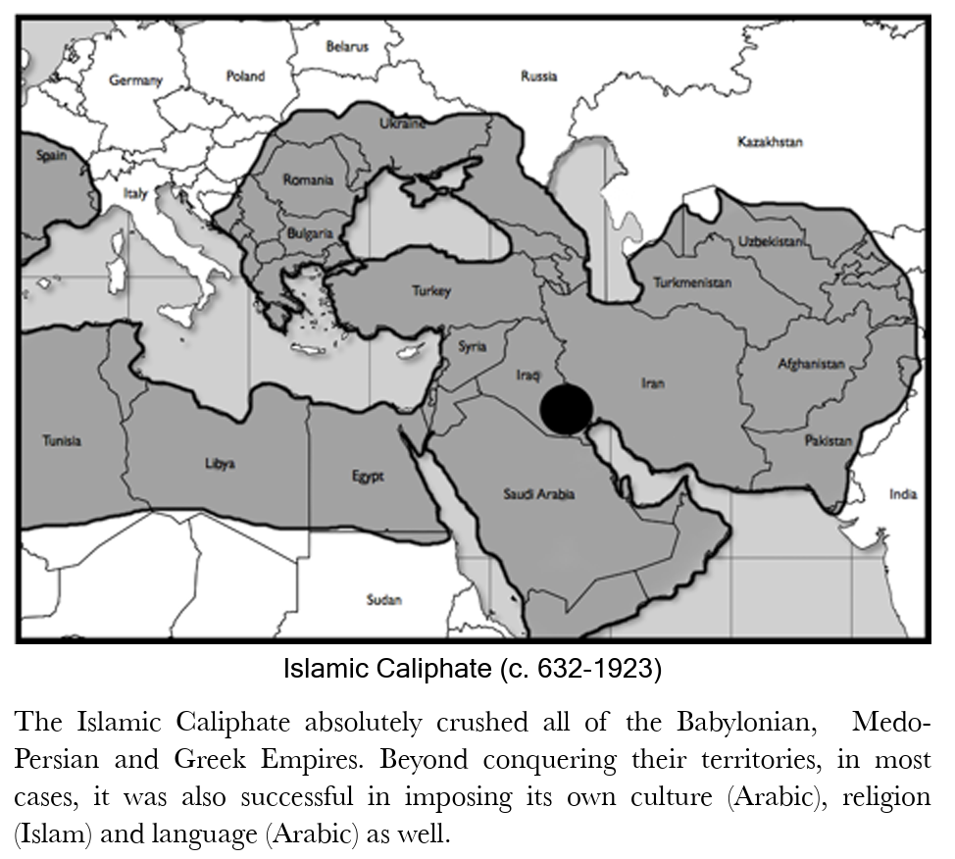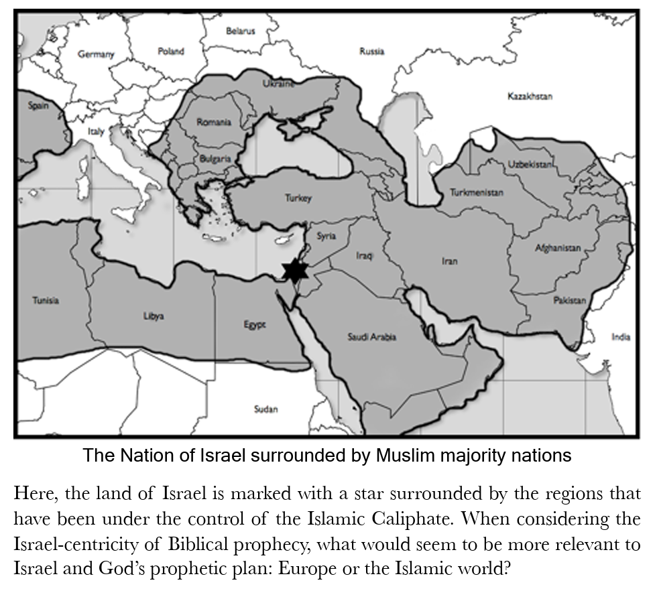
Conclusion: why Rome cannot be the “legs of iron” 1. Rome never conquered Babylon 2. The iron kingdom must rule Babylon 3. Rome did not replace Greece in Babylon’s land 4. Daniel 2 shows a continuous Middle Eastern empire line 5. The fourth kingdom must be stronger than Greece in the same region 6. The ten toes belong to the legs — they are Middle Eastern, not European 7. Rome is not named anywhere in Daniel’s writing 8. Rome was never a single “iron monarchy” 9. Rome breaks the chronological sequence of empires 10. The Roman Empire has not continued so as to exist at Christ’s Return. The Rise of the Fourth Kingdom The first problem with the Roman identification of the fourth kingdom is that the Roman Empire does not meet the specific criterion of Daniel 2:40. This verse speaks of the nature of the rise of the fourth kingdom. The text specifically says that at the time of its rise, the fourth kingdom would crush all three of the other kingdoms: And the fourth kingdom shall be as strong as iron… and like iron that crushes, that kingdom will break in pieces and crush all the others. —Daniel 2:40 NKJV Later in Daniel 7, speaking of this same empire, we find a very similar description: Thus he said: 'As for the fourth beast, there shall be a fourth kingdom on earth, which shall be different from all the kingdoms, and it shall devour the whole earth, and trample it down, and break it to pieces. —Daniel 7:23 The three other kingdoms that would be trampled and crushed, as we already know, are Babylon, Medo-Persia and Greece. The text is clear that the fourth kingdom would “crush” or conquer all three of these empires. The three empires never co-existed of course, and thus we must ask what the text means when it says that the fourth empire would “crush” all of the others. To Conquer Geographically The first meaning of the word “crush” is simply referring to geography. By examining the maps at the end of this chapter, it is clear that the Roman Empire only conquered roughly one third of the regions controlled by Babylon, Medo-Persia and Greece. But roughly two thirds of the regions controlled by these empires were left entirely untouched by the Roman Empire. In fact, the Roman Empire never even reached the two Persian capitol cities of Ecbatana and Persepolis. Consider the following modern equivalence: If an invading nation conquered Boston, but never came close to reaching New York or Washington D.C., it would hardly be accurate to say that such a nation “crushed” the United States. Neither would it be correct to say that the Roman Empire crushed the entirety of the Babylonian, Medo-Persian or Grecian Empires. Yet the text is clear; in order to fulfill the criterion of Daniel 2:40 an empire would need to crush, not one, but all three of these. The Roman Empire simply does not fulfill this requirement. Some have attempted to get around this problem by claiming that because the Roman Empire succeeded Greece, which succeeded Medo-Persia, which succeeded Babylon, it is right to say that the Roman Empire did crush all of the others. This view is articulated by Stephen R. Miller, Professor of Old Testament and Hebrew at Mid-America Baptist Theological Seminary in his commentary on the Book of Daniel: The fourth empire “will crush and break all the others.” This statement may be explained in that each previous empire was absorbed by its conquerer. Therefore when Rome conquered Greece, it overcame the empires previously defeated and absorbed by Greece.But while this view is a common one, not only is it based on faulty reasoning, it is also simply not what the text says. To show the illogical nature of this approach, let’s put it in football terms: If the New England Patriots beat the Ravens, who beat the Cowboys, who beat the Colts, would this mean that the Patriots beat the Colts? Of course not. This is what the playoffs and the Superbowl are for! But even more importantly, the text simply does not say that one would succeed another that would succeed another, etc. It says that the fourth kingdom would crush all of the others. If we are to be faithful to the text, we must adhere to what the text actually states. Although the Roman Empire did conquer portions of the land holdings of the other empires, it clearly did not conquer all of them, not even a majority of them. The Roman Empire only conquered roughly 1/5 of the landholdings of the Medo-Persian Empire, whose capital cities of Ecbatana and Persepolis forever remained hundreds of miles out of the Roman Empire’s reach. If we are to be honest, to say the Roman Empire fulfilled the criterion of Daniel 2:40 would be a stretch at best. On the other hand, the historical Islamic Caliphate fully, absolutely, completely conquered all of the lands of the others. To Conquer Culturally And Religiously But what if we expand the definition of “crush” to include more than mere geography? What if the purpose of the repeated descriptions of the beast crushing and treading everything underfoot are intended to convey more than just gaining control over a geographic region, but include the crushing of culture, religion and language also? With this expanded definition in mind, happens when we compare the Roman Empire to the Islamic Caliphate? Commentators have applied much hype to the Roman Empire as a crushing entity, often referencing the strength of the Roman military and its great ability to crush rebellions. But is putting down rebellions sufficient to satisfy the dramatic descriptions the Bible is speaking about? When we consider the nature of the Roman Empire, it was far from being a purely destructive influence to its conquered peoples. In fact, the Roman Empire is quite well-known for being a nation-building force of the ancient world. When the Roman Empire conquered a people, rather than destroying the culture, abolishing the religion and imposing a new language, it generally tolerated these things while adding law, building roads, infrastructure and creating order. The famous Roman roads reached every corner of the Roman Empire. These were well built, stone-covered roads laid on solid foundations. In order to control their territories, the Romans needed easy access even to its most outlaying provinces. Roads also caused trade to prosper, which brought with it more taxes. Eventually every town and city of the empire was connected by an elaborate system of Roman built roads system. This led to the famous phrase, “All roads lead to Rome”. Roman law and the protection of its military also created a peace and stability that came to be famously known as the Pax Romana. Rather than being a crushing force, the Roman Empire was often a positive influence to its conquered peoples. John F. Walvoord, in his commentary on the Book of Daniel, recognizes this problem and wrestles with the contradiction between the destructive nature of the fourth empire as described by the text and the constructive reality of Roman rule. Walvoord queries, “There is apparently little that is constructive of this empire in spite of Roman law and Roman roads and civilization. Beyond infrastructure, while the Romans expected to receive taxes and an acknowledgment of Caesar, by ancient standards, they were a very tolerant empire. During Jesus’s day, the Jewish Temple stood prominently in Jerusalem under Roman authority and the Jews practiced their religion freely. Roman law protected the Jew’s right to practice their religion. While there were exceptions, such as a brief period of persecution under Emperor Caligula, throughout the majority of its reign, the Roman Empire was relatively tolerant. When we ponder the idea of being a culturally destructive entity, it becomes apparent that this serves as a problem for the association of the Roman Empire with Daniel’s fourth beast. Consider for example the relationship of the Roman Empire to Greek culture. Rather than crushing Greek culture, instead much of the Roman Empire was overwhelmed by Greek ways. Under Roman hegemony (authority), during Jesus’ day, Greek was a dominant language throughout the Middle East. With regard to religion, much of the Roman culture adopted the pagan Greek pantheon of gods. While the names were changed, the basic pantheon remained the same. Zeus became Jupiter, Artemis became Diana, Aphrodite became Venus, etc. In considering the requisite of being a culturally destructive force, it is would seem apparent that the Roman Empire was not the crushing power that is being referenced in Daniel 2:40. https://joelstrumpet.com/wp-content/uploads/2019/02/MIdeast-Beast-Master-File-Joel-Richardson.pdf See chrome-extension://efaidnbmnnnibpcajpcglclefindmkaj/https://breadoflife.media/wp-content/uploads/2025/11/Daniel-Chapter-2-Misinterpreted.pdf for complete study.
See chrome-extension://efaidnbmnnnibpcajpcglclefindmkaj/https://breadoflife.media/wp-content/uploads/2025/11/Daniel-Chapter-2-Misinterpreted.pdf for complete study.
See chrome-extension://efaidnbmnnnibpcajpcglclefindmkaj/https://breadoflife.media/wp-content/uploads/2025/11/Daniel-Chapter-2-Misinterpreted.pdf for complete study.
https://joelstrumpet.com/wp-content/uploads/2019/02/MIdeast-Beast-Master-File-Joel-Richardson.pdf
Marcus Walker Van Every, https://days-of-noah.com/2020/04/02/a-deep-dive-into-daniel-part-2-the-iron-kingdom-of-islam/
Taken from John Walvoord.
Daniel 7.11-14 I beheld then because of the voice of the great words which the horn spake*: I beheld even till the beast was slain, and his body destroyed, and given to the burning flame. ¹² As concerning the rest of the beasts, they had their dominion taken away: yet their lives were prolonged for a season and time. ¹³ I saw in the night visions, and, behold, one like the Son of man came with the clouds of heaven, and came to the Ancient of days, and they brought him near before him. ¹⁴ And there was given him dominion, and glory, and a kingdom, that all people, nations, and languages, should serve him: his dominion is an everlasting dominion, which shall not pass away, and his kingdom that which shall not be destroyed. *This is referring to the fourth beast with the 10 horns of Daniel 12.7, from which came up a little horn in Daniel 12.8, before whom there were three of the first horns plucked up by the roots: and, behold, in this (the little) horn were eyes like the eyes of man, and a mouth speaking great things.
https://joelstrumpet.com/wp-content/uploads/2019/02/MIdeast-Beast-Master-File-Joel-Richardson.pdf pp 173-179
Andy Woods, What is the Identity of Babylon In Revelation 17-18?
(Merrill C. Tenney, Interpreting Revelation)
See #8 - Four Beasts/Kings, https://www.spiritandtruth.org/teaching/Book_of_Revelation/commentary/htm/topics/heads.html#4.3.2.4
https://www.spiritandtruth.org/teaching/Book_of_Revelation/commentary/htm/topics/heads.html#4.3.2.4.1
https://www.spiritandtruth.org/teaching/Book_of_Revelation/commentary/htm/topics/heads.html#4.3.2.4.1
https://joelstrumpet.com/wp-content/uploads/2019/02/MIdeast-Beast-Master-File-Joel-Richardson.pdf
Bullinger
https://www.theharvestatearthsend.com/The-Prophecies-of-Daniel-Part-9.html#gsc.tab=0]
https://www.theharvestatearthsend.com/The-Prophecies-of-Daniel-Part-9.html#gsc.tab=0]
https://joelstrumpet.com/wp-content/uploads/2019/02/MIdeast-Beast-Master-File-Joel-Richardson.pdf
Merrill F. Unger, Unger’s Commentary on the Old Testament
https://www.theharvestatearthsend.com/The-Prophecies-of-Daniel-Part-9.html#gsc.tab=0
This section is from https://www.prophecysigns.com/daniel-2. Many of the notes on Daniel 2 were taken from “The Colossus is Back!” by Marvin Rosenthal, Zion’s Fire.
https://joelstrumpet.com/wp-content/uploads/2019/02/MIdeast-Beast-Master-File-Joel-Richardson.pdf, pp. 98-99
https://fotet.org/five-essentials-getting-it-right/
See chrome-extension://efaidnbmnnnibpcajpcglclefindmkaj/https://breadoflife.media/wp-content/uploads/2025/11/Daniel-Chapter-2-Misinterpreted.pdf for complete study.
See 4.3.2 – Symbols of the Kingdom, https://www.spiritandtruth.org/teaching/Book_of_Revelation/commentary/htm/topics/heads.html#4.3.2.22 Note: While there is great attraction in the potential simplification of finding all seven of John’s heads upon Daniel’s four beasts, there are significant hurdles to doing so. It seems better to take the seven heads, which are found upon both the Beast and upon the dragon, as denoting seven historic kingdoms under the sway of Satan: Then the devil, taking Him up on a high mountain, showed Him all the kingdoms of the world in a moment of time. And the devil said to Him, “All this authority I will give You, and their glory; for this has been delivered to me, and I give it to whomever I wish. Therefore, if You will worship before me, all will be Yours.” (Luke 4:5-7) [emphasis added] For further insight see https://www.spiritandtruth.org/teaching/Book_of_Revelation/commentary/htm/topics/heads.html#4.3.2.4 .
See Section 4.3.2.4 - #4 – Seven Heads/Kings, https://www.spiritandtruth.org/teaching/Book_of_Revelation/commentary/htm/topics/heads.html#4.3.2.4 The punctuation of the AV in this verse is very faulty. Revelation 17.9 should end with the word “wisdom,” and the remainder of the verse should form part of the tenth verse. (Then v. 9 would more accurately be part of v. 10). The explanation of the angel would not then have been cut in two, and interpreted separately as is commonly the case; and the “seven mountains” would not have been treated independently of the clause which goes on to further explain what they signify. The “seven mountains” are, according to this, “seven kings.” It does not say that “there are seven kings” over and above, and beside the “seven mountains;” but that the “seven mountains are (i.e., represent) seven kings.” . . . These mountains, then, are no mere heaps of earth or rocks, but “kings.” . . . For interpreters to take these literally as “mountains,” in the midst of a context which the same interpreters take to be symbolic; and in the face of the interpretation actually given by the angel that “they are seven kings,” is to play fast and loose with the word of prophecy. See 3.17.10 - Revelation 17:10 There are also seven kings: https://www.spiritandtruth.org/teaching/Book_of_Revelation/commentary/htm/chapters/17.html#66486
While there is great attraction in the potential simplification of finding all seven of John’s heads upon Daniel’s four beasts, there are significant hurdles to doing so. It seems wiser exegetically to take the seven heads, which are found upon both the Beast and upon the dragon, as denoting seven historic kingdoms under the sway of Satan: Then the devil, taking Him up on a high mountain, showed Him all the kingdoms of the world in a moment of time. And the devil said to Him, “All this authority I will give You, and their glory; for this has been delivered to me, and I give it to whomever I wish. Therefore, if You will worship before me, all will be Yours.” (Luke 4:5-7) [emphasis added] For a fuller understanding take a look at the study of Five Fallen Kings, Four Beasts/Kings, and fuller insight to the Beasts Heads and Horns found here: https://www.spiritandtruth.org/teaching/Book_of_Revelation/commentary/htm/topics/heads.html#4.3.2.22.
My own 45 year studies of Scripture have gone from obediently studying the Word and understanding it cryptically to my understanding growing line upon line, precept upon precept, with God putting various pieces together as I could understand them and then building on that understanding while correcting things I wasn’t seeing clearly. This process is only as good as it is seen and taken from the Word of God while we at this time are still seeing through a glass darkly and not yet face to face. One thing I can assure you is that my Root (where I’ve come from and my heart to know and proclaim Jesus and His Word in TRUTH; my Fruit (my life has demonstrated and grown what I have said in words) and my Motives are to lift up the Name of Jesus and His Word and to help others to do the same.
https://fotet.org/the-revelation-generation-part-1/
https://www.spiritandtruth.org/teaching/Book_of_Revelation/commentary/htm/topics/heads.html#4.3.2.4
Just as impossible was it [as Rome] for the Babylon of Nebuchadnezzar’s day [to be the mother of harlots, Revelation 17:5]; and for the same reason. It does not date back far enough. We must go further back, and find it in Gen. 10:8-10 and 11:9. There we find it in the land of Shinar.
https://www.spiritandtruth.org/teaching/Book_of_Revelation/commentary/htm/chapters/17.html#66484E
https://www.spiritandtruth.org/teaching/Book_of_Revelation/commentary/htm/topics/heads.html#4.3.2.15
https://joelstrumpet.com/wp-content/uploads/2019/02/MIdeast-Beast-Master-File-Joel-Richardson.pdf, p.99
https://theologyinfive.com/the-islamic-antichrist-theory-a-prophetic-perspective/
https://www.spiritandtruth.org/teaching/Book_of_Revelation/commentary/htm/topics/heads.html#4.3.2.25
Further, the angel states, “Many shall run to and fro, and knowledge shall increase.” This phrase has popularly been understood as speaking of an increase of transportation and the ease of access to information in the last days. But virtually all scholars disavow this view, seeing it instead to be a reference to the gradual opening up of the prophecy by the diligent. The running to and fro involves searching the book through and through, scrutinizing it over and over until finally, at the end of the age, the book is finally unsealed and fully understood by the believing community. When Daniel asks for understanding, the angel says that this is not possible, because the revelation is hidden (wa·ḥă·ṯōm) and sealed (sə·ṯōm), period. The first word (wa·ḥă·ṯōm) means “to stop up, shut up, keep close, or secret.” This word was used when Joseph’s brothers were about to kill him, but instead chose to sell him to some Ishmaelites on their way to Egypt. Judah then asks the following question, "What profit is it if we kill our brother and conceal his blood? (Gen. 37:26). Certainly no one will argue that Joseph’s brother’s were thinking about “preserving” his blood. Clearly, they were thinking about killing him and hiding the matter. The second word is sə·ṯōm. It means, “to seal, seal up, affix a seal, lock up.” This word is used when one seals a scroll or letter with a wax seal. While the use of these two words make the meaning of the angel’s words abundantly clear, because of its problematic nature for the traditional view, many commentators have felt the need to alter the clear meaning of the passage. But we cannot alter the meaning of the words, nor the clear and plain-sense reading of the passage simply because it does not support our position. Thankfully many other teachers and scholars reject the reinterpretation of this passage.
https://fotet.org/daniel-8-vision-of-a-ram-and-goat/
https://www.spiritandtruth.org/teaching/Book_of_Revelation/commentary/htm/intro/parallels.html#2.13.4
https://fotet.org/wp-content/uploads/2023/06/Student-Daniel-9-.pdf
https://www.spiritandtruth.org/teaching/Book_of_Revelation/commentary/htm/intro/parallels.html#2.13.5.1 Weeks of Years The word translated “weeks” simply means “sevens” and can be shown from the context to be seventy sevens of years: Each year of [the Babylonian] captivity represented one seven-year cycle in which the seventh or Sabbath year had not been observed. Thus it is clear that the context refers to years, not days. The usage of the Hebrew word for “sevens” elsewhere in Daniel also argues that weeks of days are not meant here: The Hebrew word shabua is found only in one other passage of the book (Daniel 10:2-3), where the prophet states that he mourned and fasted “three full weeks.” Now here it is perfectly obvious that the context demands “weeks” of days. . . And significantly, the Hebrew here reads literally “three sevens of days.” Now if in the ninth chapter, the writer intended us to understand that the “seventy sevens” are composed of days, why did he not use the same form of expression adopted in chapter ten?⁴³ There are four good reasons for believing that the “seven” intended here is a period of seven years: (1) Daniel has just been concerned about years (Daniel 9:1-2). (2) It is impossible to fit the events of verses 24–27 into 490 days or weeks. (3) In the only other place where Daniel uses the word week, he qualifies it by adding the word days (Daniel 10:2-3). (4) Finally, the fact that Daniel 9:27 speaks of a covenant being broken at the half-way point of the seventieth seven agrees well with Daniel 7:7, 12, 25; and Revelation 12:14, which speak of three-and-one-half years as one-half of a week. Prophetic Year These 70 x 7 = 490 years can be shown to consist of exactly 360 days each. They are not based on the year of our modern calendar which is either 365 days (normal year) or 366 days (leap year) long. This reflects historical differences in how the calendar year has been adjusted to account for the fact that the astronomical year is not an exact number of days. The astronomical year consists of approximately 365 days. If we treated each year as exactly 365 days, the calendar date would slowly advance further and further ahead of the astronomical year becoming out of step with the seasons. We solve this inaccuracy by appending an extra day onto the month of February on leap year. However, in the past there have been different solutions employed for handling this problem: With modern astronomy one can reckon a year very precisely as being ‘365.24219879 days, or 365 days, 5 hours, 48 minutes, 45.975 seconds.’ However, in ancient times various systems were used. When one investigates the calendars of ancient India, Persia, Babylonia and Assyria, Egypt, Central and South America, and China it is interesting to notice that they uniformly had twelve thirty-day months (a few had eighteen twenty-day months) making a total of 360 days for the year and they had various methods of intercalating days so that the year would come out correctly. Although it may be strange to present-day thinking, it was common in those days to think of a 360-day year. The more recent Jewish Calendar utilized a combination of the sun and moon: It is called “lunar-solar” because it allowed the sun’s orbit to mark the years’ beginning but based the beginning of months on observation of the phases of the moon. The first appearance of the new moon would mark the new month. According to the Talmud, the priests would watch for this and proclaim it by sending messengers and blowing trumpets. The first problem is that the moon’s circuit is about 29 1/2 days, forcing a vacillation between a 30-day and a 29-day month; and second, that 12 of these moon/months equal 354 1/4 days, about 11 days short of the solar year. From the Babylonians the Hebrews learned to add an extra month every two or three years. In rabbinical times this “intercalary” month was inserted seven times in 19 years. Yet we have evidence from the time of Noah that months did not alternate in length between 30 days and 29 days. The book of Genesis indicates a 5-month period as being exactly 150 days in length, or five 30-day months: The time measurements encountered in Genesis chapters 7 and 8 are the result of a lunar calendar. Gen. 7:11 states the flood began on the seventeenth day of the second month, and it ended on the seventeenth day of the seventh month (Gen. 8:4), exactly five months. Both Gen. 7:24 and 8:3 declare the waters were upon the earth 150 days. Assuming each month is the same length, they would have 30 days apiece. Skeptics say that is a big assumption because the story does not cover an entire year, and thus doesn’t take into account any days the ancients may have added on to their year. It appears that the earlier Jewish calendar may have been simpler than the “lunar-solar” system. “Ussher found that the ancient Jews and the Egyptians did not use a year based on the moon. Instead they had a year made up of 12 months, each 30 days long. At the end of the year they tacked on 5 days. Every 4 years they added 6 days.” We also have indication in Scripture that a simpler 360-day calendar is found within prophetic passages: - Daniel indicates a period of seven years as the final “week” of the seventy weeks, but which is divided in half (Daniel 9:24). The period of half of this final week of years is denoted by “time, times, and half” (Daniel 7:25; 12:7), or one, two, and one-half = 3.5 years. - John records the duration of the period during which Jerusalem will be trampled by the Gentiles as “forty-two months” (Revelation 11:2). If twelve 30-day months are used, this period corresponds exactly to 3.5 years of 360 days each. - The two witnesses are said to prophesy for “one thousand two hundred and sixty days” (Revelation 11:3) which is also exactly 42 months of 30 days each or 3.5 years of 360 days each. - The woman who flees from the dragon is fed by God for “one thousand two hundred and sixty days” (Revelation 12:6) which is also described as “time and times and half a time” (Revelation 12:14). Thus 1,260 days = 3.5 years of 360 days each. - The beast is given authority for “forty-two months” (Revelation 13:5). This probably corresponds to the “one thousand two hundred and sixty days” during which the dragon persecutes the woman. It is also said to be “time and times and half a time” (Daniel 7:25). Thus 42 months of 30 days each = 3.5 years of 360 days each = 1,260 days. When the various evidences are considered, it seems best to conclude: - Daniel’s “weeks” are weeks of years. - The prophetic year consists of 360 days. The Final Week Daniel’s seventy sevens of years are divided into three sequences: seven sevens, sixty-two sevens, and a final seven (Daniel 9:25-27). After the seven and sixty-two sevens (sixty-nine total), “Messiah shall be cut off” (Daniel 9:26). Thus the sixty-ninth week is seen to come to an end before the crucifixion of Christ. Several events are seen to transpire after the sixty-ninth week, but before the last week begins. These include the cutting off of Messiah and the destruction of Jerusalem by Rome. And after the sixty-two weeks Messiah shall be cut off, but not for Himself; and the people of the prince who is to come shall destroy the city and the sanctuary. The end of it shall be with a flood, and till the end of the war desolations are determined. (Daniel 9:26) It is only after these events that the last week begins: Then he shall confirm a covenant with many for one week; but in the middle of the week he shall bring an end to sacrifice and offering. And on the wing of abominations shall be one who makes desolate, even until the consummation, which is determined, is poured out on the desolate. (Daniel 9:27) It appears that the final week begins when the “prince who is to come” (Daniel 9:26) confirms a covenant “with the many for one week.” This final seven years is known as The 70th Week of Daniel. Notice Gabriel mentions that it is in the middle of the week that he shall “bring an end to sacrifice and offering.” This would be after the covenant had been in place three and one-half years. Since the book of Revelation deals with the final stages of Jewish and Gentile history prior to the return of Messiah, it is no surprise to find the same time period set forth in relation to events it records (Revelation 11:2-3; 12:6, 14; 13:5). [The] period of totalitarian world rule under the beast is predicted to be just “forty-two months” before he is defeated and the millennium begins (Revelation 13:4, 5; 19:20). Before that period is still another period of “1260 days,” marked by the unrestrained prophesying and miraculous works of “two witnesses” (Revelation 11:3), whose influence is finally overcome by the “beast” as he consolidates his world power (Revelation 11:7). These two periods—1260 days and forty-two months—are obviously consecutive and each corresponds to a period of three-and-a-half years, . . . a final seven-year period of earth history immediately prior to the millennium. The last half of this period apparently contains the events described in Chapters 12-19. Correspondingly, the first half of the period is outlined in Chapters 4-11. Chapters 4-19 are believed to synchronize with Daniel’s Seventieth Week (Daniel 9:24 . . . ). The great tribulation begins at the middle of the “week,” and continues three and a half years (Revelation 11:3-19:21). The tribulation is brought to an end by the appearing of the Lord and the battle of Armageddon (Matt. 24:29, 30; Revelation 19:11-21). The book of Revelation provides further details corresponding to this final seven year period of Gabriel’s prophecy given to Daniel. The final fulfillment of all that Gabriel prophesied to Daniel concerning the Jews and Jerusalem is part and parcel of the revelation given to John and recorded in the book of Revelation. https://www.spiritandtruth.org/teaching/Book_of_Revelation/commentary/htm/intro/parallels.html#2.13.4
https://thebiblesays.com/en/commentary/rev+12:5
[Note: This is from https://days-of-noah.com/2019/04/01/rejecting-a-revived-roman-empire-profile-of-the-antichrist/, which is an incredible source for end times studies.]
Matthew 24:15 When ye therefore shall see the abomination of desolation, spoken of by Daniel the prophet, stand in the holy place, (whoso readeth, let him understand:) Daniel 11:31 And arms shall stand on his part, and they shall pollute the sanctuary of strength, and shall take away the daily sacrifice, and they shall place the abomination that maketh desolate. Daniel 12:11 And from the time that the daily sacrifice shall be taken away, and the abomination that maketh desolate set up, there shall be a thousand two hundred and ninety days.
Daniel 7:25 And he shall speak great words against the most High, and shall wear out the saints of the most High, and think to change times and laws: and they shall be given into his hand until a time and times and the dividing of time. Daniel 12:7 And I heard the man clothed in linen, which was upon the waters of the river, when he held up his right hand and his left hand unto heaven, and sware by him that liveth for ever that it shall be for a time, times, and an half; and when he shall have accomplished to scatter the power of the holy people, all these things shall be finished. Daniel 12:11 And from the time that the daily sacrifice shall be taken away, and the abomination that maketh desolate set up, there shall be a thousand two hundred and ninety days. ¹² Blessed is he that waiteth, and cometh to the thousand three hundred and five and thirty days. Revelation 13:5 And there was given unto him a mouth speaking great things and blasphemies; and power was given unto him to continue forty and two months. ⁶ And he opened his mouth in blasphemy against God, to blaspheme his name, and his tabernacle, and them that dwell in heaven. ⁷ And it was given unto him to make war with the saints, and to overcome them: and power was given him over all kindreds, and tongues, and nations. ⁸ And all that dwell upon the earth shall worship him, whose names are not written in the book of life of the Lamb slain from the foundation of the world.
Matthew 24:16 Then let them which be in Judaea flee into the mountains: ¹⁷ Let him which is on the housetop not come down to take any thing out of his house: ¹⁸ Neither let him which is in the field return back to take his clothes. ¹⁹ And woe unto them that are with child, and to them that give suck in those days! ²⁰ But pray ye that your flight be not in the winter, neither on the sabbath day: Revelation 12:6 And the woman fled into the wilderness, where she hath a place prepared of God, that they should feed her there a thousand two hundred and threescore days. Revelation 12:14 And to the woman were given two wings of a great eagle, that she might fly into the wilderness, into her place, where she is nourished for a time, and times, and half a time, from the face of the serpent.
Much of this study is taken (without footnotes) from: https://www.spiritandtruth.org/teaching/Book_of_Revelation/commentary/htm/intro/parallels.html#2.13.5.4.
https://fotet.org/wp-content/uploads/2023/06/Student-Daniel-9-.pdf
https://fotet.org/wp-content/uploads/2023/06/Student-Daniel-9-.pdf
For a more detailed development, see [Fruchtenbaum, The Footsteps of Messiah, 204,240,276].
2.13.5.4 - Events of the 70th Week of Daniel, https://www.spiritandtruth.org/teaching/Book_of_Revelation/commentary/htm/intro/parallels.html#2.13.5.4 For further study, check out these resources: - https://prewrathresources.wordpress.com/prewrath-articles/ - https://prewrathresources.wordpress.com/free-pre-wrath-charts/ - https://prewrathresources.wordpress.com/ - https://prewrathresources.wordpress.com/tables/ - chrome-extension://efaidnbmnnnibpcajpcglclefindmkaj/https://joelstrumpet.com/wp-content/uploads/2019/02/MIdeast-Beast-Master-File-Joel-Richardson.pdf, page 61 - https://myislam.dk/articles/en/richardson%20r18-a-summary-of-comparisons.php - https://www.4truthministry.org/main-message-daniel/ - https://www.spiritandtruth.org/teaching/Book_of_Revelation/commentary/htm/intro/parallels.html#2.13.5 - https://www.spiritandtruth.org/teaching/Book_of_Revelation/commentary/htm/topics/heads.html#4.3.2.15 - https://www.spiritandtruth.org/teaching/Book_of_Revelation/commentary/htm/chapters/17.html#66486 - https://www.spiritandtruth.org/teaching/Book_of_Revelation/commentary/htm/intro/parallels.html#2.13.5.1 - https://www.spiritandtruth.org/teaching/Book_of_Revelation/commentary/htm/chapters/13.html#13235 - https://www.prophecysigns.com/ - https://www.prophecysigns.com/daniel-2 - https://www.prophecysigns.com/daniel-7 - https://days-of-noah.com/2020/04/01/a-deep-dive-into-daniel-part-1-the-five-kingdoms/ - https://days-of-noah.com/2020/04/02/a-deep-dive-into-daniel-part-2-the-iron-kingdom-of-islam/ - https://days-of-noah.com/2020/04/03/a-deep-dive-into-daniel-part-3-the-four-beast-kingdoms/ - https://days-of-noah.com/ - https://days-of-noah.com/2019/04/01/rejecting-a-revived-roman-empire-profile-of-the-antichrist/ - https://fotet.org/daniel-8-vision-of-a-ram-and-goat/ - https://www.hope-of-israel.org/ironempire.html (Discloses a riveting exposé on the iron kingdom of Islam.) - https://www.theharvestatearthsend.com/The-Prophecies-of-Daniel-Part-9.html#gsc.tab=0 - https://fotet.org/where-will-antichrist-rise/ - https://fotet.org/prophecy-topics/daniels-prophecies/ - https://thebiblesays.com/en/commentary/rev+13:1 - https://www.thegospelcoalition.org/themelios/article/the-four-kingdoms-of-daniel-2-and-7/ - Daniel 2 Misinterpreted! The Legs of Iron True Identity, at: chrome-extension://efaidnbmnnnibpcajpcglclefindmkaj/https://breadoflife.media/wp-content/uploads/2025/11/Daniel-Chapter-2-Misinterpreted.pdf - https://theologyinfive.com/the-islamic-antichrist-theory-a-prophetic-perspective/ - https://theologyinfive.com/category/end-times/page/4/ - https://prewrathresources.wordpress.com/tables/ Here are some credible helps to understanding the Book of Revelation which we don’t have time to go through but you may want to see these: - For comparison between end times references in Matthew and 1 Thessalonians, Comparing Jesus’ and Paul’s Teachings on the Second Coming, Signs that Announce the Day of the Lord, Comparing the Beginning Birth Pains with Seals of Revelation, Events and Trends during Great Tribulation, Distinguishing between Great Tribulation and Day of the Lord, and Distinguishing between Great Tribulation and Day of the Lord for Israel, Symbols and Interpretations in Daniel 2, Symbols and Interpretations in Daniel 7 and 8, Symbols and Interpretations in Revelation 12, Symbols and Interpretations in Revelation 13, Symbols and Interpretations in Revelation 17, Kingdoms with Record of Hostility Towards Israel, Two Types of Overcoming, Two Different Covenants, Noah Lot & the Book of Exodus as Biblical Prototypes, Parallels in the Lives of Noah and Lot with the Events of Daniel’s 70th “7,” Distinguishing Between the Attacks on Israel, Comparison of Matthew 24 and 2 Thessalonians 2, Luke 21.25-28 Prepared and Unprepared, Luke 21.34-36 Prepared and Unprepared, 2 Peter 3.3-10 Prepared and Unprepared, 1 Thessalonians 4.16-5.3 Prepared and Unprepared, and Trumpets that Sound Following the 7th Trumpet - https://fotet.org/the-revelation-generation-part-1/ -- Discover Prophecies That Could Never Take Place Until Our Generation - chrome-extension://efaidnbmnnnibpcajpcglclefindmkaj/https://fotet.org/wp-content/uploads/2026/02/Student-Zech-Pt-1.pdf -- War Over Jerusalem, Zechariah 12-14 Remember it is your responsibility to check out that teachers are using Scripture in context and not cherry-picking verses [pulling one verse out and making an unusual teaching on it not substantiated in other parts of the Bible with the whole counsel of God! Let Scripture interpret Scripture! ❤️

